Enhanced Vision Systems
2015/7/30-074 (I) PP
Abstract: Lasting 10 to 15 minutes, this presentation acquaints the audience with the elements and benefits of survival knowledge, survival equipage, and training.
Format: Information Briefing - Power Point presentation
Required Personnel – FAASTeam Program Manager or designated FAASTeam Rep (s)
Optional Personnel – CFIs and DPEs who can speak on Enhanced Vision Systems
AFS 850 Support:
In addition to this guidance document, a Power Point presentation that supports the program is provided. FPMs and presenters are encouraged to customize this presentation to reflect each individual program.

Appendix I – Equipment and Staging
Equipment:
- Projection Screen & Video Projector suitable for expected audience
  - Remote computer/projector control available at lectern or presenter location
    - In lieu of remote – detail a Rep to computer/projector control.
- Presentation Computer
  - Note: It is strongly suggested that the entire program reside on this computer.
- Back up Projector/Computer/Media as available.
- PA system suitable for expected audience
  - Microphones for Moderator and Panel
    - Optional Microphone (s) for audience
- Lectern (optional)
Staging:
- Arrange the projection screen for maximum visibility from the audience.
- Equip with PA microphones
- Place Lectern to one side of screen. This will be used by presenters and moderator

Slides | Script
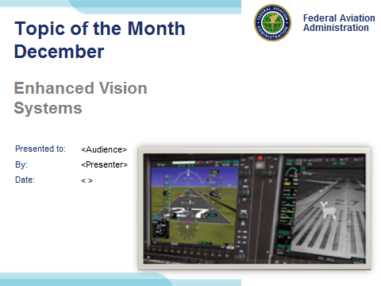 | Slide 1  2015/7/30-074 (I) PP Original Author, FAASTeam (JWS); POC Kevin Clover, AFS-850 Operations Lead, Office 562-888-2020; reviewed by John Steuernagle 7/17/2015  Presentation Note: This is the title slide for Enhanced Vision Systems  Presentation notes (stage direction and presentation suggestions) will be preceded by a Bold header: the notes themselves will be in Italic fonts.  Program control instructions will be in bold fonts and look like this: (Click) for building information within a slide; or this: (Next Slide) for slide advance.  Some slides contain background information that supports the concepts presented in the program.  Background information will always appear last and will be preceded by a bold Background: identification.  We have included a script of suggested dialog with each slide. Presenters may read the script or modify it to suit their own presentation style.  The production team hope you and your audience will enjoy the show. Break a leg!  (Next Slide)
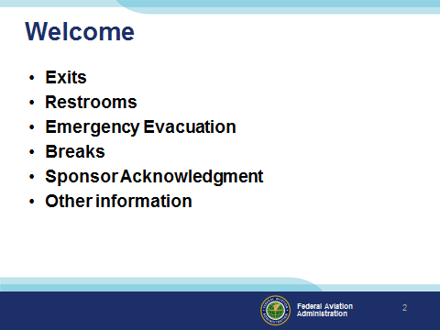 | Slide 2  Presentation Note: Here’s where you can discuss venue logistics, acknowledge sponsors, and deliver other information you want your audience to know in the beginning.  You can add slides after this one to fit your situation. (Next Slide)
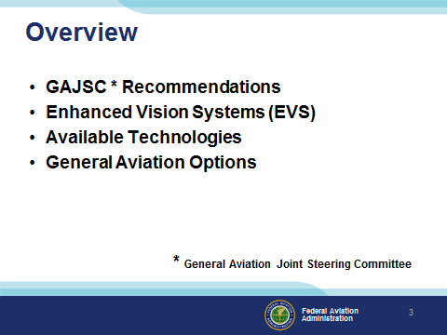 | Slide 3  In this presentation we’ll address recommendations from the General Aviation Joint Steering Committee – a government / industry group that analyzes GA accidents and incidents. The Committee feels Enhanced and Synthetic vision technology can significantly improve general aviation utility and reduce the chance of accidents during night, and IMC operations. We’ll take a look at available technologies and GA options.  Presentation Note: If you’ll be discussing additional items, add them to this list (Next Slide)
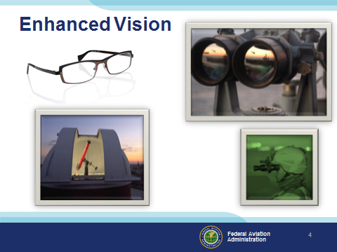 | Slide 4  We’ve been looking for ways to improve our vision for a long time. Up until recently we were dealing with improvements to optical systems. Night vision scopes and goggles initially used infrared illumination but today, they’re passive systems that amplify what little light there is on even the darkest of nights.  (Next Slide)
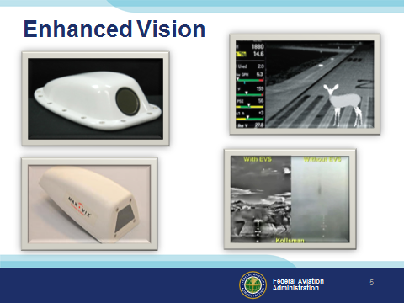 | Slide 5  Infrared cameras are available for installation on GA airplanes and their output can be displayed on multi function displays. Of course it’s nice to be able to see wildlife and other obstructions on the runway but they’re also quite useful in depicting terrain in weather or on a dark night.  A word of caution though. Enhanced vision technology takes some getting used to. You’ll have to make the transition to visual reference at some point and that can be a challenge – especially if you’re not viewing the world through a Head Up Display or HUD.  (Next Slide)
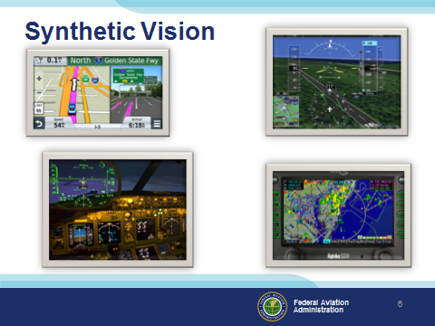 | Slide 6  For some time now, we’ve been able to combine imagery from sensors and navigation systems, with our own natural vision to see the world as never before. We call this  Synthetic Vision (Click)  Using information from navigation databases we can create a picture of the flight environment and overlay that picture with aircraft instrumentation, and weather information to create a single image that contains all of the information necessary for safe flight operations. (Click)  Developed for tactical military flying, the HUD or Head Up Display presents information from aircraft instrument displays directly in pilots’ fields of view as they look through their wind screens. HUD technology is already installed in many airline cockpits and it’s rapidly making its’ way to General Aviation as well.  (Next Slide)
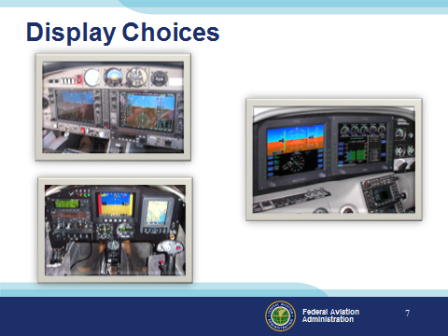 | Slide 7  Enhanced and Synthetic vision systems interface with a wide variety of general aviation multi function displays.  Presentation Note: Poll audience as to what sort of instrumentation they’re flying. If there are glass cockpit aviators in the audience ask them to talk about their transition experience and how long it took to be comfortable with the new technology.  Expect transitions to take longer if the aircraft you’re training in has unfamiliar glass cockpit instrumentation.  You can reduce training time and make time in the aircraft more productive if you log some time on an avionics simulator  Most manufacturers have personal computer-based simulations for their products  Many avionics packages can be operated in simulator mode.  (Next Slide)
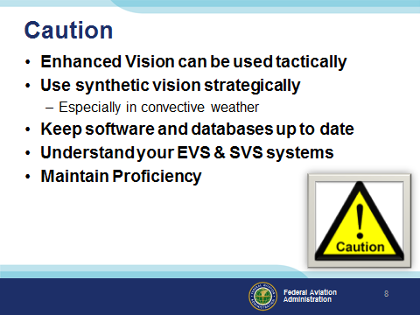 | Slide 8  Finally some cautions: (Click)  Enhanced vision, created from real time on board data sources can be used tactically. You know you have the latest information to act on because it’s generated from sensors on your  airplane. (Click)  Synthetic vision – especially when depicting weather events will be driven by data that is at best, 5 minutes old and it could be much older. That’s usually good enough to get the big picture but inadequate if you want to pick your way between thunderstorms. So if you’re not radar or storm scope equipped you’re better off to give convective weather  a very wide berth. (Click)  Obviously you’ll need to keep your software and databases up to date. (Click)  Understand how your enhanced and synthetic systems work, what graphical indications mean, and what failure modes look like. (Click)  And maintain proficiency in all flight evolutions, equipment use, and programming. Periodic proficiency training with a CFI who’s proficient on the equipment in your airplane will give you the confidence to use all of your equipment effectively.  (Next Slide)
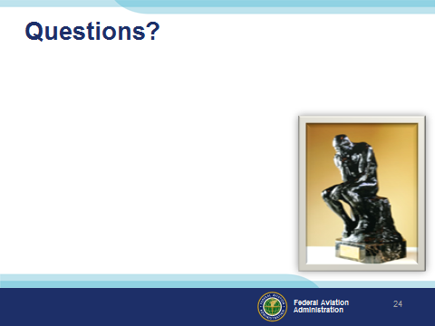 | Slide 25  Presentation Note: You may wish to provide your contact information and main FSDO phone number here. Modify with  Your information or leave blank.  (Next Slide)
Slide 26

(The End)

