Notes
Pilots and Medications
2015/05/13-071 (I) PP Rev 2
Abstract: Lasting 10 to 15 minutes, this presentation acquaints the audience with the hazards associated with flying while taking prescription and/or over-the-counter (OTC) medications
Format: Information Briefing - Power Point presentation
Required Personnel – FAASTeam Program Manager or designated FAASTeam Rep (s)
Optional Personnel – CFIs and DPEs who can speak on the benefits of CRM
AFS 850 Support:
In addition to this guidance document, a Power Point presentation that supports the program is provided. FPMs and presenters are encouraged to customize this presentation to reflect each individual program.

Appendix I – Equipment and Staging
Equipment:
- Projection Screen & Video Projector suitable for expected audience
  - Remote computer/projector control available at lectern or presenter location
    - In lieu of remote – detail a Rep to computer/projector control.
- Presentation Computer
  - Note: It is strongly suggested that the entire program reside on this computer.
- Back up Projector/Computer/Media as available.
- PA system suitable for expected audience
  - Microphones for Moderator and Panel
    - Optional Microphone (s) for audience
- Lectern (optional)
Staging:
- Arrange the projection screen for maximum visibility from the audience.
- Equip with PA microphones
- Place Lectern to one side of screen. This will be used by presenters and moderator

Slides | Script
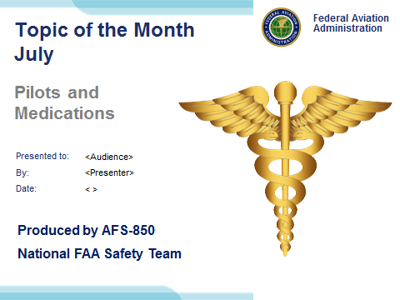 | Slide 1  2015/05/13-071 (I) PP Rev 2 Original Author: John Steuernagle; POC Kevin Clover, AFS-850 Operations Lead, Office 562-888-2020;  Presentation Note: This is the title slide for Pilots and Medications  Presentation notes (stage direction and presentation suggestions) will be preceded by a Bold header: the notes themselves will be in Italic fonts.  Program control instructions will be in bold fonts and look like this: (Click) for building information within a slide; or this: (Next Slide) for slide advance.  Some slides may contain background information that supports the concepts presented in the program.  Background information will always appear last and will be preceded by a bold Background: identification.  We have included a script of suggested dialog with each slide. Presenters may read the script or modify it to suit their own presentation style.  The production team hope you and your audience will enjoy the show. Break a leg!  (Next Slide)
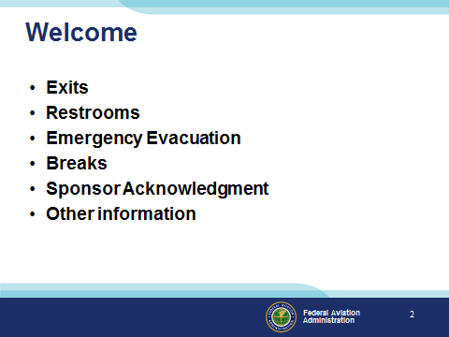 | Slide 2  Presentation Note: Here’s where you can discuss venue logistics, acknowledge sponsors, and deliver other information you want your audience to know in the beginning.  You can add slides after this one to fit your situation. (Next Slide)
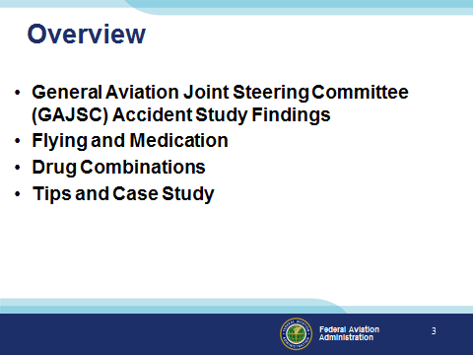 | Slide 3  In this presentation we’ll talk a little bit about a recent GAJSC study that features some interesting findings with respect to pilots and medications  We’ll talk generally about flying while medicating and the problems associated with taking multiple drugs.  Finally we’ll offer some tips for safe flying while on medications and we’ll discuss a case study.  Presentation Note: If you’ll be discussing additional items, add them to this list  (Next Slide)
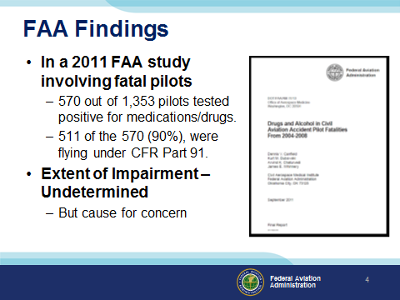 | Slide 4  In a 2011 study from the FAA’s CAMI Toxicology Lab drugs/medications were found in 570 pilots (42%) from 1,353 total fatal pilots tested. Most of the pilots with positive drug results, 511 (90%), were flying under CFR Part 91.” (Click)  While there were a couple instances of recreational drugs, the majority were prescription or over the counter medications. Antihistamines were the most commonly found. Left undetermined was the extent of pilot impairment – if any – due to drug use but the issue is cause for concern for several reasons:  (Next Slide)
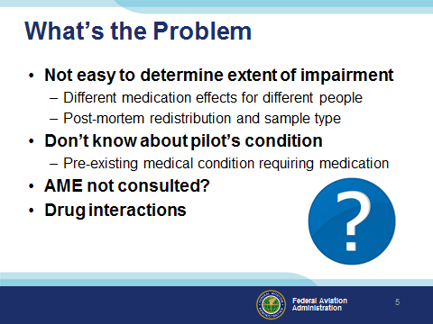 | Slide 5  So what’s the problem:  First of all – We all know that some medications may compromise a pilot’s ability to control the aircraft and/or adversely affect judgment and decision-making. (Click)  What’s not so obvious is it’s difficult for investigators to say for sure that pilot performance was compromised because the effect of drugs and medications varies widely among individuals. In addition, post-mortem redistribution of a substance creates some confusion as to the actual blood levels prior to the accident. The amount of a substance may vary considerably in different tissues. (Click)  A less obvious problem poses the question; what pre-existing physical condition requires the use of medication in the first place? (Click)  It’s not unusual to find that pilots are evaluated and treated for conditions that are not revealed to their Aviation Medical Examiners. In those cases an AME doesn’t have an opportunity to review the complete medical history of diagnoses and treatments for some of the pilots they examine. (Click)  There’s also the issue of drug interactions but we’ll get to that a little bit later. (Click)  A less obvious problem poses the question; what underlying physical condition requires the use of medication in the first place? (Click)  It’s not unusual to find that pilots are evaluated and treated for conditions that are not revealed to their Aviation Medical Examiners. In those cases the AME doesn’t have an opportunity to review complete pilot history of diagnosis and treatment. (Click)  There’s also the issue of drug interactions but we’ll get to that a little bit later.  (Next Slide)
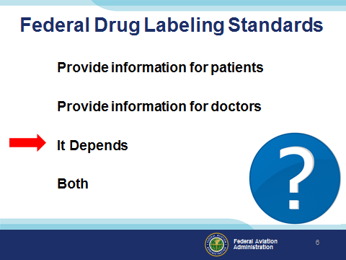 | Slide 6  Fortunately – the FDA requires standard labeling for prescription and over the counter medications (Click)  but are those labeling standards primarily for patients or doctors or both.  Presentation Note: Ask for a show of hands with respect to each statement then (Click)  As it turns out the correct answer is it depends.  (Next Slide)
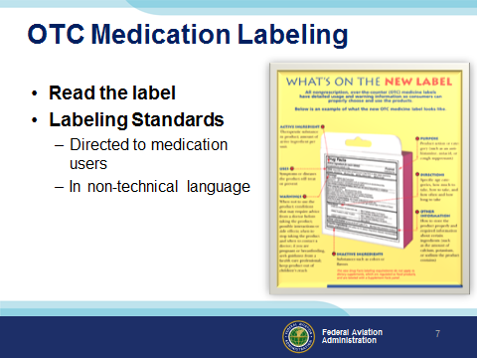 | Slide 7  Food and Drug Administration (FDA) OTC labeling requirements are directed to users so be sure to read the label before you medicate and fly.  (Next Slide)
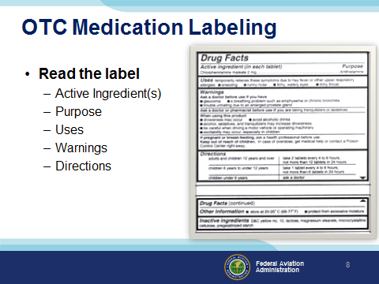 | Slide 8  The standard OTC Label will tell you the active ingredients, purpose, and uses for the drug as well as warnings and directions for use.  Note in this example we’re looking at an antihistamine that we might take to address cold symptoms.  Note the warnings of drowsiness and those associated with driving a motor vehicle or operating machinery. Do you think it would be safe to fly while using this drug? How long will it reside in your system? How soon would you be safe to fly after stopping the drug?  You won’t find the answers to any of those questions on the label. This might be a good time to consult your AME.  (Next Slide)
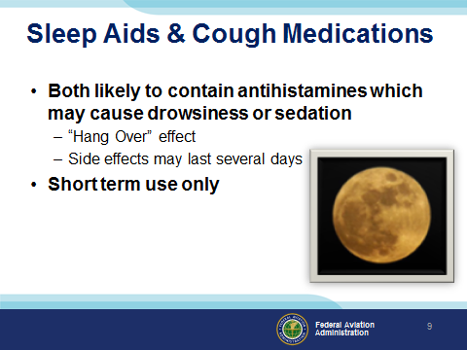 | Slide 9  A word on OTC sleep aids and cough medications: (Click)  Sleep aids obviously are intended to promote sleep but their effects – resembling a hangover - may persist into the several days – not a good idea if you’re going flying. (Click)  Also – tolerance to active ingredients builds quickly so you’ll find you’re taking more and more medicine to achieve the same result. (Click)  All OTC medications are intended for temporary use. Taking them for longer than the recommended time may mask symptoms of a significant or serious underlying medical condition.  (Next Slide)
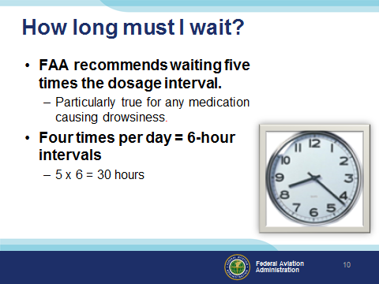 | Slide 10  If you’ve been taking a medication that precludes flying, how long must you wait after ceasing the medication before you return to the air? (Click)  This is a good question for your AME to answer but the general rule is to wait until 5 times the dosage interval has passed. (Click)  For example; if you take a medication 4 times a day (6-hour intervals) you should wait at least 30 hours before resuming pilot duties.  (Next Slide)
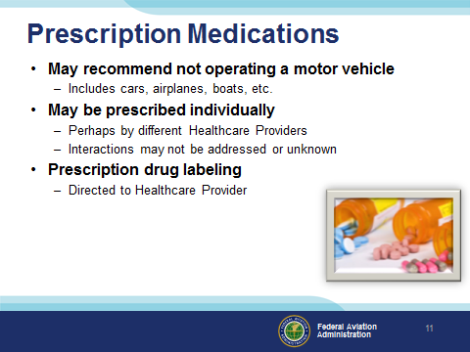 | Slide 11  Prescription meds are a little bit different. They’re often stronger versions of what you can get over-the-counter. Many carry a warning to not operate motor vehicles or perform tasks that require alertness. Remember boats and planes are considered motor vehicle and piloting an airplane certainly requires alertness!  Prescription drugs are often prescribed individually – sometimes by different healthcare providers. Interactions may not be addressed or may be unknown.  Unlike those for OTC products, the labeling standards for prescription drugs are primarily for the use of medical professionals so they’re not as helpful to the lay public. Be sure to ask remind your prescribing healthcare provider you are a pilot and how the drug is likely to affect your motor skills, judgment, and decision-making.  (Next Slide)
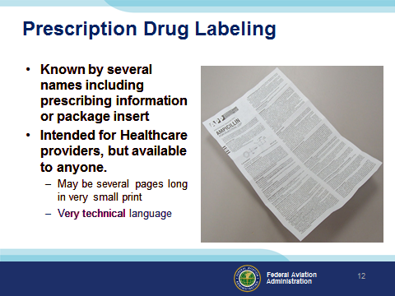 | Slide 12  Per Food and Drug Administration (FDA) the acceptable names are: prescribing information, package insert, professional labeling, direction circular, package circular  This information is intended for health professionals and is rarely given to the patient although it is readily available on line. Currently it consists of written document included in the medication box or attached to a container, but FDA is trying to change this to electronic format. Highly detailed information in technical language and in a standard format.  (Next Slide)
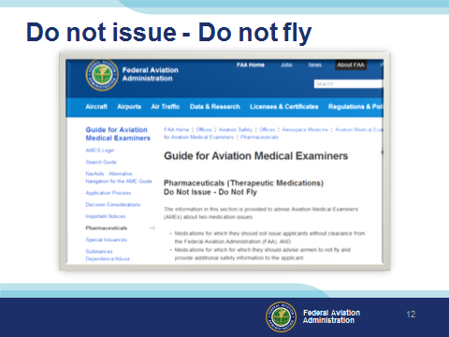 | Slide 13  The FAA maintains a list of drugs that will preclude the issuance of any medical certificate or should not be taken while in flight status. The easiest way to access the list is to Search for “Do Not Issue – Do Not Fly”. You’ll be directed to the web page shown here.  There are other lists available to members of pilot organizations and to the public. If you don’t see your medication on the list or if you have any questions call your AME for the latest information.  (Next Slide)
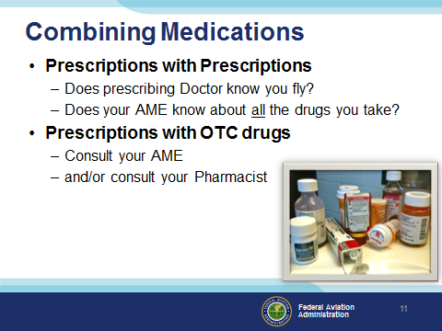 | Slide 14  Look into any medicine cabinet and you’re likely to find a mixture of OTC and prescription meds. Who’s responsible for assessing the affects and possible drug interactions? Making those assessments is something they don’t teach us in pilot school so this may also be a good time to seek some professional help. Before you do that though let’s talk about prescription drugs alone or in combination.  Does your prescribing doctor know you fly? Maybe a more suitable drug could be prescribed if your doctor knows you’re a pilot.  Even more importantly, does your AME know about all the drugs you take and the conditions for which you take them?  Combining prescription and OTC drugs introduces another challenge – the self medicating pilot. Once again it’s safer to consult your AME and/or pharmacist before adding OTC meds to your system.  We’re not going to address recreational drugs here. We all know that flying is about the best recreation there is. It’s not safe and not legal to fly under the influence.  We will look at one case from the GAJSC study though. We’ll discuss it with respect to the PAVE checklist that’s familiar to most if not all of us. I think you’ll find the case study illuminating.  (Next Slide)
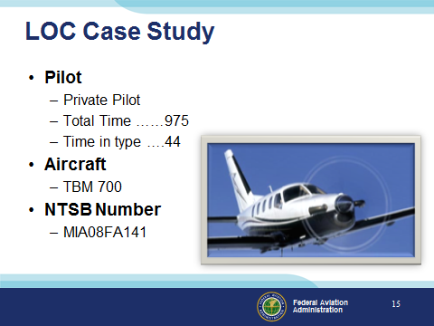 | Slide 15  The case involved a private pilot with just under a thousand hours total time with 44 of those hours in the TBM 700  (Next Slide)
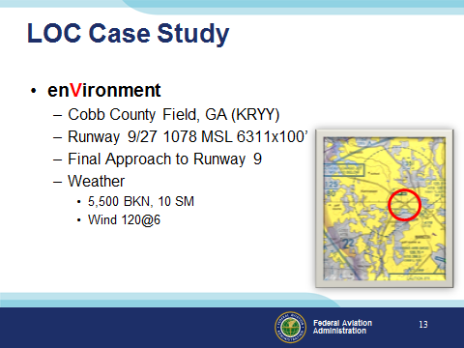 | Slide 16  During approach to runway 9, at Cobb County Field near Atlanta, GA, the tower controller instructed the pilot to perform an “S” turn 3 miles from the runway. The pilot initiated the “S” turn to the left, and after turning back to the right towards the runway to complete the other half of the turn, the controller advised the pilot that he did not need to finish the maneuver, and could turn onto final approach. The last recorded ground speed was 89 knots when the pilot banked the airplane sharply to the left. Witnesses stated that the airplane seemed to do a wing over onto its back and go straight down.  Subsequent flight simulation tests revealed that while making a steep turn and not adding power, as the bank angle increased the airspeed would decrease and the airplane would enter an aerodynamic stall.  (Next Slide)
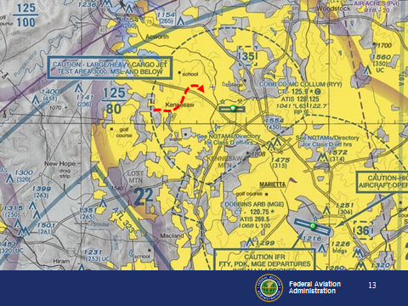 | Slide 17  Here’s a larger view of the area – the flight path is not to scale but you get the idea.  (Next Slide)
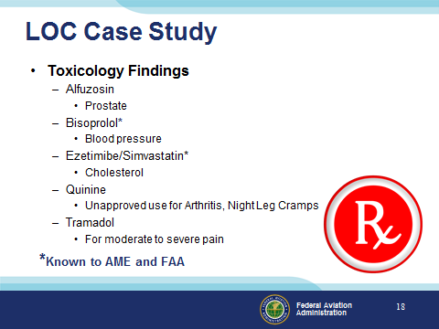 | Slide 18  Toxicology testing indicated that the pilot had been using tramadol, a prescription painkiller with potentially impairing effects. The pilot had not reported its use on his most recent application for airman medical certificate approximately 20 months prior to the accident. It is unclear what role, if any, the medication or the condition for which it might have been used played in the accident.  Alfuzosin – a prostate medicine, Bisoprolol – a beta blocker, Quinine – taken by some arthritis sufferers, and Tramadol – for moderate to severe pain were found in the toxicology study. Of these only Bisoprolol was known to the pilots’ Aviation Medical Examiner.  The National Transportation Safety Board determined the probable cause(s) of this accident as follows: The pilot’s failure to maintain airspeed during final approach resulting in an aerodynamic stall.  As an additional comment they also stated: “It is unclear what role, if any, the medication or the condition for which it might have been used played in the accident.”  (Next Slide)
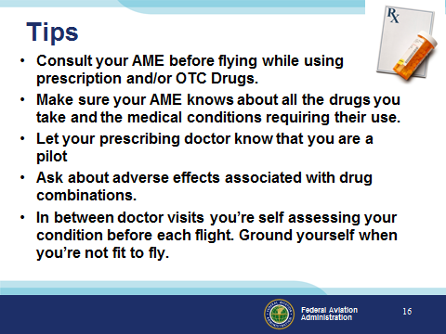 | Slide 19  Finally – here are some tips for safe flying while taking prescribed or OTC medications.  Consult your AME before flying while using prescription and/or OTC Drugs.  Make sure your AME knows about all the drugs you take and the medical conditions requiring their use.  Let your prescribing doctor know that you are a pilot.  Ask about adverse effects associated with drug combinations.  In between doctor visits you’re self assessing your condition before each flight. Ground yourself when you’re not fit to fly.  (Next Slide)
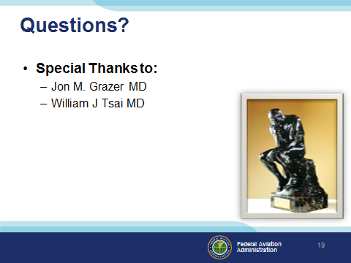 | Slide 20  Presentation Note: You may wish to provide your contact information and main FSDO phone number here. Modify with your information or leave blank.  (Next Slide)
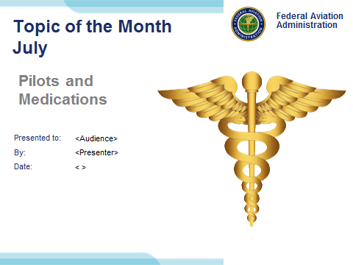 | Slide 21  (The End)

