Notes
PD Avoidance
2016/09/19-092 (I) PP
Abstract: Lasting 10 to 15 minutes, this presentation acquaints the audience with the hazards associated with pilot deviations and offers tips on avoiding PDs
Format: Information Briefing - Power Point presentation
Required Personnel – FAASTeam Program Manager or designated FAASTeam Rep (s)
Optional Personnel – CFIs and DPEs who can speak on the benefits of PD Avoidance
AFS 850 Support:
In addition to this guidance document, a Power Point presentation that supports the program is provided. FPMs and presenters are encouraged to customize this presentation to reflect each individual program.

Appendix I – Equipment and Staging
Equipment:
- Projection Screen & Video Projector suitable for expected audience
  - Remote computer/projector control available at lectern or presenter location
    - In lieu of remote – detail a Rep to computer/projector control.
- Presentation Computer
  - Note: It is strongly suggested that the entire program reside on this computer.
- Back up Projector/Computer/Media as available.
- PA system suitable for expected audience
  - Microphones for Moderator and Panel
    - Optional Microphone (s) for audience
- Lectern (optional)
Staging:
- Arrange the projection screen for maximum visibility from the audience.
- Equip with PA microphones
- Place Lectern to one side of screen. This will be used by presenters and moderator

Slides | Script
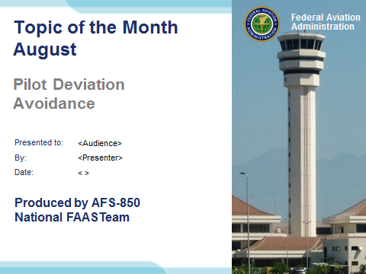 | Slide 1  2016/09/19-092 (I) PP Original Author: John Steuernagle 09/14/2016; POC Kevin Clover, AFS-850 Operations Lead, Office: 562-888-2020; revised by (Name) (MM/DD/YYYY)  Presentation Note: This is the title slide for Pilot Deviation Avoidance  Presentation notes (stage direction and presentation suggestions) will be preceded by a Bold header: the notes themselves will be in Italic fonts.  Program control instructions will be in bold fonts and look like this: (Click) for building information within a slide; or this: (Next Slide) for slide advance.  Some slides may contain background information that supports the concepts presented in the program.  Background information will always appear last and will be preceded by a bold Background: identification.  We have included a script of suggested dialog with each slide. Presenters may read the script or modify it to suit their own presentation style.  The production team hopes you and your audience will enjoy the show. Break a leg!  (Next Slide)
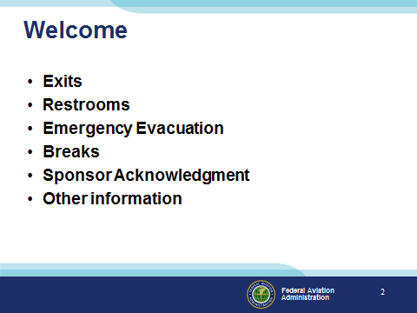 | Slide 2  Presentation Note: Here’s where you can discuss venue logistics, acknowledge sponsors, and deliver other information you want your audience to know in the beginning.  You can add slides after this one to fit your situation. (Next Slide)
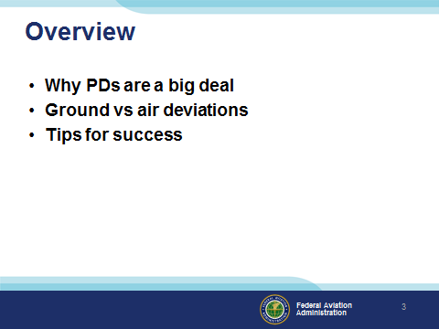 | Slide 3  Today we’ll be discussing why pilot deviations are such a big deal. We’ll discriminate between ground and air deviations and offer tips for success in PD Avoidance.  Presentation Note: If you’ll be discussing additional items, add them to this list  (Next Slide)
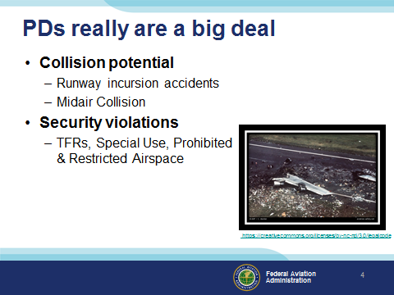 | Slide 4  PDs really are a big deal principally due to their potential for collision. In fact the greatest loss of life in a single airplane accident was the result of a runway incursion.  585 passengers and crew lost their lives when two 747 aircraft collided on the island of Tenerife. (Click)  PDs have also resulted in safety and security violations of temporary flight restriction areas and special use, prohibited, and restricted airspace.  (Next Slide)  Background: This photo is licensed through creative commons. No commercial distribution is permitted. A link to the license appears on the slide. (Next Slide)
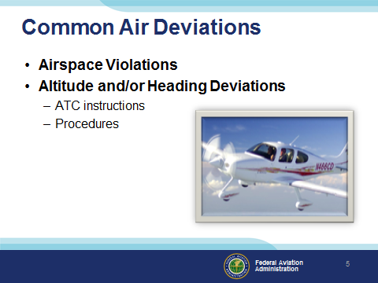 | Slide 5  Common Air Deviations include:  Airspace Violations – Operating in airspace without clearance to do so  Altitude and/or heading deviations resulting from failure to comply with ATC instructions or published procedures  (Next Slide)
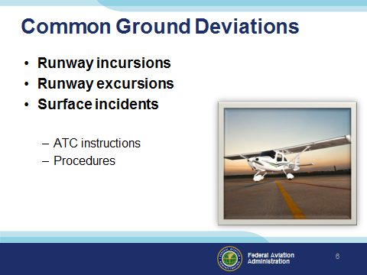 | Slide 6  Common Ground Deviations include:  Runway Incursions – the unauthorized presence on a runway;  Runway Excursions – departures from a runway such as overshoots, ground loops, etc.  and Surface Incidents – such as unauthorized presence in the airport movement area.  (Next Slide)
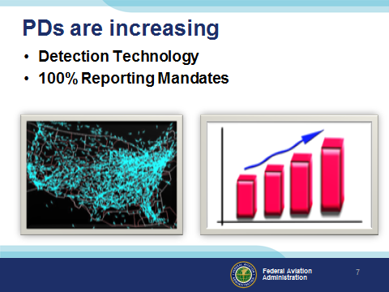 | Slide 7  PDs are on the increase – particularly those that occur in flight. (Click)  That’s not surprising considering the fact that automated reporting systems are in place across the country and air traffic controllers are required to report all deviations that they observe. This is not so good because it results in pilots and FAA inspectors spending thousands of hours processing deviations. But it is good in the sense that we’re learning a lot about how deviations occur and what we can do to reduce occurrences.  (Next Slide)
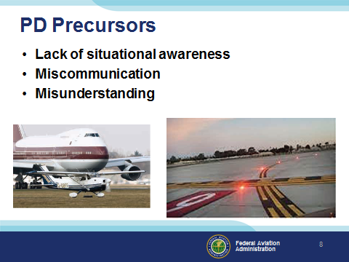 | Slide 8  One or more of these precursors is present in most pilot deviations.  (Next Slide)
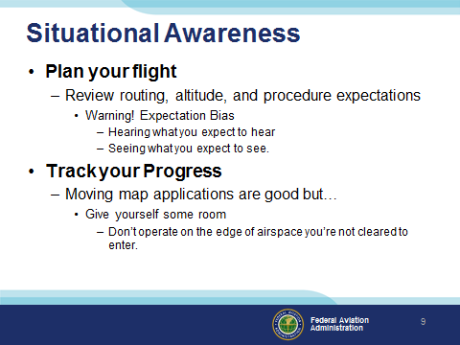 | Slide 9  Here are some tips to help you maintain situational awareness: (Click)  Plan your flight – even if you make the same flight every week. Review your routing, altitude, and the procedures you expect to fly. But be aware that this review will create a strong expectation bias. You must carefully consider any ATC, weather, or self generated changes to your plan carefully. Make sure you understand the new plan before you agree to fly it. (Click)  Track your Progress – it’s essential to know where you are and GPS navigation equipment and mapping applications make this easier than ever. There is one downside though. Many pilots have used GPS guidance to fly too close to airspace they’re not cleared to enter. Air Traffic Radar can show you in a slightly different position than your GPS does. This problem will get better as we equip with ADS-B technology but for now, give yourself some room and fly at least a mile outside airspace you’re not cleared to enter.  (Next Slide)
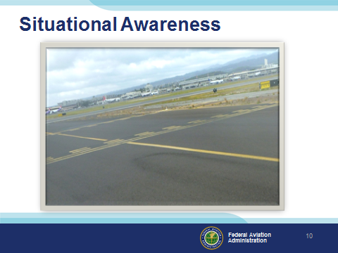 | Slide 10  In some ways – situational awareness is more challenging to maintain on the ground – especially at night. Here’s an interesting photograph from Honolulu International Airport in Hawaii. It looks as if the hold lines have been painted incorrectly but it’s the result of an increased Runway Safety Area dimension at an airport that was designed before the current runway safety area standards were adopted. We’re trained to clear the runway expeditiously after landing and we’re used to seeing hold lines that will allow us to do that. Imagine what you would do if you hadn’t planned your taxi route, noted the unusual proximity of runways and expected something unusual.  (Next Slide)  Background: Avoid Loss of Situational Awareness between HNL Runways 4L and 4R  The problem: There have been numerous pilot deviations involving Taxiways C, D E, & F between HNL International Airport’s Runways 4L and 4R. Pilots are not recognizing the ‘hold short line’ that applies to their direction of taxi due to an unusual configuration.  Why: Honolulu International Airport was designed many years ago and Runways 4L and 4R do not meet current FAA design standards because they are so close to each other. Current Runway Safety Area requirements resulted in an overlap of taxiway pavement that must be protected from any obstacles that might pose a hazard to aircraft using the associated runway. For this reason, the airport has established 2 hold short markings on taxiways in between the runways and their positions may appear to be reversed. The hold short bar that applies to a direction of taxi is NOT always the one closest to the runway.  What to Do: Refer to the attached picture and note how the first hold short bars have 2 solid lines indicating a pilot must have air traffic approval prior to crossing. Do not cross these lines without the specific direction of ATC. Again referring to the picture, note the second set of hold short lines that are next to the runway. Note the dashed lines facing you. These indicate that, once cleared to proceed, you can cross these lines without specific instruction. If you were to be taxiing in the opposite direction, you would again face 2 solid lines; again, requiring you to stop and obtain ATC approval prior to crossing. Note that compliance with the hold short markings between Runways 4L and 4R at HNL will result in your not clearing the runway behind you. This is an acceptable consequence of meeting the Runway Safety Criteria and ATC is aware of it and plan traffic flow accordingly.  For Reference: Please Review AIM, Chapter 2 Aeronautical Lighting and Airport Visual Aids, Section 3, Airport Marking Aids and Signs. “…Runway Holding Position Markings… indicate where an aircraft is supposed to stop when approaching a runway. They consist of four yellow lines, two solid and two dashed…The solid lines are always on the side where the aircraft is to hold.”
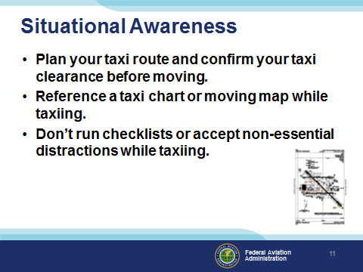 | Slide 11  Tips for maintaining situational awareness on the ground include:  Plan your taxi route and confirm your taxi clearance before moving.  Reference a taxi chart and/or moving map while taxiing.  Don’t run checklists of accept non-essential distractions while taxiing.  (Next Slide)
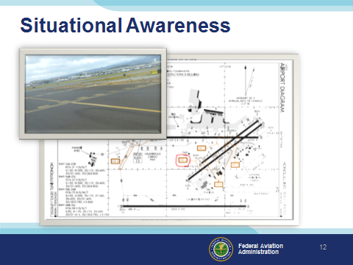 | Slide 12  When studying airport diagrams, be sure to note hot spots. These are places on the airport with high potential for runway incursions.  (Next Slide)
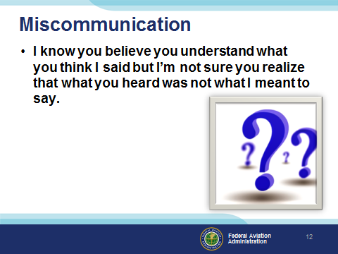 | Slide 13  Miscommunication has been a problem since humans began to speak and wars have been fought because of it. Thankfully we have a standard aviation vocabulary that does a lot toward reducing opportunities for miscommunication. Still there are problems, such as:  (Next Slide)
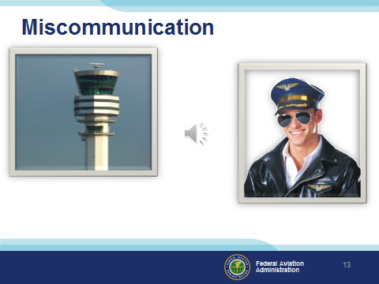 | Slide 14  Miscommunication has been a problem since humans began to speak and wars have been fought because of it. Thankfully we have a standard aviation vocabulary that does a lot toward reducing opportunities for miscommunication. Still there are problems, such as:  Presentation Note: Click on Speaker Icon to play audio file. Then advance to next slide.  (Next Slide)
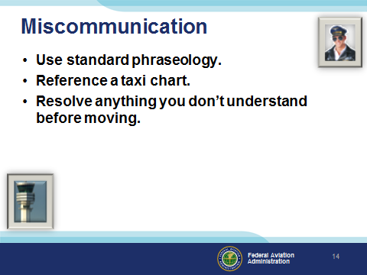 | Slide 15  Standard phraseology works best if both parties use it. We suggest you copy each clearance on paper – then read it back verbatim. Next refer to your taxi chart to see where the route takes you. Now’s the time to request clarification of anything you don’t understand in the clearance. Once you’re confident you know what you’re expected to do it’s time to taxi.  (Next Slide)
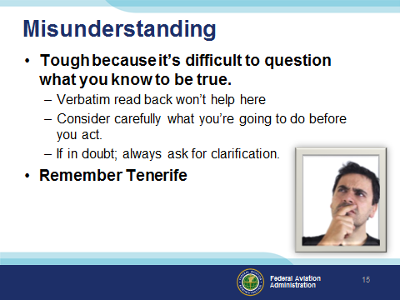 | Slide 16  Misunderstanding is really tough because it’s difficult to know when what you know to be true – isn’t. This can happen when you’re interpreting a procedure chart or trying to comply with a clearance or instruction. A verbatim read back won’t help in this case if you don’t understand what you’re expected to do. In fact there are numerous instances of pilots correctly reading back hold short clearances then taking off without a takeoff clearance. Flying rarely calls for immediate action. Take the time to carefully consider what you’re going to do before you do it. And if at all in doubt; always ask for clarification.  That brings us back to Tenerife where one 747 took off without clearance while another 747 was crossing the runway. The takeoff crew were questioning whether they were cleared to go but ultimately resolved the question in the cockpit. How much different would it have turned out if they had confirmed their takeoff plans with the tower before advancing the throttles.  (Next Slide)
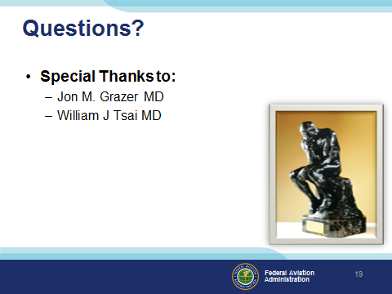 | Slide 17  Presentation Note: You may wish to provide your contact information and main FSDO phone number here. Modify with your information or leave blank.  (Next Slide)
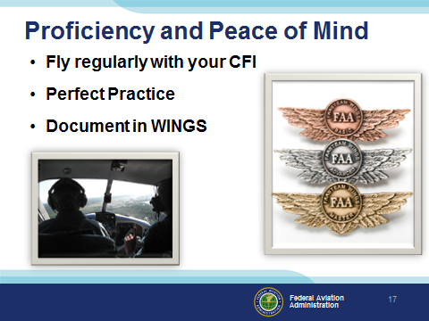 | Slide 18  There’s nothing like the feeling you get when you know you’re playing your A game and in order to do that you need a good coach (Click)  So fly regularly with a CFI who will challenge you to review what you know, explore new horizons, and to always do your best. Of course you’ll  have to dedicate time and money to your proficiency program but it’s well worth it for the peace of mind that comes with confidence. (Click)  Vince Lombardi, the famous football coach said, “Practice does not make perfect. Only perfect practice makes perfect.” For pilots that means  flying with precision. On course, on altitude, on speed all the time. (Click)  And be sure to document your achievement in the Wings Proficiency Program. It’s a great way to stay on top of your game and keep your flight review current.  (The End)
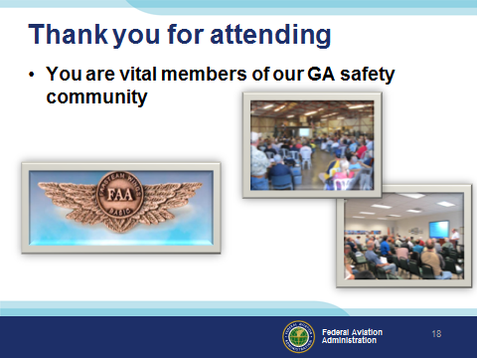 | Slide 19  Your presence here shows that you are vital members of our General Aviation Safety Community. The high standards you keep and the examples you set are a great credit to you and to GA.  Thank you for attending.  (The End)
Slide 20

(The End)

