Notes
Preflight After Maintenance
2019/02-11-146(I)PP

Abstract: Lasting 20 to 25 minutes, this presentation acquaints the audience with the benefits of conducting a thorough preflight on an aircraft after it comes out of a maintenance.
Format: Information Briefing - Power Point presentation
Required Personnel – FAASTeam Program Manager or designated FAASTeam Rep (s)
Optional Personnel – DPE and DMEs, CFIs, and other pilots and mechanics who can speak on the benefits of preflights after maintenance.
AFS 920 Support:
In addition to this guidance document, a Power Point presentation that supports the program is provided. FPMs and presenters are encouraged to customize this presentation to reflect each individual program.

Appendix I – Equipment and Staging
Equipment:
- Projection Screen & Video Projector suitable for expected audience
  - Remote computer/projector control available at lectern or presenter location
    - In lieu of remote – detail a Rep to computer/projector control.
- Presentation Computer
  - Note: It is strongly suggested that the entire program reside on this computer.
- Back up Projector/Computer/Media as available.
- PA system suitable for expected audience
  - Microphones for Moderator and Panel
    - Optional Microphone (s) for audience
- Lectern (optional)
Staging:
- Arrange the projection screen for maximum visibility from the audience.
- Equip with PA microphones
- Place Lectern to one side of screen. This will be used by presenters and moderator

Slides | Script
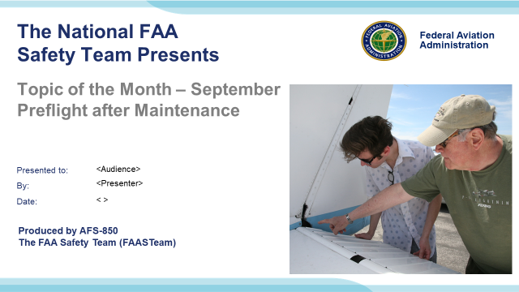 | Slide 1  (QMS File Number) Original Authors: Eddie Shields, Dan Vengen, Barry Byrd, Tony Alfaya, and Steven Steele 17 October 2018 POC Keven Clover, AFS-850 Operations Lead Office: (562-888-2020); revised by John Steuernagle 15 November 2018.  Presentation Note: This is the title slide for Preflight after Maintenance  Presentation notes (stage direction and presentation suggestions) will be preceded by a Bold header: the notes themselves will be in Italic fonts.  Program control instructions will be in bold fonts and look like this: (Click) for building information within a slide; or this: (Next Slide) for slide advance.  Some slides may contain background information that supports the concepts presented in the program.  Background information will always appear last and will be preceded by a bold Background: identification.  We have included a script of suggested dialog with each slide. Presenters may read the script or modify it to suit their own presentation style.  The production team hope you and your audience will enjoy the show. Break a leg!  (Next Slide)
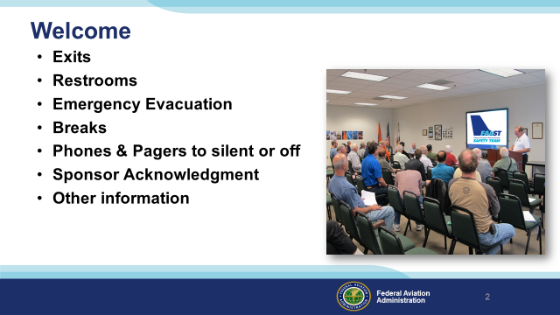 | Slide 2  Presentation Note: Here’s where you can discuss venue logistics, acknowledge sponsors, and deliver other information you want your audience to know in the beginning.
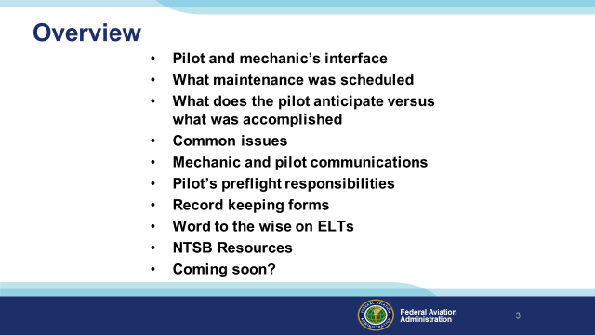 | Slide 3  Presentation note: The presentation begins with a Chicken Wings cartoon depicting an example of poor preparation and preflight by the pilot; and most importantly, a total lack of proper communication with the mechanic performing the maintenance to determine the airworthiness of the aircraft after maintenance was performed. A true story follows portraying the same. This presentation will then discuss Pilot and Mechanic Interfaces, What Maintenance Was Scheduled, What Does the Pilot Anticipate Versus What Was Accomplished, Common Issues, Mechanic and Pilot Communications, Pilot’s Preflight Responsibilities, Record Keeping Forms, Word to the Wise on ELTs, NTSB Resources, and What is Coming Soon.  Next Slide
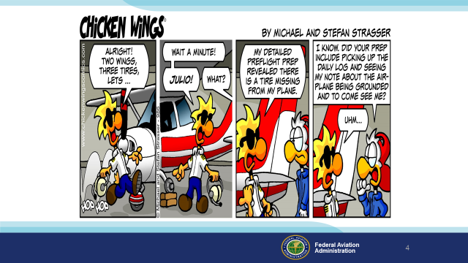 | Slide 4  Presentation Note: Pause approximately 15 seconds to allow time for the airman to read the comic strip.  Next Slide
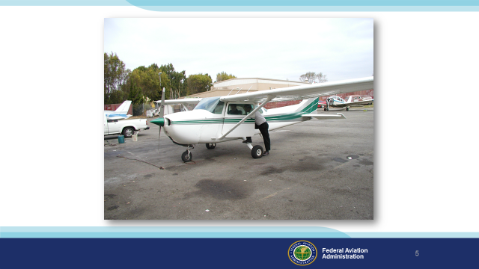 | Slide 5  Story line:  A club aircraft was in maintenance. The aircraft owners were a man and his wife.  The aircraft was almost done with the maintenance so the mechanic informed the club that the aircraft would be ready the following day. The maintenance personnel had found a thread bare tire and removed the wheel. The tire was not in stock so they ordered it and just put the tire/wheel on hand tight so it would not to be on jacks overnight. The Pilot showed up early and flew the aircraft around the pattern. When the mechanics arrived at work they realized the aircraft was gone, and flying in the pattern. They got in touch with the pilot’s wife who quickly called the tower and advised him to land.  Upon inspection of the aircraft two Aviation Safety Inspectors found the wheel not properly installed and the photos that follow are of the aircraft after flight.  Next Slide
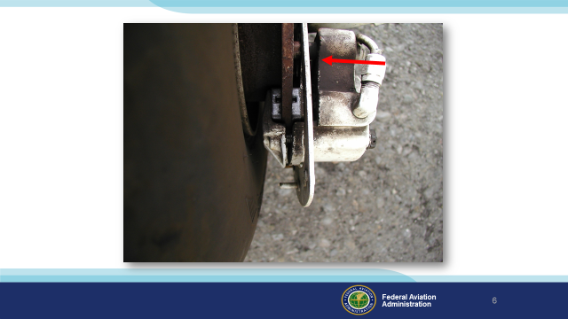 | Slide 6  Notice the gap between the caliper and the mounting surface. It is small but should have been noticed, especially after scheduled maintenance.  Next Slide
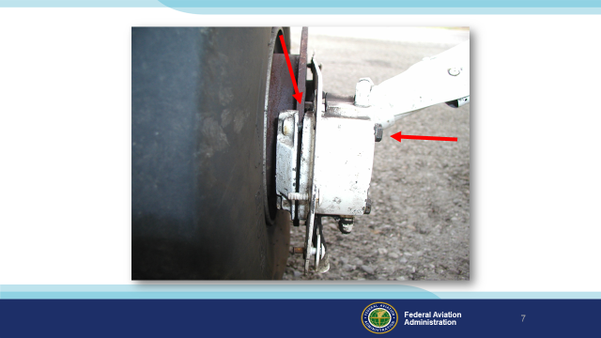 | Slide 7  A proper preflight should have identified the hand tightened brake assembly.  Please Note: There is no safety wire on the bolts.  Next Sl
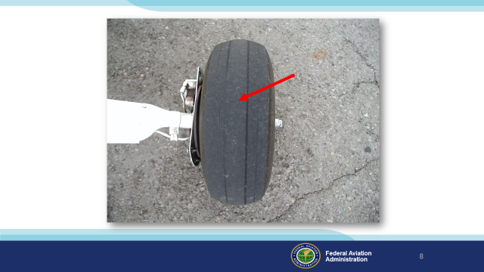 | Slide 8  Make sure you check with the applicable manufacturer’s tire manual to ascertain serviceability of the tires.  Next Slide
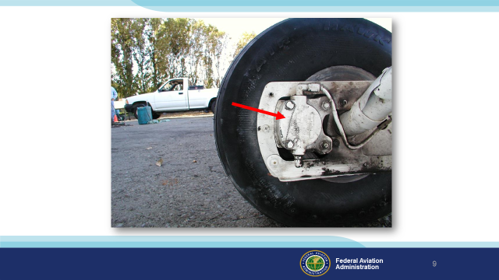 | Slide 9  This photo was taken post flight after the aircraft was properly repaired. This is the proper visual the pilot should have seen.  Moral of the story:  1. Don’t tell the customer the aircraft is ready to go while still undergoing maintenance.  - Mechanics need to make an unairworthy item(s) easily identifiable.  - The pilot must always do a thorough preflight after maintenance and speak to the mechanic to ascertain the status of the aircraft.  (Next Slide)
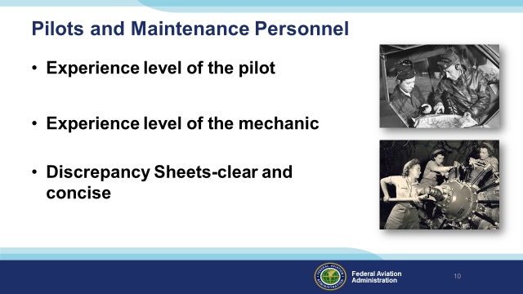 | Slide 10  Make sure you are a good candidate for retrieving an aircraft right out of maintenance. Make sure you are prepared and experienced enough to handle any occurrence.  Get to know the mechanic! He or she needs to know you as well. You need to understand how your mechanic thinks, how thorough they are, and how knowledgeable they are on your type of aircraft. It would probably be best to consider using a shop or mechanic that works on GA aircraft versus one that works on all types of turbo prop or jet aircraft. Ask other owners about the mechanic or shop you intend to use.  Make sure the discrepancies you discuss with the maintenance shop are clear and concise. If they do not seem to understand them, sit down and explain the discrepancies in detail. If they do not understand what is wrong, then they will not be able to explain what was done to fix the problem. Use a good discrepancy sheet that is clear, concise, and easy to understand. That will also help you to understand the corrective action taken by the mechanic.  (Next Slide)
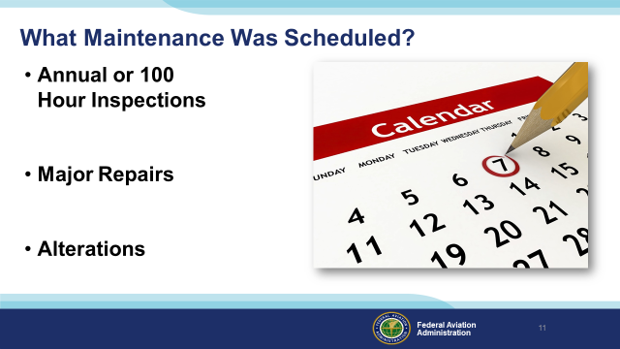 | Slide 11  A question to ask yourselves: How many of you are involved in the maintenance or scheduling of maintenance on the aircraft you fly? For those of you that do not get that involved, do you understand the items that you see here on the screen?  The inspections seen here often require opening up the entire aircraft. If you have not participated in one, or at least watched someone perform one of these inspections, it would be highly recommended that you do so. Afterward, you will never perform an ‘enhanced preflight’ after maintenance the same way again! There are so many ways to put the aircraft back together incorrectly. In addition, follow-up maintenance actions maybe required.  Ensure to ask about any repairs especially major repairs. What was touched, repaired, or replaced. This should also include any alterations. Take notes so you remember what to look at when you go to the aircraft.  (Answer questions as needed)  Background (Optional):  However, please have a good sit down with your mechanic (A&P or IA) and discuss all the issues (discrepancies) and those that were found during any inspection or repair. The maintenance shop should inform you of any repairs. They should also inform you of what to watch for on the first flight. However, you should always ask.  Most importantly remember that an open dialogue with your mechanic or maintenance shop is the only way to stay on top of your safety margin.  (Next Slide)
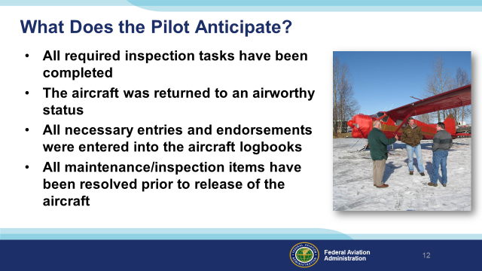 | Slide 12  Required inspections: Who developed the required checklist (14 CFR part 43.15 (c)(1)) the mechanic used for the inspection & does it meet the requirements of 14 CFR part 43, appendix D in Scope and Detail? How did mechanic record discrepancies and their corrective actions, including the removal of equipment & disconnecting of systems to facilitate other maintenance?  Airworthy status & necessary entries in maintenance records:  - Was the aircraft approved for return to service using the similar worded statements in 14 CFR part 43.11.  a. (Airworthy) “I certify that this aircraft has been inspected in accordance with (insert type) inspection and was determined to be in airworthy condition.” or  b. (UnAirworthy) “I certify that this aircraft has been inspected in accordance with (insert type) inspection and a list of discrepancies and unairworthy items dated (date) has been provided for the aircraft owner or operator”.  All maintenance/inspection items have been resolved? For all discrepancies corrected or for those items permitted to be inoperative under §91.213(d)(2), did mechanic place an appropriate placard that meets the aircraft's airworthiness certification. For the cockpit control of each item of inoperative equipment, was the marking of the word, “Inoperative,” placed next to the inoperative instrument. Also, did the mechanic add these items to the signed and dated list of discrepancies given to the owner or lessee?  (Next Slide)
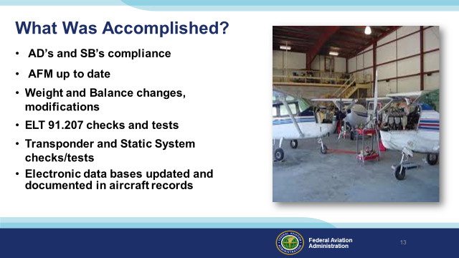 | Slide 13  AD’s (airworthiness directives) are one of the most common items found in non-compliance with GA aircraft. Make sure to get a status sheet from the mechanic to assure you know when the next inspection of recurring AD notes will be due.  Remember: Once the mechanic has done his job all bets are off once you fly the airplane after the inspection. If an AD comes due within 5 hours after an annual inspection, it is not the mechanics fault that you flew the aircraft over the time or inspection limits generally found within an AD.  Make sure the ELT battery’s expiration date is current and not going to expire soon.  If a major alteration (STC) or new equipment has been installed, make sure the weight and balance is changed.  Have a new equipment list created and a new copy placed in the aircraft records. The transponder/encoder and static system is usually checked at the same time. Remember, if you use the transponder system, it must be within the 24 month inspection time frame.  Data bases for GPS‘s, if dash mounted, can be updated by the pilot but must be tested and signed off in the aircraft records before flight. If you only use the GPS as a back up, then you need to use current charts for all flight planning and navigation.  (Next Slide)
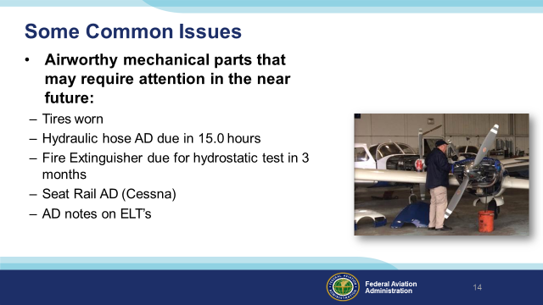 | Slide 14  ADs have a way of slipping by owners and pilots because they may not have been due at the time of the Annual or 100 inspection. Some owner/operators will request not to accomplish an AD prior to it being due, so , they basically set themselves up for a “Gotcha” to themselves. Including ELT batteries', transponder checks, and a required AD note later in the year etc. KNOW BEFORE YOU GO! This is another reason to have a good status sheet to go inside the aircraft. Discuss the sheet with the mechanic.  Background (Optional):  The mechanic should repair or replace any part that may not meet minimum standards before the next inspection. Many times the owner/operator will want to take all inspections out to the actual service times. The mechanic should provide the owner/operator a list of inspection items that will come due before the next required inspection. Many times in GA the owner/operator will not authorized the replacement of a part which, in reality, is still airworthy but will expire within the next inspection cycle.  Overdue ADs are the responsibility of the Owner/Operator. This does not absolve the mechanics responsibility to do due diligence in researching AD of the whole aircraft. The aircraft owner relies on the expertise of the mechanic to ensure the aircraft is airworthy.  AD notes on ELTs are frequently missed and the installation of the ELT is not checked for security. If the ELT is not secure it will dislodge and be useless in the event of a crash. Many ELTs were installed with Velcro, Velcro will degrade with time and temperature extremes making it unusable. The Velcro must be checked and replaced if this degrading has occurred.  The maintenance and inspection of an aircraft is a team project. The mechanic must have the integrity to properly inspect and repair the aircraft, and the pilot must take the time to do a thorough preflight inspection of the aircraft with the mechanic to indicate what work was accomplished and what work will need to be done before the next inspection. This communication is essential to the safe operation of the aircraft.  (Next Slide)
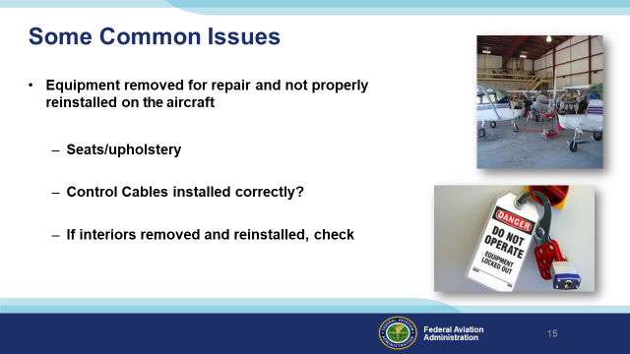 | Slide 15  See what was accomplished during the last scheduled maintenance. Review the mechanic’s maintenance records. Verify inspection covers are secured. Check for correct and unimpeded flight control surface deflections.  Background (Optional):  Seat Belt maintenance – Rail Stops in place  Cessna Seat Rail AD 2011-10-09 (New) Do you remember why this was made effective?  Better to find out that the cables are backwards on the ground during the preflight than during your take-off roll?  Auto-Pilot users – At what minimum altitude should you be at before turning on your auto-pilot system? Did you test it during run-up procedures? Was the aircraft test flown after return to service by the maintenance shop? All systems verified to work properly? Are your controls really free and have correct movement or did you just say that to complete the checklist?  - Seats  - Seat stops reinstalled? Correct ones?  - If reupholstered, was the AD complied with? Are there burn certification documentation.  - Control Cables installed correctly (even if they did not work specifically on the control system), need to check:  - Trim  - Elevator/ailerons/flaps - visually  - Autopilot System  - If interiors removed and reinstalled, check  - Screws missing resulting in improper fit, jammed controls, seats not gliding freely on tracks? Were the proper length screws installed. Are they mismatched?  (Next Slide)
 | Slide 16  Most owners do not conduct their own maintenance. Good communication skills and constant contact with the maintenance shop is a must!  Background (Optional):  Aircraft Altered- Discuss the required out-come of the alteration with your mechanic. Do not just accept that the work was accomplished “NOW PAY ME”. Don’t just let the maintenance shop leave the logs, expect you or someone else to just pick up the logbooks, pay the bill, and fly away.  Considerations:  - Approval Basis? Supplemental Type Certificate (STC), Amended Type Certificate Data Sheet (TCDS), FAA Approved Service Bulletin/Letters (SB) (SL), Field Approval, etc.  - Refit/Alteration Stacking- Many times your aircraft is configured different then the original STC’d or TCDS aircraft and the systems may not be compatible…  - ICA’s- Instructions for Continued Airworthiness… They are required for all major alterations. ICA’s include all required maintenance & intervals…  - AFM Supplement- Did alteration require a Supplement and was it installed in the AFM. Furthermore, become familiar with emergency procedures in the Supplement..  - Operating Handbooks- Many are required as part of the STC.  - Weight & Balance updated?  - Equipment List updated?  - MEL Change Required?  - Training required?  (Next Slide)
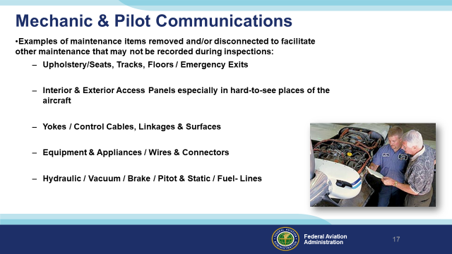 | Slide 17  Discuss the out-come of the inspection with your mechanic. Do not just accept that the work was accomplished- “NOW PAY ME”. Don’t just let the maintenance shop leave the logs and expect you or someone else to just pick up the books, pay the bill, and fly away.  Better to find out that the cables are backwards on the ground during the preflight than during your take-off roll?  Background (Optional):  Did you test all your systems during your run-up procedures? Was an aircraft flight operational check accomplished after maintenance? Were all systems verified to work properly? Are the controls really free and have correct movement or did you just say that to complete the checklist?  - Upholstery / Seats, Tracks, Floors / Emergency Exits  - Seat stops reinstalled? Correct ones? Seats not gliding freely on tracks? All hardware installed on tracks & floor?  - Check emergency exits to insure they are not blocked/restricted?  - If reupholstered, were burn certs. included in the records package? If interiors, including seat covers, cushions, upholstery, carpeting, and/or veneer is removed and replaced, insure the new material has the required burn certifications (FAA FORM 8110-3)  - Interior / Exterior Access /Inspection Panels:  - Verify that all access / inspection covers have fasteners/screws installed securely…  - Pitot/Static covers:  - Inspect these areas to insure that any tape and/or covers have been removed.  - Aircraft Painted:  - Verify maintenance record entry stating that control surfaces were balanced after painting…  - Yokes /Control Cables, Linkages, & Surfaces are installed correctly:  - Trim  - Elevator/ailerons/flaps - visually  - Autopilot System  - If interiors removed and reinstalled, check:  - Screws missing or wrong length, resulting in improper fit, & jammed/binding controls, seats not gliding freely on tracks?  (Next Slide)
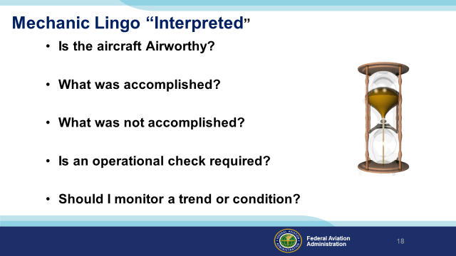 | Slide 18  Two things determine airworthiness:  Does the aircraft meet its type design?  Is the aircraft in a condition for safe operation?  The mechanic should properly document all maintenance that was performed, maintenance required, operational checks performed, and any items that may need to be monitored prior to the next scheduled inspections.  It is your responsibility to ensure your aircraft is properly maintained. If you don’t understand, ask until you do!  Background (Optional)  AS the PIC picking up an aircraft after maintenance, ask the questions:  - Is it Airworthy? (To determine Airworthiness you must meet the following two conditions)  a. The aircraft must conform to its type design (TC). Conformity to type design is considered attained when the aircraft configuration and the components installed are consistent with the drawings, specifications, and other data that are part of the TC (Type Certificate), which includes any supplemental type certificate (STC) or other approved alterations.  b. The aircraft must be in a condition for safe operation. This refers to the condition of the aircraft relative to wear and deterioration, for example, skin corrosion, window de- lamination or crazing, fluid leaks, tire wear, etc.  2. What was accomplished? If inspection revealed that the aircraft is found to be airworthy and approved for return to service, the following or a similarly worded statement - “I certify that this aircraft has been inspected in accordance with (insert type) inspection and was determined to be in airworthy condition.” (14CFR part 43.11(a)(4))  a. If discrepancies were discovered & corrected during the inspection, there must be a maintenance record entry containing the following information:  (1) A description (or reference to data acceptable to the Administrator) of work performed.  (2) The date of completion of the work performed.  (3) The name of the person performing the work if other than the person specified in paragraph (a)(4) of this section.  (4) If the work performed on the aircraft, airframe, aircraft engine, propeller, appliance, or component part has been performed satisfactorily, the signature, certificate number, and kind of certificate held by the person approving the work. The signature constitutes the approval for return to service only for the work performed. (Consider removing this reference to the reg)  3.What was not accomplished? If the aircraft is not approved for return to service because of needed maintenance, noncompliance with applicable specifications, airworthiness directives, or other approved data, the following or a similarly worded statement - “I certify that this aircraft has been inspected in accordance with (insert type) inspection and a list of discrepancies and un-airworthy items dated (date) has been provided for the aircraft owner or operator.”  4. Is operation check required? And how to properly sign it off? Signed off in accordance with 14 CFR part 43.9(a)(1)-(4), including a “Description of the Work Performed”, “Date Work was Completed”, and If the work has been performed satisfactorily,“...the signature, certificate number, and kind of certificate held by the person approving the work” (e.g., PP, CP, or ATP might be used to indicate private, commercial, or airline transport pilot, respectively)  5. Should I monitor for a trend or progression? Many times what appear to be discrepancies are within the manufacturer’s published limits and should be monitored in between inspections to insure that the condition does not worsen… (GIVE example here) Also consider what items are deferred waiting on parts? Does the aircraft have an MEL to fly with inoperative equipment on board. ? Or Does Part §91.213 “inoperative instruments and equipment” play into effect  Note: Make sure the Equipment List is current, so a thorough Airworthiness Directive (AD) search, of appliances is accomplished. Also insure if there are any ICA that are required from a previous major alteration or major repair that they are accomplished and recorded…  (Next Slide)
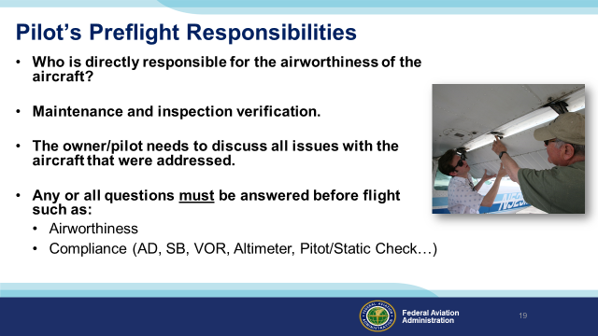 | Slide 19  Remember your responsibility to 14 CFR part 91.7, “KNOW BEFORE YOU GO!” Work with your mechanic and have him give you a “Status Sheet” on your aircraft.  Ask about ALL the items that were either repaired or replaced during the inspection. Ask what to look for and watch for during the first flight after maintenance. Is there maintenance that is required after the first flight or so many hours of post maintenance operation? After all, the mechanic knows what needs to be watched right after an inspection or maintenance.  (Next Slide)
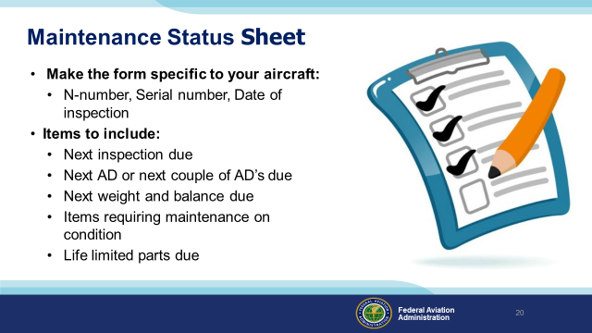 | Slide 20  Help the maintenance technician build a status sheet. Include everything about your aircraft to verify inspections, AD’s, etc. that could become due. Especially for any and all persons that will be flying the aircraft if in a club.  (Next Slide)
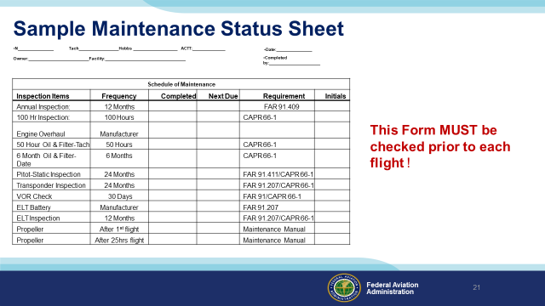 | Slide 21  Having a good “Status Sheet” to follow will keep you and other pilots informed on the airworthiness of the aircraft. Note the propeller. Wood propellers may have special post maintenance or inspection requirements.  (Next Slide)
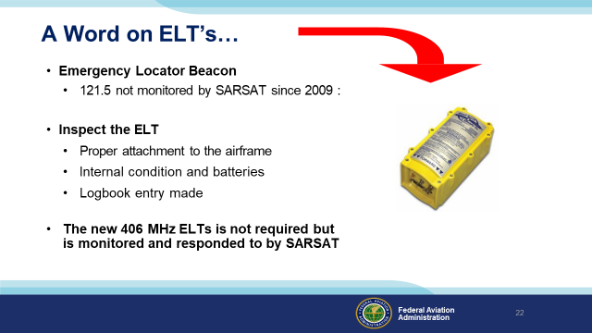 | Slide 22  (From AOPA site): ELTs were originally intended for use on the 121.5 MHz frequency to alert air traffic control and aircraft monitoring the frequency of distressed aircraft. In 1982, a satellite-based monitoring system, COSPAS-SARSAT, was implemented to provide a better way to detect these distress signals. In 2009, the international COSPAS-SARSAT satellite system discontinued satellite-based monitoring of the 121.5/243 MHz frequencies. Pilots should be aware that existing 121.5 MHz ELTs, although still legal from the FAA's perspective, will provide extremely limited assistance if an aircraft crashes, especially in a remote location.  (From COSPAS-SARSAT site): The 406 MHz should be tested using the safety precautions identified by the manufacturer. ALL signals generated by the 406 MHz received by COSPAS-SARSAT immediately alert and begin the search and rescue process  (Next Slide)
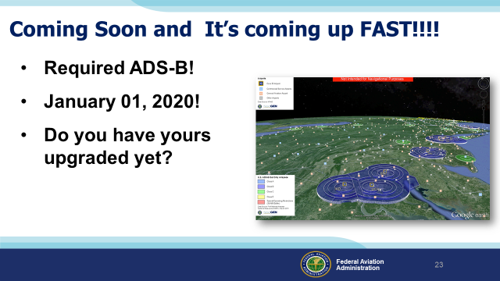 | Slide 23  Jan 1, 2020 is coming around fast. Avionic shops are getting busier. Don’t be grounded because you waited to long and now can't get into an avionics shop to have ADS-B installed.  (Next Slide)
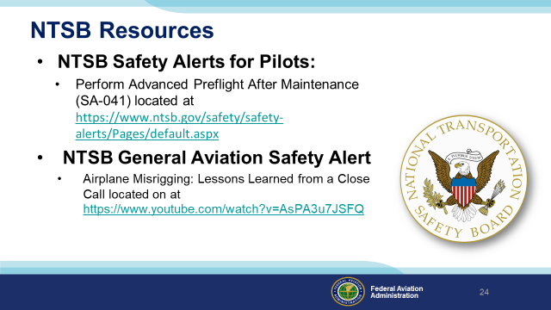 | Slide 24  For additional information on this topic please review these two resources from NTSB Safety Alerts that reinforce and give examples of inadequate preflights conducted after maintenance.  (Next Slide)
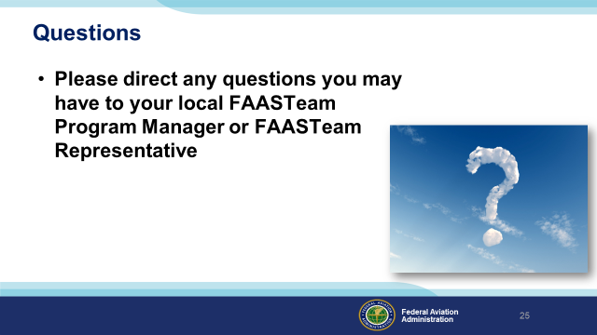 | Slide 25  (Next Slide)
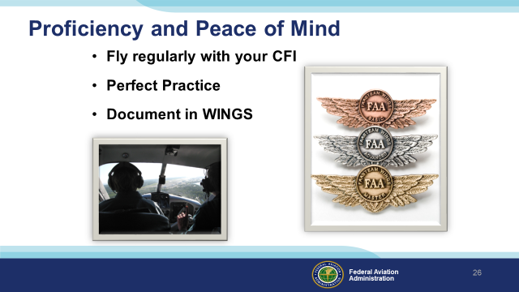 | Slide 26  There’s nothing like the feeling you get when you know you’re playing your A game and in order to do that you need a good coach (Click)  So fly regularly with a CFI who will challenge you to review what you know, explore new horizons, and to always do your best. Of course you’ll have to dedicate time and money to your proficiency program but it’s well worth it for the peace of mind that comes with confidence. (Click)  Vince Lombardi, the famous football coach said, “Practice does not make perfect. Only perfect practice makes perfect.” For pilots that means flying with precision. On course, on altitude, on speed all the time. (Click)  And be sure to document your achievement in the Wings Proficiency Program. It’s a great way to stay on top of your game and keep you flight review current.  (Next Slide)
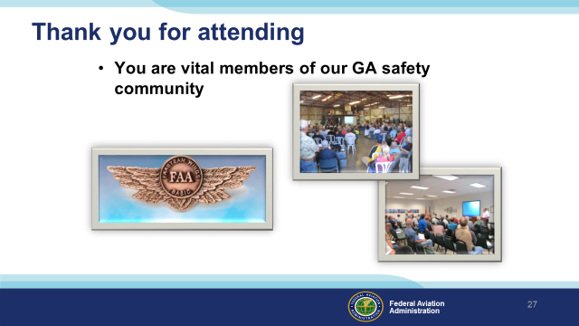 | Slide 27  Your presence here shows that you are vital members of our General Aviation Safety Community. The high standards you keep and the examples you set are a great credit to you and to GA.  Thank you for attending.  (Next Slide)
 | (The End)

