Notes
CFIT & Overreliance on Automation
2019/04-19-161(I)PP

Abstract: Lasting 10 to 15 minutes, this presentation acquaints the audience with thhazards associated with flying while taking prescription and/or over-the-counter (OTC) medications
Format: Information Briefing - Power Point presentation
Required Personnel – FAASTeam Program Manager or designated FAASTeam Rep (s)
Optional Personnel – Flight Instructors,
AFS 920 Support:
In addition to this guidance document, a Power Point presentation that supports the program is provided. FPMs and presenters are encouraged to customize this presentation to reflect each individual program.

Appendix I – Equipment and Staging
Equipment:
- Projection Screen & Video Projector suitable for expected audience
  - Remote computer/projector control available at lectern or presenter location
    - In lieu of remote – detail a Rep to computer/projector control.
- Presentation Computer
  - Note: It is strongly suggested that the entire program reside on this computer.
- Back up Projector/Computer/Media as available.
- PA system suitable for expected audience
  - Microphones for Moderator and Panel
    - Optional Microphone (s) for audience
- Lectern (optional)
Staging:
- Arrange the projection screen for maximum visibility from the audience.
- Equip with PA microphones
- Place Lectern to one side of screen. This will be used by presenters and moderator

Slides | Script
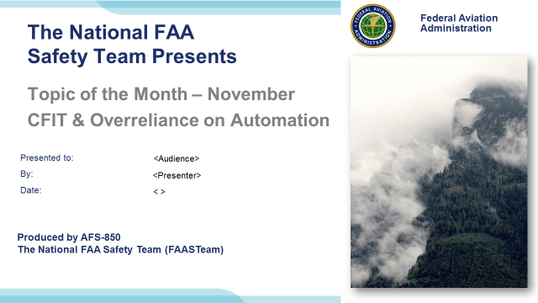 | Slide 1  2019/04-19-161(I)PP Original Author: John Steuernagle; POC Kevin Clover, AFS-850 Operations Lead, Office 562-888-2020  Presentation Note: This is the title slide for CFIT and Overreliance on Automation  Presentation notes (stage direction and presentation suggestions) will be preceded by a Bold header: the notes themselves will be in Italic fonts.  Program control instructions will be in bold fonts and look like this: (Click) for building information within a slide; or this: (Next Slide) for slide advance.  Some slides may contain background information that supports the concepts presented in the program.  Background information will always appear last and will be preceded by a bold Background: identification.  We have included a script of suggested dialog with each slide. Presenters may read the script or modify it to suit their own presentation style.  The production team hope you and your audience will enjoy the show. Break a leg!  (Next Slide)
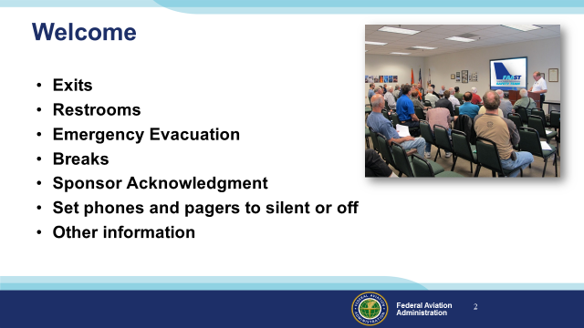 | Slide 2  Presentation Note: Here’s where you can discuss venue logistics, acknowledge sponsors, and deliver other information you want your audience to know in the beginning.  You can add slides after this one to fit your situation. (Next Slide)
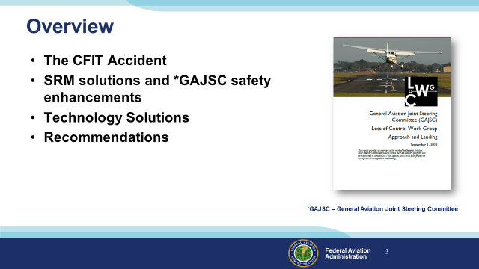 | Slide 3  In this presentation we’ll talk a little bit about Controlled Flight Into Terrain (CFIT) Accidents and recommendations (termed safety enhancements) from the General Aviation Joint Steering Committee - a work group that studies General Aviation Accidents. We’ll discuss some Safety Risk Management and Technological solutions to CFIT challenges and, finally; we’ll give you some recommendations that will help you to avoid CFIT accidents.  Presentation Note: If you’ll be discussing additional items, add them to this list  (Next Slide)
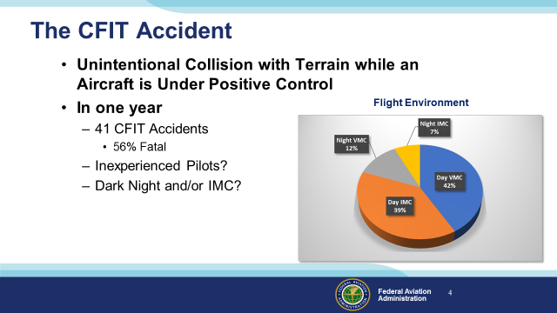 | Slide 4  CFIT is defined as an unintentional collision with terrain while an aircraft is under positive control.  For this presentation we looked at a typical year in which we see about forty CFIT Accidents at least half of which are fatal. (Click)  It’s logical to think that CFIT accidents usually involve inexperienced pilots in dark night and/or instrument meteorological conditions. (Click)  In fact, in a typical year more than 75 percent of CFIT accidents occur in daylight and more than half of those are in visual conditions.  (Next Slide)
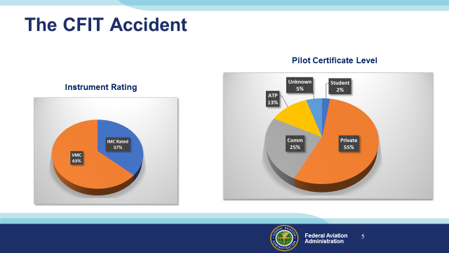 | Slide 5  As we might expect – the majority of CFIT pilots hold Private certificates but Commercial and ATP pilots and flight instructors are well represented too.  You might think that most CFIT Pilots are not instrument rated and that’s correct. (Click)  But in a typical year, more than a third of CFIT pilots hold instrument ratings.  (Next Slide)
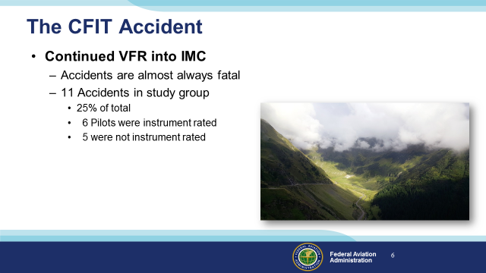 | Slide 6  Continued VFR into IMC is the deadliest accident precursor. We don’t know how often pilots are successful in pursuing the impossible dream. Undoubtedly some get away safely but continued VFR into IMC accidents are usually fatal. (Click)  Of the 41 accidents in our study group, 11 – or 25% of the total – were preceded by Continued VFR into IMC and they were all fatal. You’d think that VFR pilots would more often be involved in Continued VFR accidents but they were evenly split in this study group.  (Next Slide)
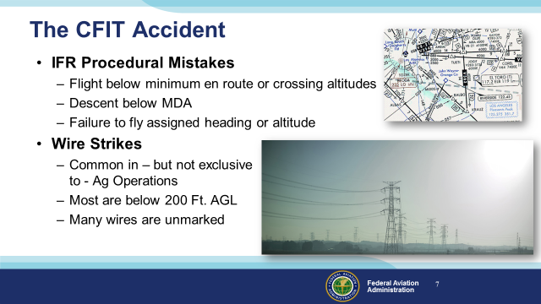 | Slide 7  IFR procedural mistakes account for a significant portion of CFIT accidents each year. Instrument pilots must be sure they’re complying with all aspects of the clearances they accept and the procedures they fly. (Click)  Wire Strikes are often cited in CFIT accident reports and they are common in Agricultural Operations but more than half of them are not associated with Ag flying. It’s true that there are some very high towers around and their support wires can extend well beyond the tower itself. But there are relatively few collisions with tall towers or their support structures. (Click)  In fact, most wire strikes occur below 200 feet AGL. You’ve got to wonder; what required the pilots to be that low – especially in the vicinity of wires? (Click)  And be aware that many wires are unmarked. Give yourself some room. A little extra altitude – even 500 feet – will keep you above 90% of the wires.  (Next Slide)
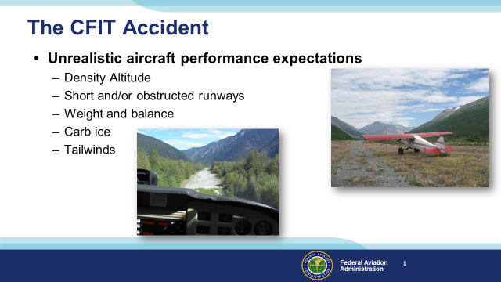 | Slide 8  Some CFIT accidents are caused by unrealistic expectations for aircraft performance. High Density Altitude combined with a short and/or obstructed runway and aircraft at near gross weight have resulted in collisions with obstacles on take off. Carburetor or induction system ice can reduce climb performance with the same result. And tailwinds on approach or takeoff can precede CFIT.  (Next Slide)
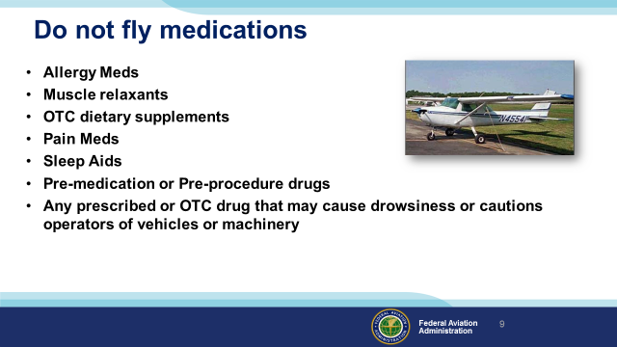 | Slide 9  While these drugs may not disqualify applicants for medical certificates, they do preclude flying until the effects of the drug are no longer present.  (Next Slide)
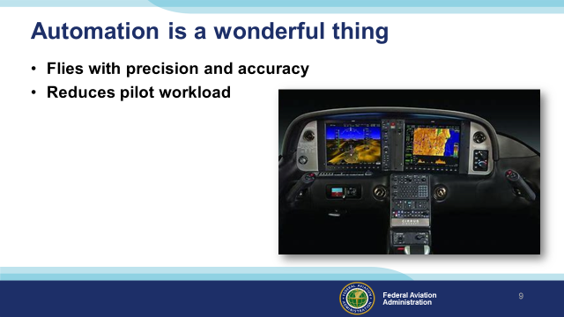 | Slide 9  Automation is without a doubt a wonderful thing. Today’s autopilots and associated nav equipment fly our GA aircraft with  greater precision and accuracy than most pilots are capable of achieving. Pilot workload is markedly reduced. You can  arrive at your destination refreshed – not in a state of physical and mental exhaustion. Those are all good things and, on  balance, we’re safer with automation than we ever were before but……  (Next Slide)
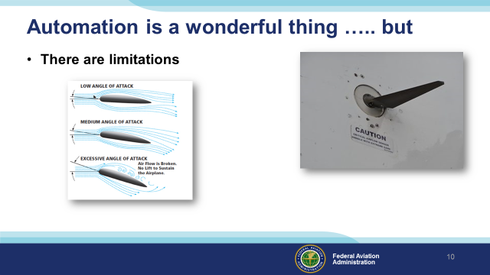 | Slide 10  Because automation has limitations and failure modes, pilots must understand the operational parameters, logic, and limitations inherent in their automated equipment. They must be able to recognize when automation is operating as intended and when it is not and they must be prepared to fly their aircraft when automated systems fail. (Click)  We’re all familiar with recent air carrier mishaps in which automation was a factor. Autopilots – like pilots must have good data input in order to fly precisely or, in some cases, in order to fly at all. Pilots receive data input through their senses. Those data are interpreted and the information thus derived is used to make decisions and to control the aircraft. Faulty data can lead to faulty decisions so data quality must be constantly evaluated throughout the flight. Faulty sensor input can cause autopilots to respond inappropriately to aircraft attitude changes.  (Next Slide)
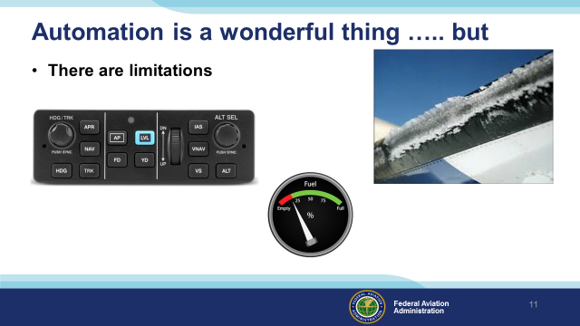 | Slide 11  Most general aviation autopilots will hold a heading and many will hold altitude as well. These features have led to surprises though. Pilots flying on autopilot at night have failed to notice ice accretion until the autopilot disconnects when it can no longer maintain altitude. (Click)  And lateral fuel imbalances that you’d be sure to notice while hand flying can be masked by the autopilot until it disconnects because it can no longer keep wings level. A sudden heading excursion  is not the best way to become aware that you’ve forgotten to switch fuel tanks.  (Next Slide)
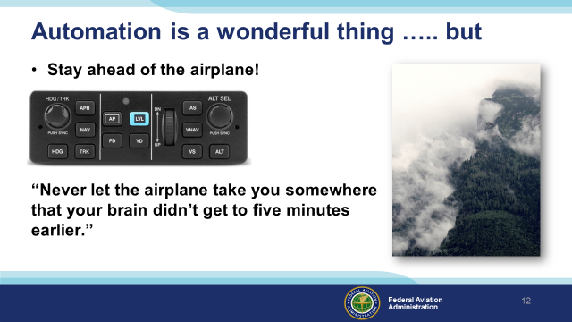 | Slide 12  There are a few automation systems that integrate aircraft position and terrain information and we’ll see more in the future but the fact is – we are unlikely to be flying with them anytime soon. Therefore it’s imperative that we remain responsible for adequate terrain and obstruction clearance whether hand-flying or on autopilot. This is relatively easy to do in good Day-VFR weather conditions but night, IMC, or reduced visibility conditions are another matter. (Click)  Or as the old saying goes, “never let the airplane take you somewhere that your brain didn’t get to five minutes earlier”.  (Next Slide)
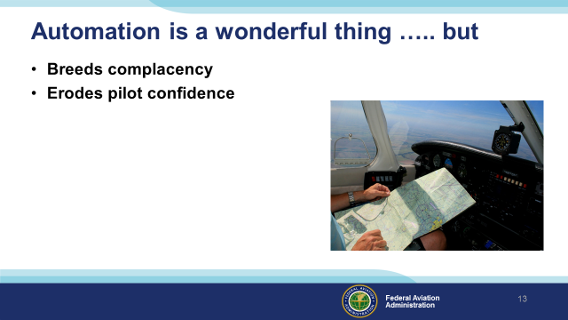 | Slide 13  Perhaps the most insidious aspect of automation is its propensity to breed complacency and erode pilot confidence. Here’s how that works: (Click)  The more time we spend on autopilot, the less time is available to maintain our hands-on skills. Instrument approaches on autopilot are so precise that it’s tempting to  “let George do it” all the time but, how would you feel if that was your policy and “George” decided to take a break in the middle of an instrument approach? That might be a time when you wished you’d spent some recent time hand-flying “on the gauges”. It’s a fact that the less time people spend in practicing a skill, the less confidence they have in their performance.  Of course it’s also true that the less you use automation the less confidence you’ll have in it. Achieving a balance between hands-on and automated flying is important.  (Next Slide)
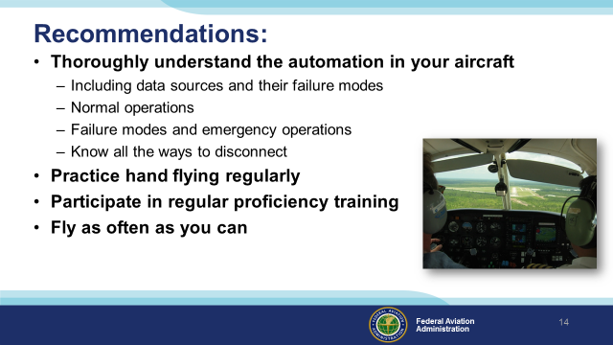 | Slide 14  Here are our recommendations for successful human/automation relationships. (Click)  Make sure you understand how your automation works and how it behaves when it isn’t working.  Understand where your automation is getting its information and how  it will respond if that information is missing or flawed.  There are at least 2 ways to disconnect your automation – many aircraft have more. Know all the ways to quickly disconnect your automation and revert to hand flying. (Click)  Practice hand flying regularly. Many experienced instrument pilots hand-fly at least one instrument approach on each flight. That way they keep their skill and confidence levels high. (Click)  Commit to regular proficiency training. It’s the best way to keep on top of your game. (Click)  And finally, fly as often as you can. After all we love to do it and the more we fly – the better we get – especially if we’re training with a really good coach.  (Next Slide)
 | Slide 15  Presentation Note: You may wish to provide your contact information and main FSDO phone number here. Modify with your information or leave blank.  (Next Slide)
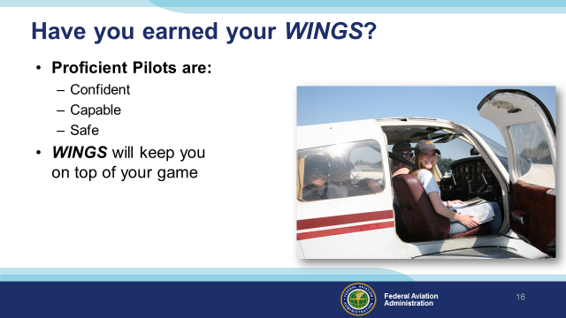 | Slide 16  Have you earned your WINGS? Proficiency is key to success in almost every thing worth doing – especially flying. Proficient pilots are confident, capable, and safe.  WINGS is a proficiency training system specifically designed for general aviation pilots and, regular participation will keep you on top of your flying game.  (Next Slide)
 | Slide 17  Now there’s even more reasons to participate in WINGS. Every time you complete a WINGS Phase you’re eligible to win cash the WINGS Sweepstakes.  The sweepstakes is generously funded by Paul Burger, a long time advocate for general aviation safety and a retired aviator who believes participation in this program saves lives. VISIT WWW.MYWINGSINIATIVE.ORG to learn more and enter the sweepstakes.  (Next Slide)
 | Slide 18  After you’ve completed a phase of WINGS you can enter the sweepstakes by clicking on “Claim Rewards” in the “WINGS – at a glance” section of your My WINGS page and select WINGS Sweepstakes. Or you can go directly to the mywingsinitiative.org website.  (Next Slide)
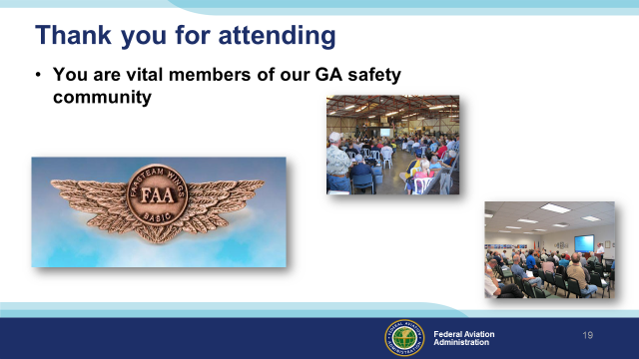 | Slide 19  Your presence here shows that you are vital members of our General Aviation Safety Community. The high standards you keep and the examples you set are a great credit to you and to GA.  Thank you for attending.  (Next Slide)
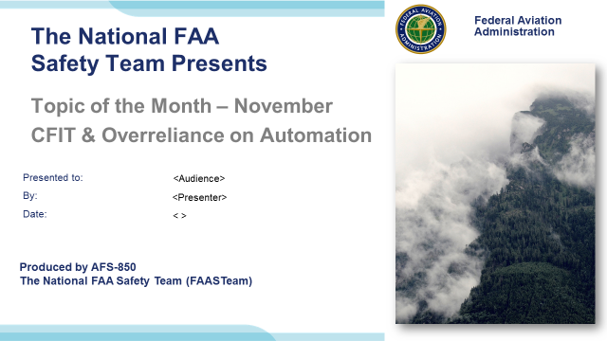 | Slide 20  (The End)

