Presentation Notes
Aeronautical Decicion Making 2020/12/04-180(I)PP

This outreach guidance is provided to all FAA and aviation industry groups that are participating in outreach efforts sponsored by the General Aviation Joint Steering Committee (GAJSC). It is important that all outreach on a given topic is coordinated and is free of conflicts. Therefore, all outreach products should be in alignment with the outline and concepts listed below for this topic.

Outreach Month: January 2021

Topic: Aeronautical Decision Making - ADM (LOC-SE-3)
The FAA and industry will conduct a public education campaign emphasizing the safety benefits of effective ADM

Background:

The General Aviation Steering Committee (GAJSC) Loss of Control work groups contend that many GA accidents stem from inadequate ADM and safety resource management. The GAJSC also feel that promoting and teaching sound decision making and resource management processes will result in safer General Aviation operations.

Teaching Points:
- Discuss the hazards associated with poor decision making and resource management.
- Discuss the safety benefits of Safety Risk Management and Flight Risk Assessment Tools (FRATS).
- Acquaint pilots with the availability of ADM resources.
- Encourage pilots to adopt sound ADM processes.

References:
- Aeronautical Decision Making PowerPoint

- Aviation Risk Management Handbook (FAA-H-8083-2) – Chapters Five and Six
  - https://www.faa.gov/regulations_policies/handbooks_manuals/aviation/media/risk_management_hb_change_1.pdf

Abstract: Lasting 10 to 20 Minutes, this presentation acquaints the audience with the benefits of effective Aeronautical Decision Making and Safety Resource Management.

Format: Information Briefing – Power Point presentation

Required Personnel: FAASTeam Program Manager or designated FAASTeam Rep (s)

Optional Personnel: Flight Instructor or others who can speak on ADM

AFS 850 Support: In addition to this document, a Power Point presentation that supports the program is provided. FPMs and presentaers are encouraged to customize this presentation to reflect each individual program.

Slides | Script
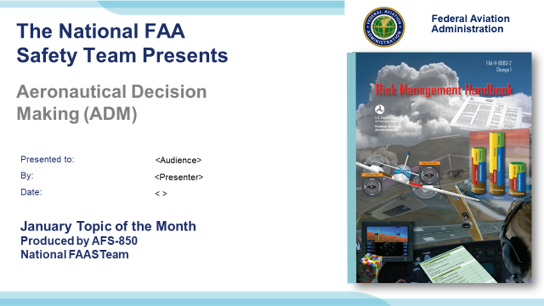 | Slide 1  2020/12/04-180(I)PP Original Author: J. Steuernagle 12/04/2020); POC Kevin Clover AFS-850 Ops Lead; Office 562-888-2020 Revised by:  Presentation Note: This is the title slide for FY 2021 Topic of the Month – January – Aeronautical Decision Making (ADM)  - Script - We have included a script of suggested dialog with most slides. The script will always appear in a non-italic font. Presenters may read the script or modify it to suit their own presentation style. See template slides 5 and 6 for examples of a slides with script.  - Presentation Instructions - (stage direction and presentation suggestions) will be preceded by a Bold header: the instructions themselves will be in Italic fonts. See slide 2 for an example of a slide with Presentation Instructions only.  - Program control instructions - will be in bold fonts and look like this: (Click) for building information within a slide; or this: (Next Slide) for slide advance.  - Background information - Some slides may contain background information that supports the concepts presented in the program.  Background information will always appear last and will be preceded by a bold Background: identification.  The production team hope you and your audience will enjoy the show. Break a leg!  (Next Slide)
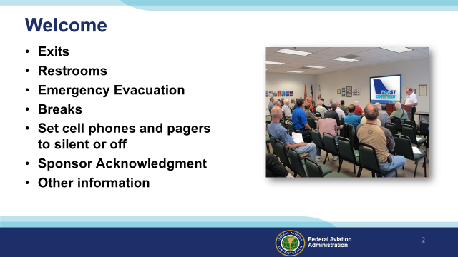 | Slide 2  Presentation Note: Here’s where you can discuss venue logistics, acknowledge sponsors, and deliver other information you want your audience to know in the beginning.  You can add slides after this one to fit your situation (Next Slide)
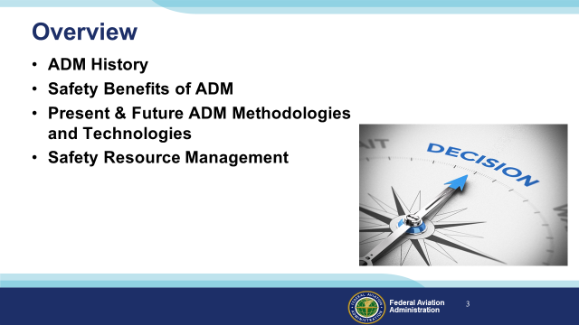 | Slide 3  We want to take just a few minutes to talk about Aeronautical Decision Making or ADM.  We’ll discuss the History and safety benefits of ADM,  As well as present and future ADM methodologies and technologies.  And we’ll address the challenge of managing multiple informational and operational resources.  Presentation Note: If you’ll be discussing additional items, add them to this list  (Next Slide)
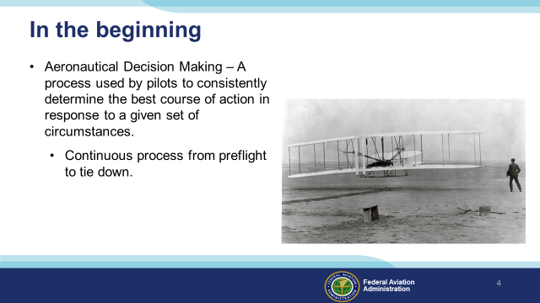 | Slide 4  Orville and Wilbur practiced ADM before, briefly during, and after their historic first flight on 17 December 1903. Nearly 120 years later pilots  are still using ADM to determine the best course of action. (Click)  Presentation note: Read the ADM definition – then:  In other words ADM is what pilots intend to do based on the latest information they have.  (Next Slide)
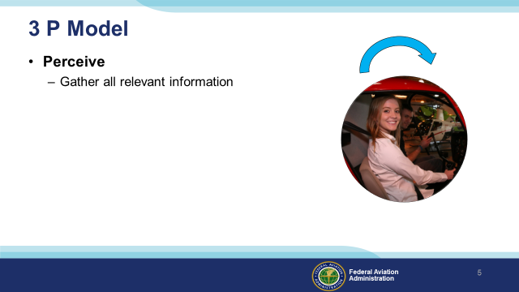 | Slide 5  The ADM process begins during preflight planning, continues throughout the flight and ends with a post flight analysis.  In it’s simplest form ADM is a 3-step process beginning with perception. The pilot gathers all relevant information from disparate sources in order to perceive the mission  and the environment within which it will be flown. As we’ll see later, effective resource management is an essential flight management skill. Information gathering begins before takeoff  and continues throughout the flight.  (Next Slide)
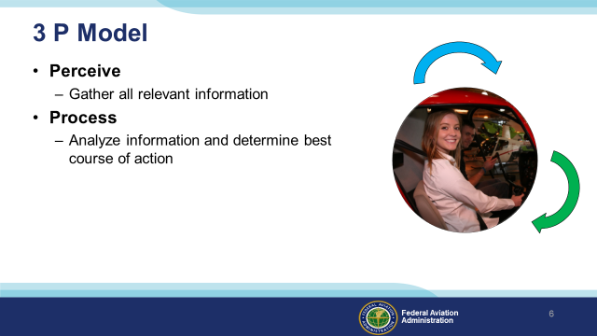 | Slide 6  Pilots process the information they gather; analyzing it to determine the best course of action. This analysis continues throughout the flight as new information is received  (Next Slide)
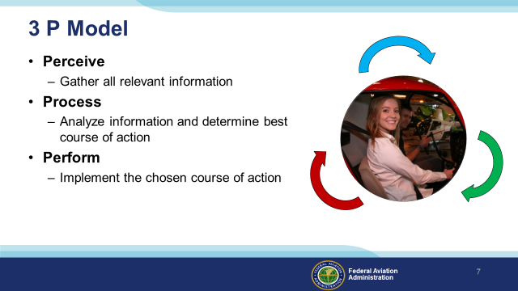 | Slide 7  Once a course of action is chosen it’s implemented but we’re not done yet. Performance results become information to be perceived and analyzed  In the course of that analysis, the pilot will decide whether to continue with the chosen action or to choose a different course to pursue.  We mentioned that resource management is essential to effective processing of perceived information. Let’s take a closer look at the resource management process.  (Next Slide)
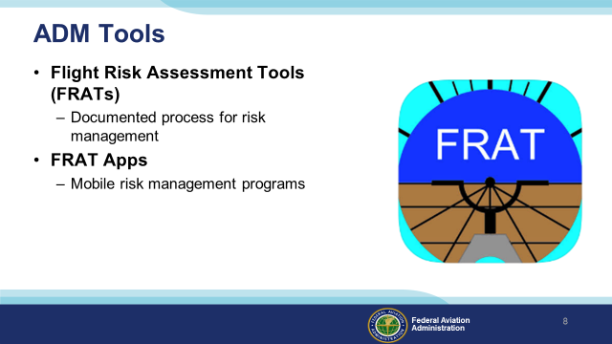 | Slide 8  Many data monitoring operations involve no automation at all. Flight engineers used to handle the monitoring and record keeping (Click)  And test pilots were expected to keep notes while flying.  (Next Slide)
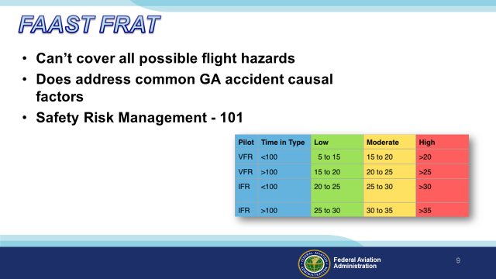 | Slide 9  No FRAT can cover all possible flight hazards but this one – produced by the FAASTeam– does address some factors that are common to GA accidents. We hope it’s use will prompt  you to learn more about Safety Risk Management.  To get your copy here’s what you do……….  (Next Slide)
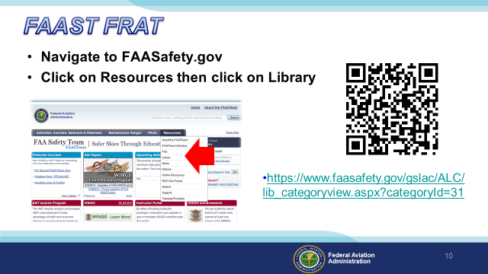 | Slide 10  Navigate to FAASafety.gov  Click on Resources, then click on Library. The QR code or URL on screen will take you to the FRAT Category in the library.  Presentation note: The QR code on screen will open the FRAT Category on FAASafety.gov  (Next Slide)
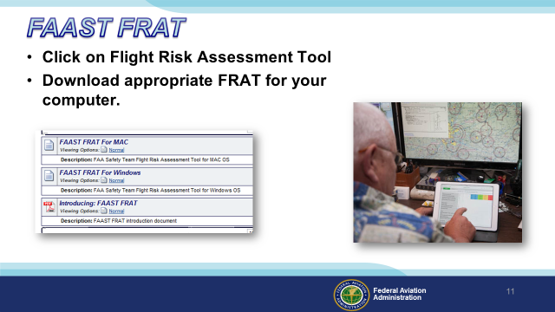 | Slide 11  Click on Flight Risk Assessment Tool (FRAT).  Then download the appropriate FRAT for your computer.  (Next Slide)
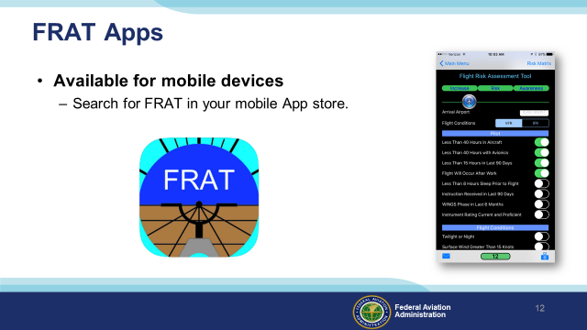 | Slide 12  There are also a number of mobile FRAT Apps available for Apple and Android Devices. Search for FRATS in your mobile emporium.  (Next Slide)
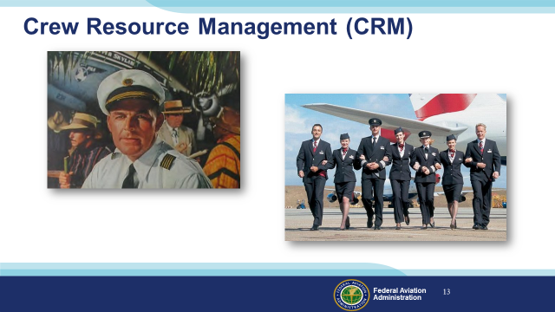 | Slide 13  Crew Resource Management is another essential component of ADM. In the beginning the captain was in charge and made all the decisions in isolation. (Click)  These days the captain’s still the final authority but the crew and other internal and external resources are involved in the decision making process and that’s a very good thing. The captain manages those  Resources to effect safe, efficient, and hopefully profitable operations.  (Next Slide)
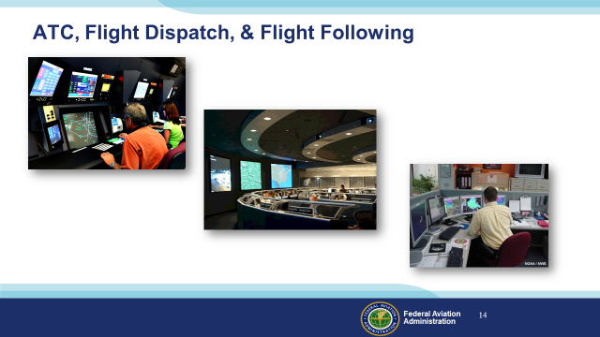 | Slide 14  Captains draw on a host of external resources provided by Air Traffic Controllers of course but also (Click)  Flight Dispatch and Flight Following personnel (Click)  Meteorologists, and Maintenance specialists.  And, through pilot reports, other pilots in the air.  (Next Slide)
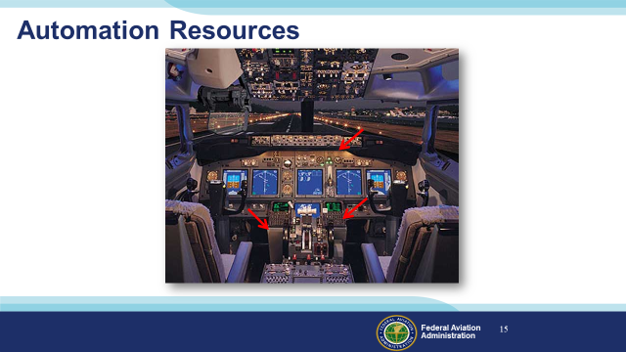 | Slide 15  And of course they have autopilot and flight management resources to manage as well. (Click)  (Next Slide)
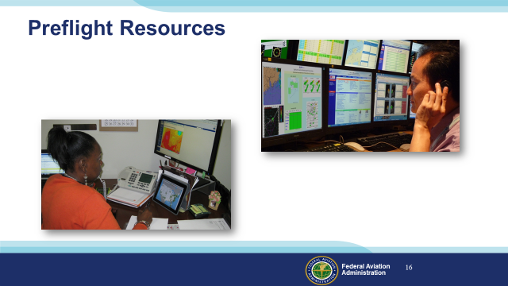 | Slide 16  General Aviation Single-pilot operations offer many opportunities for resource management but most of the human resources aren’t in the airplane with you.  As you complete your flight planning , a call to Flight Service will get you the latest weather and operational information including TFR’s. Many pilots use this call to confirm the information they’ve already accessed on line. And a route briefing just before takeoff will attest to the fact that you have the latest TFR information.  In the air those same specialists are available for consultation. They’re just a radio call away.  (Next Slide)
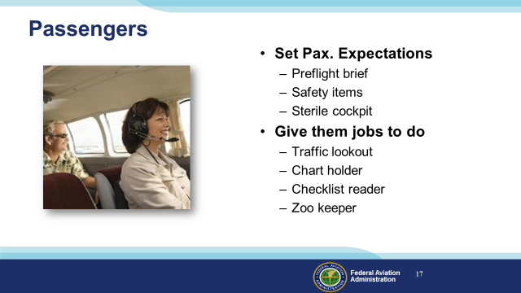 | Slide 17  Passengers can go a couple of ways: They can, and will if you let them, distract you from your piloting; or they can be a valuable part of the crew. (Click)  Set passenger expectations before you start engines. Give them a synopsis of the flight route and what they’ll see and hear. (Click)  Cover the standard safety items such as restraints, smoking, & egress. (Click)  And insist on a sterile cockpit for taxi, takeoff, climb, descent, & landing. (Click)  Give your passengers jobs to do. (Click)  Traffic spotting assistance is always appreciated. We know of one pilot who pays his kids a buck for each target they spot before he does. The last we checked, he’s  into them for more than a hundred. Passengers can also be chart holders and, with training & supervision, checklist readers. If family pets are carried they should  also be assigned zoo keeper duties.  All of these things make the time pass more quickly and increase the safety and enjoyment of flight.  (Next Slide)
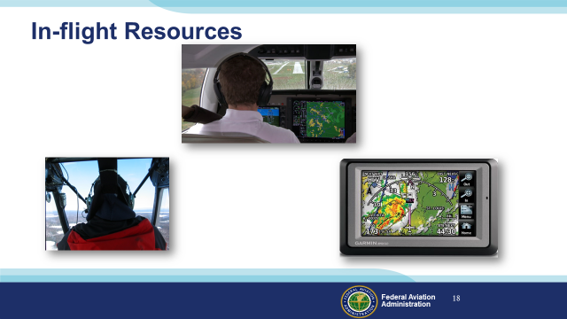 | Slide 18  You may be piloting a plane with the latest glass cockpit equipment that displays traffic and weather. But you might be flying older technology aircraft with a mobile device for navigation and weather data assistance. Either way it’s nice to confirm what you’re seeing with weather specialists or controllers on the ground.  (Next Slide)
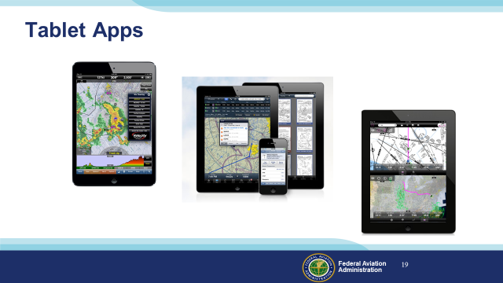 | Slide 19  There are a host of tablet-based aviation apps available these days and many pilots are using them. Be sure you’re thoroughly familiar with your app of choice and that you have the latest information uploaded before flight. We suggest an alternate power supply to guard against dark screens when you need them most.  Here’s a couple of additional tips:  - Practice with your device on the ground before flying with it. Find out where best to locate it and practice all in-flight app functions while scanning for traffic.  - Don’t let the app distract you from important flying tasks and, even though your app depicts all airspace boundaries; give yourself some room. Fly at least 2 miles outside all airspace  you don’t have clearance to enter. When it comes to pilot deviations, ATC radar trumps i-pad every time.  (Next Slide)
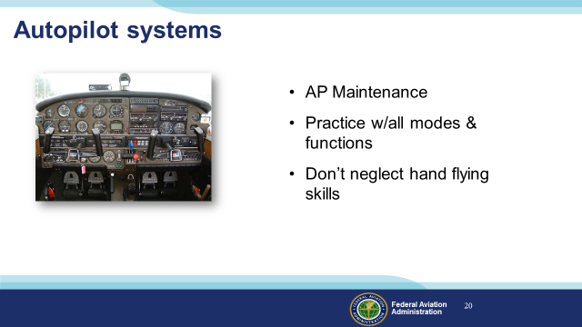 | Slide 20  Finally – many GA aircraft are equipped with autopilot systems. These valuable crew members can take care of basic wing leveling and, in many cases, navigation tasks while you’re attending to other matters but you have to know how to use them: (Click)  - Make sure your autopilot system is properly maintained and functions properly. (Click)  - Practice using the autopilot in all modes and functions. (Click)  - Don’t neglect your hand flying skills. They deteriorate quickly. Many pilots recommend hand flying alternating between hand flown and autopilot approaches. We recommend 2 hand flown approaches for each autopilot approach.  (Next Slide)
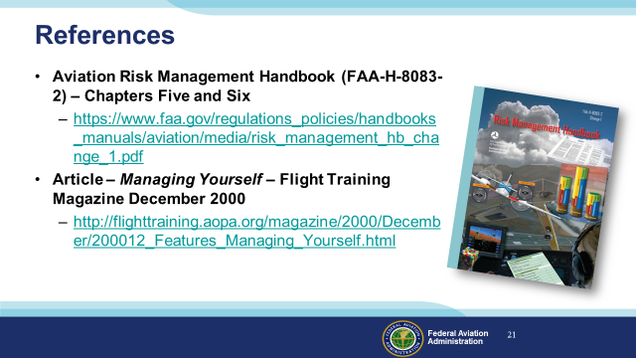 | Slide 21  (Next Slide)
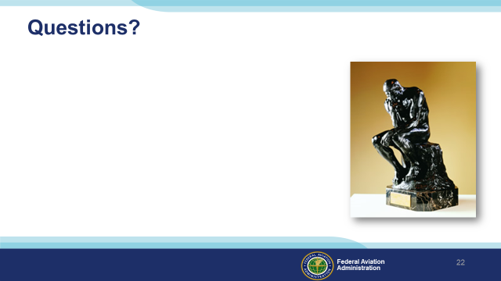 | Slide 22  Presentation Note: You may wish to provide your contact information and main FSDO phone number here. Modify with Your information or leave blank.  (Next Slide)
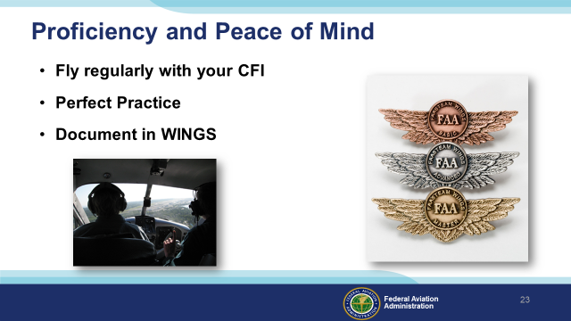 | Slide 23  There’s nothing like the feeling you get when you know you’re playing your A game and in order to do that you need a good coach (Click)  So fly regularly with a CFI who will challenge you to review what you know, explore new horizons, and to always do your best. Of course you’ll  have to dedicate time and money to your proficiency program but it’s well worth it for the peace of mind that comes with confidence. (Click)  Vince Lombardi, the famous football coach said, “Practice does not make perfect. Only perfect practice makes perfect.” For pilots that means  flying with precision. On course, on altitude, on speed all the time. (Click)  And be sure to document your achievement in the Wings Proficiency Program. It’s a great way to stay on top of your game and keep you flight review current.  (Next Slide)
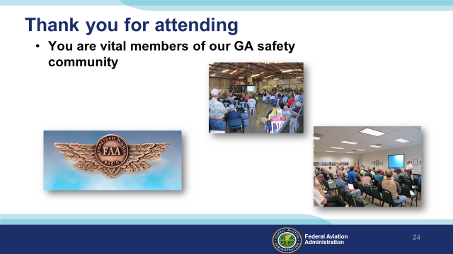 | Slide 24  Your presence here shows that you are vital members of our General Aviation Safety Community. The high standards you keep and the examples you set are a great credit to you and to GA.  Thank you for attending.  (Next Slide)
Slide 25

(The End)

Appendix I – Equipment and Staging
Equipment:
- Projection Screen & Video Projector suitable for expected audience
  - Remote computer/projector control available at lectern or presenter location
    - In lieu of remote – detail a Rep to computer/projector control.
- Presentation Computer
  - Note: It is strongly suggested that the entire program reside on this computer.
- Back up Projector/Computer/Media as available.
- PA system suitable for expected audience
  - Microphones for Moderator and Panel
    - Optional Microphone (s) for audience
- Lectern (optional)
Staging:
- Arrange the projection screen for maximum visibility from the audience.
- Equip with PA microphones
- Place Lectern to one side of screen. This will be used by presenters and moderator
- IMPORTANT – Once you have completed outreach on this topic, please help us track the outreach you have done by entering a PTRS record.

