General Aviation Joint Steering Committee
Loss of Control Working Group
Outreach Guidance Document
2021/03-11-221(I)PP

This outreach guidance is provided to all FAA and aviation industry groups that are participating in outreach efforts sponsored by the General Aviation Joint Steering Committee (GAJSC). It is important that all outreach on a given topic is coordinated and is free of conflicts. Therefore, all outreach products should be in alignment with the outline and concepts listed below for this topic.

Outreach Month: April 2022

Topic: Angle of Attack
The FAA and industry will conduct a public education campaign emphasizing the value of equipage with angle of attack indicators and stall awareness training with and without angle of attack indicators.
Background:
Stalls and spins still account for many general aviation accidents. The GAJSC feels that increased stall awareness training and the use of angle of attack indicators would significantly reduce the number of stall/spin accidents.
Teaching Points:
- Wings stall when the critical angle of attack is exceeded.
- Airspeed indicators and stall warning systems are useful but imprecise ways of alerting pilots to impending stall conditions.
- The use of angle of attack indicators not only gives pilots precise knowledge of impending stall conditions but also provides guidance for the most efficient approch and climb angles of attack.
- General aviation aircraft owners should consider retrofitting angle of attack indicators.
- Regular proficiency training and practice in stall awareness and stall recovery, with or without angle of attack indicators, is essential to preventing stall/spin accidents.

References:
- Angle of Attack PowerPoint
  - Available on the National FAASTeam Share Point site under Approved Presentations.
- AC 61-91J – WINGS – Pilot Proficiency Programs

- AC 61-67C – Stall and Spin Awareness Training
http://www.faa.gov/documentLibrary/media/Advisory_Circular/AC_61-67C_Chg_2.pdf
- Airplane Flying Handbook
https://www.faa.gov/regulations_policies/handbooks_manuals/aviation/airplane_handbook/
- Pilot’s Handbook of Aeronautical Knowledge
https://www.faa.gov/regulations_policies/handbooks_manuals/aviation/phak/media/pilot_handbook.pdf
ttps://www.faasafety.gov/gslac/ALC/libview_normal.aspx?id=135893

Abstract: Lasting 10 to 15 minutes, this presentation acquaints the audience with the benefits of Stall and Spin Awareness Training and Angle of Attack Indicators.
Format: Information Briefing - Power Point presentation
Required Personnel – FAASTeam Program Manager or designated FAASTeam Rep (s)
Optional Personnel – CFIs and DPEs who can speak on Stall Training and Angle of Attack Indicators
AFS 850 Support:
In addition to this guidance document, a Power Point presentation that supports the program is provided. FPMs and presenters are encouraged to customize this presentation to reflect each individual program.

Slides | Script
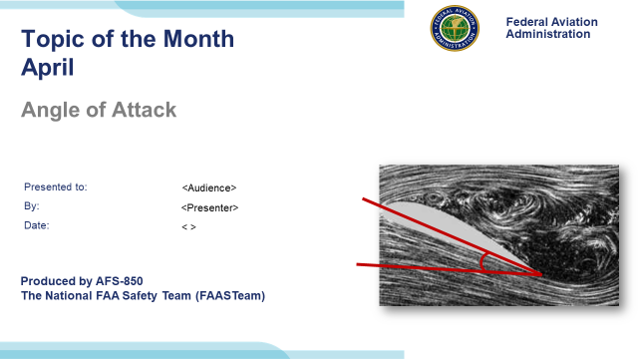 | Slide 1  2021/04-07-222(I)PP Original Author, FAASTeam (JWS); POC Kevin Clover, AFS-850 Operations Lead, Office 562-888-2020; reviewed by John Steuernagle 07/28/2016.  Presentation note: This is the title slide for Angle of Attack.  - Script - We have included a script of suggested dialog with most slides. The script will always appear in a non-italic font. Presenters may read the script or modify it to suit their own presentation style. See template slides 5 and 6 for examples of a slides with script.  - Presentation Instructions - (stage direction and presentation suggestions) will be preceded by a Bold header: the instructions themselves will be in Italic fonts. See slides 2, 3, and 4 for examples of slides with Presentation Instructions only.  - Program control instructions - will be in bold fonts and look like this: (Click) for building information within a slide; or this: (Next Slide) for slide advance.  - Background information - Some slides may contain background information that supports the concepts presented in the program.  Background information will always appear last and will be preceded by a bold Background: identification.  The production team hope you and your audience will enjoy the show. Break a leg!  (Next Slide)
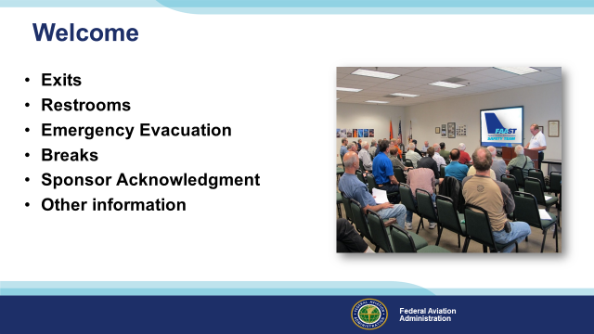 | Slide 2  Presentation Note: Here’s where you can discuss venue logistics, acknowledge sponsors, and deliver other information you want your audience to know in the beginning.  You can add slides after this one to fit your situation. (Next Slide)
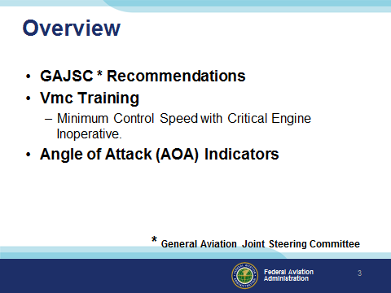 | Slide 3  In this presentation we’ll address recommendations from the General Aviation Joint Steering Committee – a government / industry group that analyzes GA accidents and incidents. The Committee feels that more frequent stall training & practice reduces the risk of stall/spin accidents. They also heartily endorses Angle of Attack Indicators as an affordable technology to reduce stall/spin accidents.  We’ll review stall aerodynamics, discuss Angle of Attack (AOA) Indicators and offer some proficiency training recommendations.  Presentation Note: If you’ll be discussing additional items, add them to this list  (Next Slide)
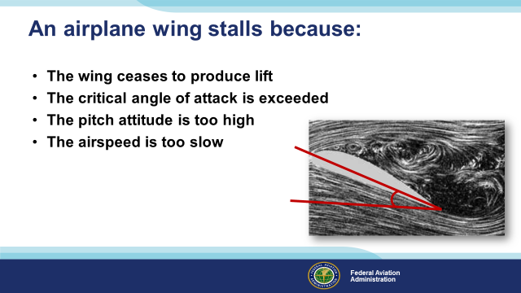 | Slide 4  Let’s do a little review to begin. What causes an airfoil to stall? All of these answers are related but what’s the best answer?  Presentation note: Lead a discussion to arrive at the best answer, then: (Click)  That’s right. An airplane wing stalls when the critical angle of attack has been exceeded. The wing will still be producing some lift but not enough to support level flight. The pitch attitude may be high and the airspeed may be low but airspeed, in particular, is an indirect indicator of angle of attack.  (Next Slide)
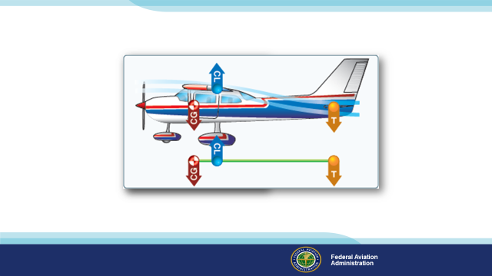 | Slide 5  We’re accustomed to see the nose drop during stall practice. This is actually a good thing and it’s due to the fact that in most of the airplanes we fly, lift is centered aft of the center of gravity. (Click)  That requires some downforce on the tail to maintain a level flight attitude and if the critical angle of attack is exceeded and the wing stalls, the aircraft will pitch around the center of gravity reducing the angle of attack.  (Next Slide)
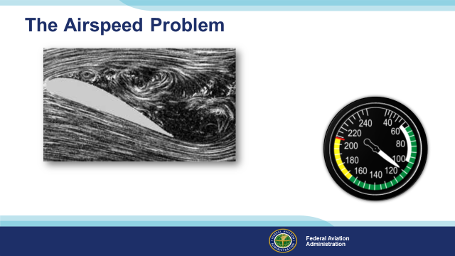 | Slide 6  We often discuss stalls with respect to airspeed and that can be a problem.  Wings stall when their critical angle of attack is exceeded. Airspeed is a secondary indication of how close we are to the critical angle of attack.  (Next Slide)
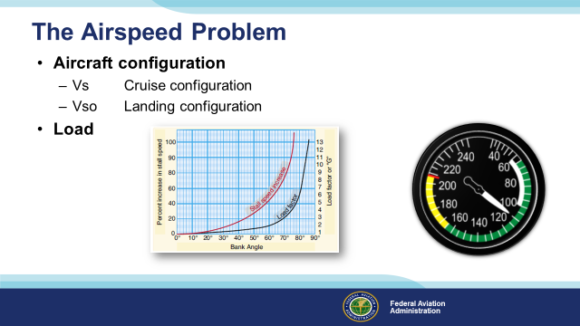 | Slide 7  There are other problems with using airspeed indications for stall avoidance. (Click)  One being that Stall speed changes with aircraft configuration. (Click)  Another has to do with aircraft load. As load or weight increase, stall speed will also increase.  So if a wing can stall at any airspeed in any configuration pilots must manage angle of attack and that argues for Angle of Attack awareness.  (Next Slide)
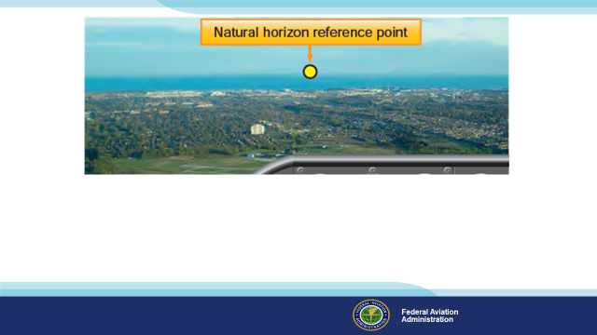 | Slide 8  From our first flight lesson we’re taught to relate aircraft attitude to the world outside our windshield.  (Next Slide)
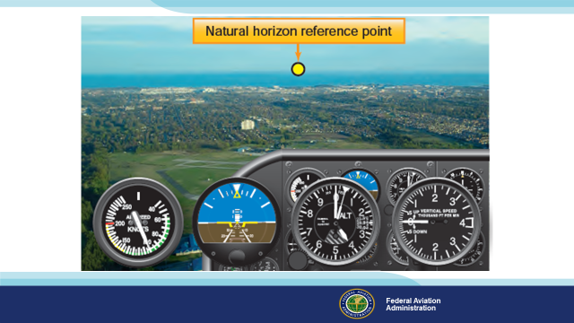 | Slide 9  And we learn that the flight instruments provide a graphical depiction of that relationship.  (Next Slide)
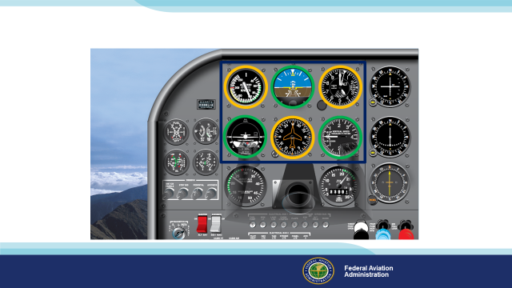 | Slide 10  When we fly; many, if not most of us, still see a panel that looks like this. “Steam gauge instrumentation is definitely last century’s technology but that’s changing rapidly. It’s still widely available though so a little review of the basic “six pack” may be in order. (Click)  Our primary instruments tell us that: If we’re maintaining a constant speed, (Click)  constant altitude, (Click)  and constant heading; we must be in straight and level, un-accelerating or decelerating flight. (Click)  The supporting instruments; turn coordinator, vertical speed indicator and attitude indicator confirm that this is so.  Of course the instruments are just confirming what we see out of the windows and over the nose.  (Next Slide)
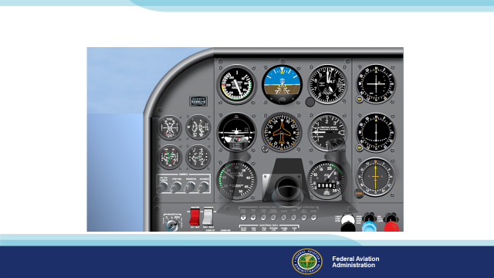 | Slide 11  When the natural horizon reference is obscured, we must rely totally on the instruments and what you see in the way of instrumentation varies a lot these days (Click)  Here’s a multi-function display representation. While one six pack looks pretty much like any other, there’s a lot more variety in electronic displays. Let’s take a look at just a few of many options.  Presentation note: Advance through the next six slide fairly quickly. The intent is to show the wealth of information available in about the same panel space as the traditional six pack.  (Next Slide)
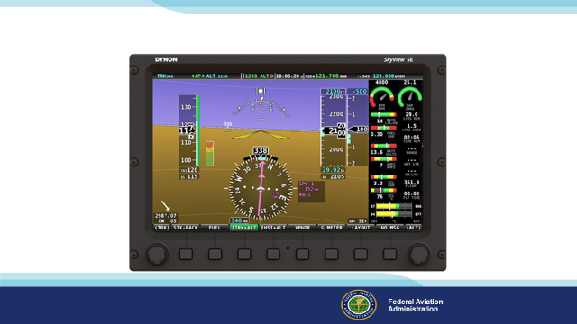 | Slide 12  AOA indicators are showing up on many new aircraft and The first thing you notice is the different ways six-pack instrumentation is presented. There’s a lot of information  on this screen and it’ll take more than a couple of minutes to become familiar with it.  (Next Slide)
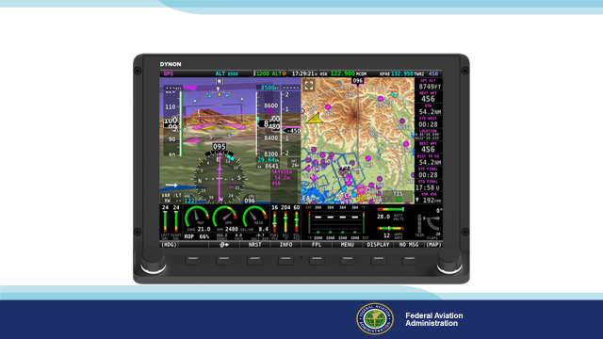 | Slide 13  Here’s another configuration that adds a moving map. Note that engine and fuel state have moved to the bottom of the screen and trim and flap indicators have been added.  (Next Slide)
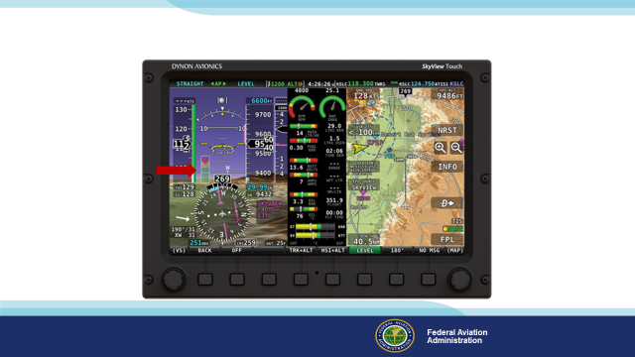 | Slide 14  Here’s another configuration. This one includes an angle of attack indication. Let me know when you’ve spotted it.  Presentation note: Give the audience time to spot the AOA indicator then: (Click)  Let’s look at just a couple more.  (Next Slide)
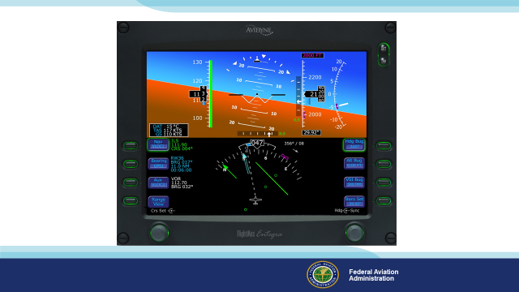 | Slide 15  Less information here but a cleaner display.  (Next Slide)
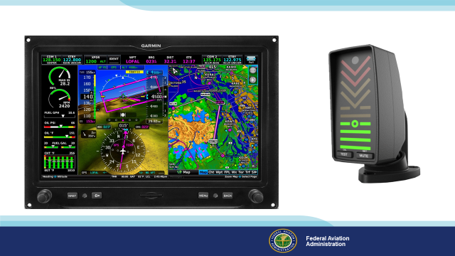 | Slide 16  This the last display we’ll look at but there are many more configurations in the GA fleet. Gone are the days of six dedicated instruments. They’re now integrated in a host of multi-function displays. It’s wonderful to have so much information in one place but it can also be quite confusing if you’re not thoroughly familiar with operating and interpreting the display. If Angle of Attack information is vital wouldn’t it be great to have a dedicated source of AOA information? The go-to place when workload and stress are high. (Click)  Here’s a dedicated Angle of Attack that compliments this display. It’s mounted on the glare shield in the pilot’s field of view. It’s easy to scan when flying visually or on instruments. It’s only one of many AOA indicator options that pilots would do well to consider.  (Next Slide)
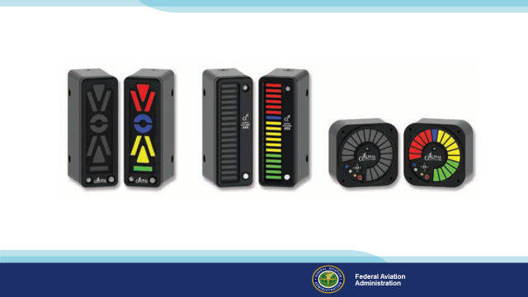 | Slide 17  Here are a few more options and there are many others. No matter what you’re flying there’s an Angle of Attack option for you.  (Next Slide)
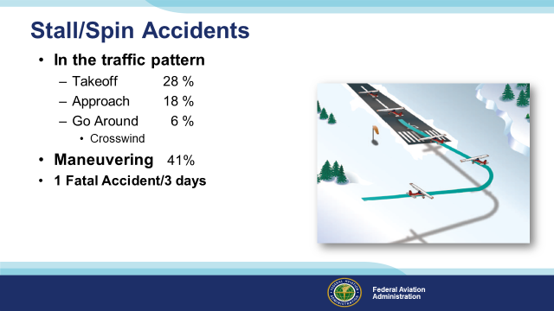 | Slide 18  Here’s the lowdown on Stall/Spin Accidents. They are deadly. More than half occur in the traffic pattern and most of the rest involve maneuvering – usually too close to the ground for recovery.  That all works out to one fatal accident every three days for the past ten years. We can’t say how many but flying with reference to AOA would certainly have prevented a lot of these accidents.  (Next Slide)
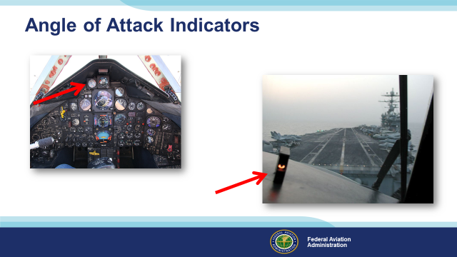 | Slide 19  Military aircraft have had AOA indicators for years. They’re essential to getting optimum performance in challenging situations but also very useful in routine flying as well. Only recently have they become more available and affordable for GA aircraft.  We urge you to consider equipping with an AOA indicator.  (The End)
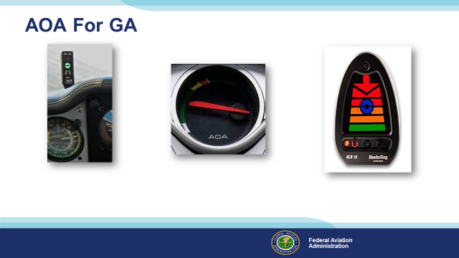 | Slide 20  AOA indicators are showing up on many new aircraft and there are many affordable options for retrofit as well. Angle of attack sensing & display go a long way toward reducing the number of stall/spin accidents.  (The End)
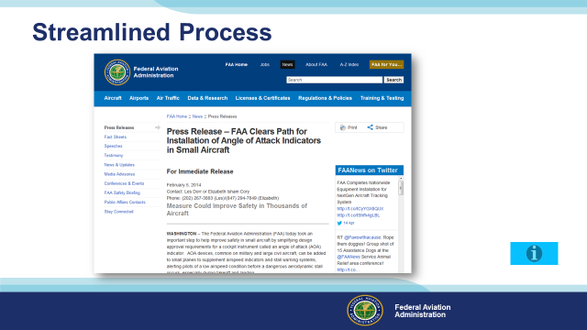 | Slide 21  FAA’s Small Airplane Directorate has streamlined the process for production and retrofit approval of AOA devices. That means real savings on installation and certification of this effective safety technology.  Presentation Note: If you have an internet connection you can access the Press Release by clicking on the information button on the lower right of the screen. http://www.faa.gov/news/press_releases/news_story.cfm?newsid=15714  (Next Slide)
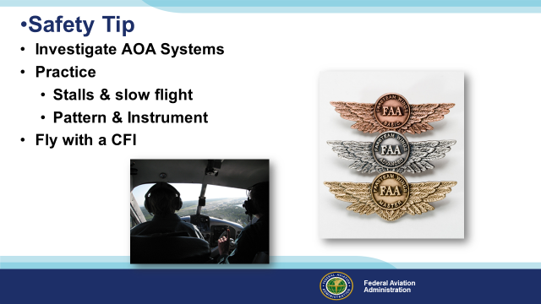 | Slide 22  Angle of Attack systems promise so much benefit that we urge you to look into them for the aircraft you own or fly (Click)  And be sure to keep your skills sharp through practice of stalls & slow flight as well as pattern and instrument work. (Click)  Fly regularly with a CFI and be sure to document your achievement in the Wings Proficiency Program. It’s a great way to stay on top of your game.  (Next Slide)
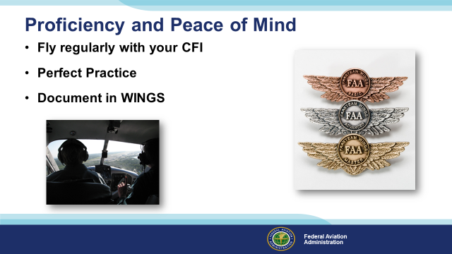 | Slide 23  There’s nothing like the feeling you get when you know you’re playing your A game and in order to do that you need a good coach (Click)  So fly regularly with a CFI who will challenge you to review what you know, explore new horizons, and to always do your best. Of course you’ll  have to dedicate time and money to your proficiency program but it’s well worth it for the peace of mind that comes with confidence. (Click)  Vince Lombardi, the famous football coach said, “Practice does not make perfect. Only perfect practice makes perfect.” For pilots that means  flying with precision. On course, on altitude, on speed all the time. (Click)  And be sure to document your achievement in the Wings Proficiency Program. It’s a great way to stay on top of your game and keep you flight review current.  (Next Slide)
 | Slide 24  One More Reason to Train with WINGS?  WINGS Industry Sweepstakes!  Paul and Fran Burger are offering $10,000 in their sweepstakes again this year!  The WINGS Sweepstakes mission is to reduce the nation's accident and incident rate by increasing pilot participation in the WINGS FAASTeam Pilot Proficiency Program. The WINGS program has courses based on real world accident and incident causes so flight instructors, pilots and student pilots get training that can truly make a difference.  Studies indicate that pilots who complete WINGS phases are safer aviators. Please join us in saving lives.  Learn about the program and its many benefits at : https://www.mywingsinitiative.org/  (Next Slide)
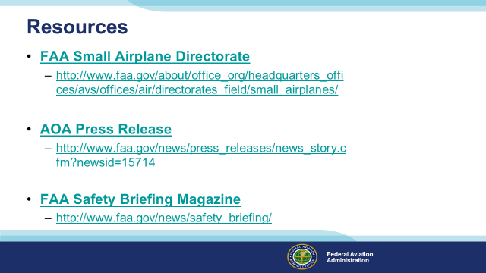 | Slide 25  Presentation Note: If you have an internet connection you can access the resources by clicking on text. If there’s no internet access the audience can copy the URLs below each item.  Here are some places you can go for more information.  (Next Slide)
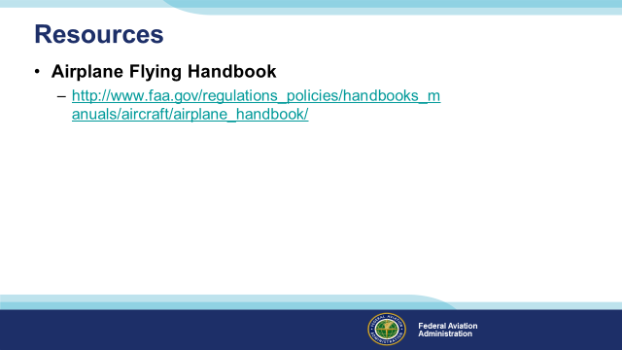 | Slide 26  Presentation Note: If you have an internet connection you can access the resources by clicking on text. If there’s no internet access the audience can copy the URLs below each item.  Here’s another source of more information.  (Next Slide)
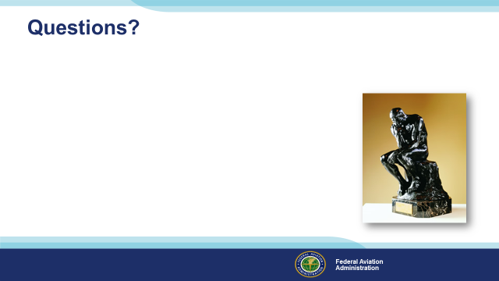 | Slide 27  Presentation Note: You may wish to provide your contact information and main FSDO phone number here. Modify with  Your information or leave blank.  (Next Slide)
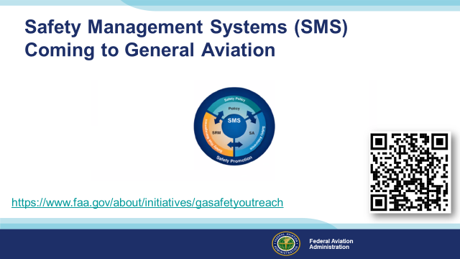 | Slide 28  Safety Management Systems are a set of policies and processes that can increase the safety and efficiency of any flight operation. And FAA is bringing SMS to General Aviation. You may have heard of SMS but thought it was only for large organizations but actually SMS can be scaled to fit any operation large or small.  There are 4 major components to a Safety Management System (Click)  Safety Policy – a documented commitment to safety that runs from the head of an organization to its newest member. (Click)  Safety Risk Management – a process that identifies hazards within an operation, determines to what extent an identified hazard may impact flight safety, and controls the risk of occurrence to an acceptable level. (Click)  Safety Assurance – By collecting and analyzing information derived from safety performance data Safety Assurance ensures the performance and effectiveness of Safety Risk Controls. (Click)  Safety Promotion communicates safety information and commitment throughout the organization. (Click)  You can find more information about Safety Management Systems at the URL on the Screen.  (Next Slide)
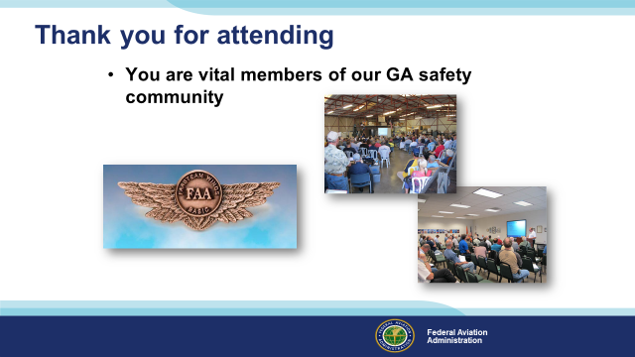 | Slide 28  Your presence here shows that you are vital members of our General Aviation Safety Community. The high standards you keep and the examples you set are a great credit to you and to GA.  Thank you for attending.  (Next Slide)
Slide 29

(The End)

Appendix I – Equipment and Staging
Equipment:
- Projection Screen & Video Projector suitable for expected audience
  - Remote computer/projector control available at lectern or presenter location
    - In lieu of remote – detail a Rep to computer/projector control.
- Presentation Computer
  - Note: It is strongly suggested that the entire program reside on this computer.
- Back up Projector/Computer/Media as available.
- PA system suitable for expected audience
  - Microphones for Moderator and Panel
    - Optional Microphone (s) for audience
- Lectern (optional)
Staging:
- Arrange the projection screen for maximum visibility from the audience.
- Equip with PA microphones
- Place Lectern to one side of screen. This will be used by presenters and moderator
IMPORTANT – Once you have completed outreach on this topic, please help us track the outreach you have done by entering a PTRS record.


