Outreach Guidance and Presentation Notes
Use of Weather Information
Topic of the Month August 2021
Background:

Based on Safety Enhancement (SE) 13 of the GAJSCs study, Weather Technology was found as follows: FAA & Industry educate GA community on available WX Info Technologies. i.e. NOAA ADDS Icing Tool. (FAAST-Lead, EAA, AOPA, NAFI, SAFE, Tng. Providers)

Teaching Points:
- In this electronic age, the weather sources we utilize for our preflight and in-flight planning are not the single source providers used 20 years ago. Simply put each source has a way they would like you to see weather data.
- Self briefings need to utilze multiple sources for the best possibly outcome.
- Planning and interpretation of the data requires you the pilot to make sense of what is reported and then plan according to your findings.
- Plan for unforecast conditions. Develop “Plan B” strategies in your initial assessment, NOT once your in the air.
- Confirm and update weather as you fly. Report what you see, alter your plan as needed.

Abstract: Lasting 15 to 20 minutes, this presentation acquaints the audience with preflight weather self briefing, weather pitfalls with regard to multiple service disparities, and the necessity for developing risk strategies that include enroute weather updates, alternate routes, and alternate airports.

Format: Information Briefing - Power Point presentation
Required Personnel – FAASTeam Program Manager or designated FAASTeam Rep (s)
Optional Personnel – Professional Pilots experienced in the use and technology of AOAs, CFIs, Professors on the theory of flight and aerodynamics.
.
National FAASTeam Support:
In addition to this guidance document, a Power Point presentation that supports the program is provided. FPMs and presenters are encouraged to customize this presentation to reflect each individual program.

Slides | Script
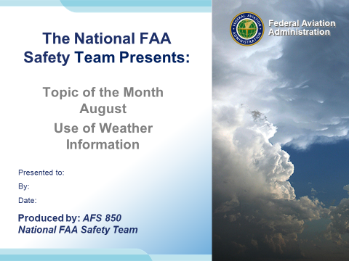 | Slide 1  2020/08-27-199(I)PP Original Author: Jay M Flowers; POC Kevin Clover, National FAASTeam Operations Lead, Office 562-888-2020  Presentation Note: This is the title slide for Use of Weather Information.  - Script - We have included a script of suggested dialog with most slides. The script will always appear in a non-italic font. Presenters may read the script or modify it to suit their own presentation style. See template slides 5 and 6 for examples of slides with script.  - Presentation Instructions - (stage direction and presentation suggestions) will be preceded by a Bold header: the instructions themselves will be in Italic fonts. See slide 2, for an example of slides with Presentation Instructions only.  - Program control instructions - will be in bold fonts and look like this: (Click) for building information within a slide; or this: (Next Slide) for slide advance.  - Background information - Some slides may contain background information that supports the concepts presented in the program.  Background information will always appear last and will be preceded by a bold Background: identification.  The production team hope you and your audience will enjoy the show. Break a leg! (Next Slide)
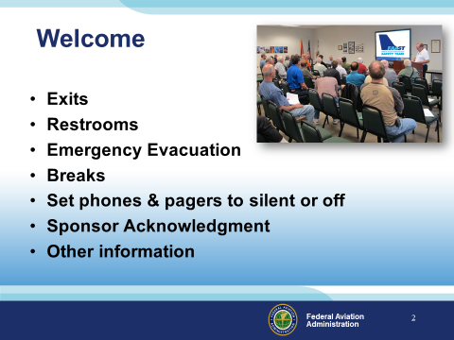 | Slide 2  Presentation Note: Here’s where you can discuss venue logistics, acknowledge sponsors, and deliver other information you want your audience to know in the beginning.  You can add slides after this one to fit your situation.  (Next Slide)
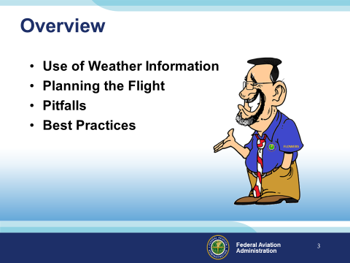 | Slide 3  Presentation Note: If you’ll be discussing additional items, add them to this list  Todays discussion will include the following:  - Use of Weather Information  - Planning the Flight  - Pitfalls of the sources and weather in general  - Best Practices  (Next Slide)
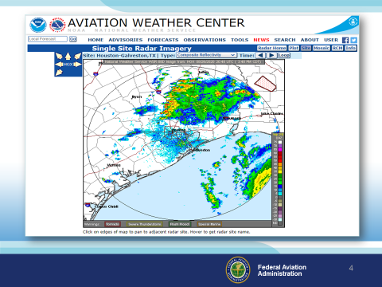 | Slide 4  Today’s pilots enjoy an abundance of weather information sources, but having weather information available is only part of the weather decision-making equation. Knowing how to acquire, interpret, and make operational decisions based on weather information is essential to safe flying. This brief presentation acquaints general aviation pilots with available weather information sources and offers guidance on making well-informed weather decisions.  (Next Slide)
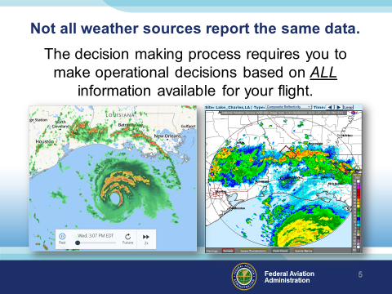 | Slide 5  Not all weather sources report the same data.  The decision making process requires you to make operational decisions based on ALL information available for your flight.  (Next Slide)
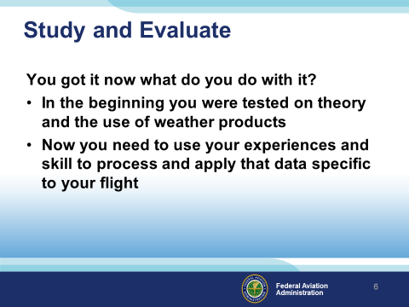 | Slide 6  Study and Evaluate  You got it now what do you do with it?  - In the beginning you were tested on theory and the use of weather products  - Now you need to use your experiences and skill to process and apply that data specific to your flight  (Next Slide)
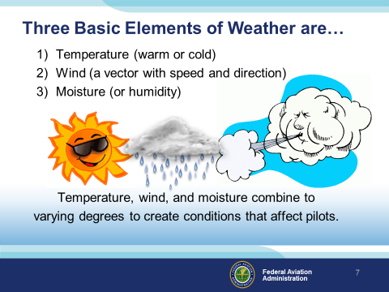 | Slide 7  The three basic elements of weather are:  - Temperature (warm or cold)  - Wind (a vector with speed and direction)  - Moisture (or humidity)  Temperature, wind, and moisture combine to varying degrees to create conditions that affect pilots.  (Next Slide)
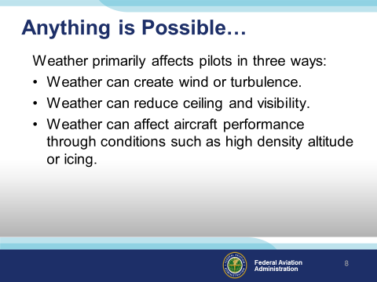 | Slide 8  Anything is possible.  Weather primarily affects pilots in three ways:  - Weather can create wind or turbulence.  - Weather can reduce ceiling and visibility.  - Weather can affect aircraft performance through conditions such as high density altitude or icing.  One approach to practical weather analysis is to review weather data in terms of how current and forecast conditions will affect visibility, turbulence, and aircraft performance for your specific flight.  (Next Slide)
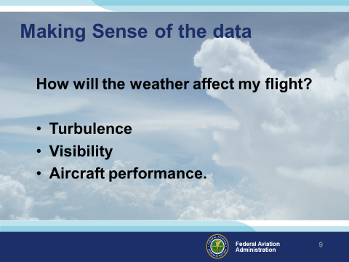 | Slide 9  Making Sense of the data and using it in the practical sense has a few steps to get the job done.  Note: Audience participation time.  Look at your weather data in terms of the ways that weather can affect your flight How about turbulence? Mountainous terrain can be a killer when turbulent  How about visibility?  - Is this a photo Op flight?  - Joy ride?  Aircraft performance?  - Aircraft loaded to maximum weight?  - Short Field?  - Long trip?  (Next Slide)
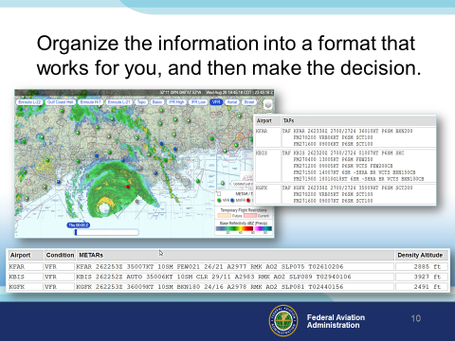 | Slide 10  Organize the information into a format that works for you, and then make the  decision:  Get the big picture, take the time necessary to do the task prior  to the flight, not while you’re walking out the door to preflight.  Check your sources and confirm with local airman if need be.  (Next Slide)
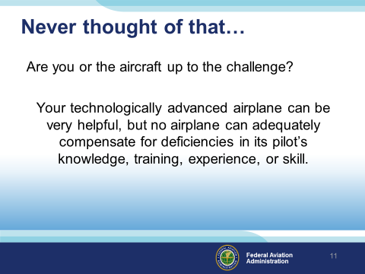 | Slide 11  Never thought of that…  Make an honest evaluation of whether your skill and/or aircraft capability are up to the challenge posed by this particular set of weather conditions.  IFR? VFR? Icing? New aircraft to you? Equipment familiarity?  It is very important to consider whether the combined “pilot-aircraft team” is sufficient.  (Next Slide)
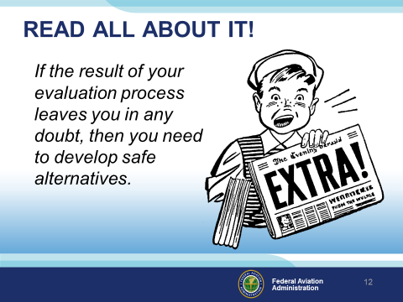 | Slide 12  One way to “self-check” your decision (regardless of your experience) is to ask yourself if the flight has any chance of appearing in the next day’s newspaper. If the result of the evaluation process leaves you in any doubt, then you need to develop safe alternatives.  (Next Slide)
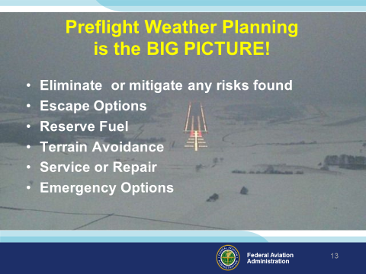 | Slide 13  Preflight weather planning is the BIG PICTURE.  Eliminate or mitigate any risks found  Note: Risk strategies vary across the country. Seasonal weather, snow, rain, temperatures, wind, terrain, runway surface type, and available procedures if IFR need to be considered for your intended and alternate routes.  - Escape Options – Alternates, box canyons, poor visibility  - Reserve Fuel – If I turn around now, can I make it?  - Terrain Avoidance – Wind induced issues, hills, mountains, trees at the airport  - Service or Repair – if I get there and something breaks, can I continue IFR?  - Emergency Options – Unforecast conditions, Ice, reduced visibility, fog  (Next Slide)
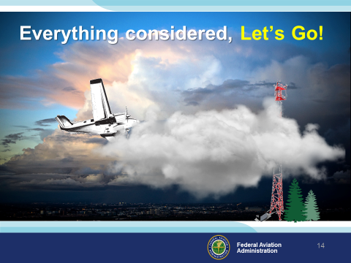 | Slide 14  Everything Considered?  Weather is constantly changing. What we see out the window may not always be what they report in the data you planned on.  (Next Slide)
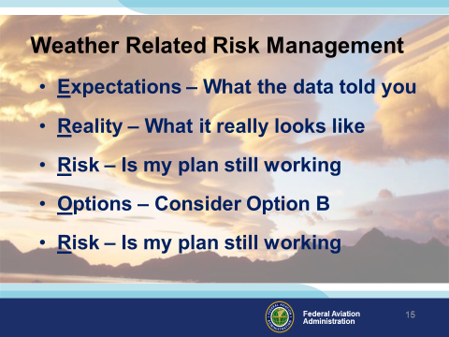 | Slide 15  Weather related Risk Management never stops.  Comprehensive preflight risk assessments allow you the best possible outcome for your flight, however… the trick is to constantly reassess your risk while enroute.  ERROR is a rather humbling acronym that may remind you of the need to correct or manage your risk along the way:  - Expectations – Seeing is believing. Is the weather what you see out the window? Is your groundspeed as predicted? Will the change in weather affect your Expected Time of Arrival? Will you have enough fuel to get there?  - Reality – The weather is not quite what you planned for.  - Risk – If the weather is not as expected, will it affect your planned flight? Is fatigue going to be a factor? Can you continue with your flight given your current assessment? Are you making your decisions solely on the safety of flight or are you feeling pressure to complete the flight?  - Options – Are your options still open? If the weather is unforecast, maybe your destination is now south of course rather than north of course. Did you plan for that?  - Risk – Has the safety of the flight been jeopardized?  How you answer these questions will determine if your plan of action pays off.  (Next Slide)
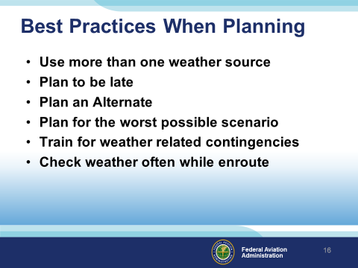 | Slide 16  Best Practices when planning:  - Use more than one weather source – utilize local weather cameras, ASOS and AWOS data by phone for actual current weather, pilot reports (if nobody has been reporting the weather ask flight service or ATC to pass along the request for some.  - Plan to be late – Get thereitis is an excuse not a planned solution.  - Plan an Alternate – If IFR and weather is questionable you must. Why not for VFR?  - Plan for the worst possible scenario – See “Plan for an Alternate”.  - Train for weather related contingencies – “The weather is predictable and the weather man is always right…maybe”.  - Check weather often while enroute – Altimeter settings every 100 miles…why not the weather?  (Next Slide)
Slide 17

WINGS! Starting the day right.

(Next Slide)

Slide 18
The WINGS Pilot Proficiency Program.
- Pilots never stop learning, and those who participate in regular proficiency training are competent, confident, and safe.
- Earn WINGS awards and recognition based on a combination of practical knowledge and hands on coaching or skill
- Get started now!

(Next Slide)
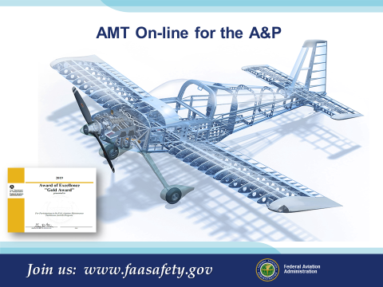 | Slide 19  AMT On-line for the A&P.  (Next Slide)
Slide 20

The AMT Awards Program.
- The AMT Awards program can help you fulfill your commitment to aviation maintenance excellence through continuing education and training.
- Earn annual awards based on core training hours at Bronze, Silver, and Gold levels.
- Get started now!

(Next Slide)

Slide 21

Presenter: For each presentation year, update this link by verifying the QR code link.
THIS SLIDE IS REQUIRED AS PART OF ALL FAASTEAM PRESENTATIONS!

(Next Slide)

Slide 22

Presenter: Update this slide for your presentation.

(Next Slide)

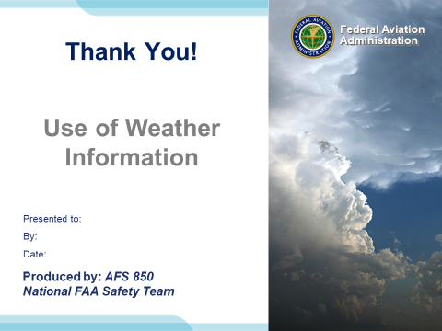 | Slide 23  Thank You for stopping by! Join us again soon.

Appendix I – Equipment and Staging
Equipment:
- Projection Screen & Video Projector suitable for expected audience
  - Remote computer/projector control available at lectern or presenter location
    - In lieu of remote – detail a Rep to computer/projector control.
- Presentation Computer
  - Note: It is strongly suggested that the entire program reside on this computer.
- Back up Projector/Computer/Media as available.
- PA system suitable for expected audience
  - Microphones for Moderator and Panel
    - Optional Microphone (s) for audience
- Lectern (optional)
Staging:
- Arrange the projection screen for maximum visibility from the audience.
- Equip with PA microphones
- Place Lectern to one side of screen. This will be used by presenters and moderator

References:

AOA Press Release - http://www.faa.gov/news/press_releases/news_story.cfm?newsid=15714

FAA Safety Briefing Magazine -
https://www.faa.gov/news/safety_briefing/2020/media/MarApr2020.pdf

IMPORTANT – Once you have completed outreach on this topic, please help us track the outreach you have done by entering a PTRS record.

