Takeoff and Landing
2021/08-08-225(I)PP
Abstract: Lasting 10 to 20 minutes, this presentation acquaints the audience with the safety of flying precise traffic patterns and participating in regular structured proficiency training.
Format: Information Briefing - Power Point presentation
Required Personnel – FAASTeam Program Manager or designated FAASTeam Rep (s)
Optional Personnel – CFIs and DPEs who can speak on takeoff and landing operations
AFS 850 Support:
In addition to this guidance document, a Power Point presentation that supports the program is provided. FPMs and presenters are encouraged to customize this presentation to reflect each individual program.

Slides | Script
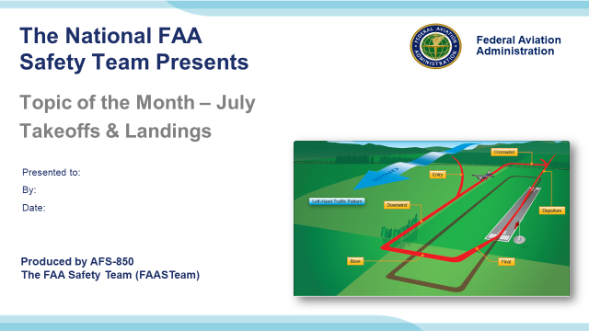 | Slide 1  2021/08-08-225(I)PP Original Author: John Steuernagle 01/30/2019; POC Kevin Clover AFS-850 Operations Program Manager, Office (562-888-2020 revised by (Name) (MM/DD/YYYY)  Presentation Note: This is the title slide for Takeoff and Landing  Presentation notes (stage direction and presentation suggestions) will be preceded by a Bold header: the notes themselves will be in Italic fonts.  Presentation notes (stage direction and presentation suggestions) will be preceded by a Bold header: the notes themselves will be in Italic fonts.  Program control instructions will be in bold fonts and look like this: (Click) for building information within a slide; or this: (Next Slide) for slide advance.  Some slides contain background information that supports the concepts presented in the program.  Background information will always appear last and will be preceded by a bold Background: identification.  We have included a script of suggested dialog with each slide. Presenters may read the script or modify it to suit their own presentation style.  The production team hope you and your audience will enjoy the show. Break a leg!  (Next Slide)
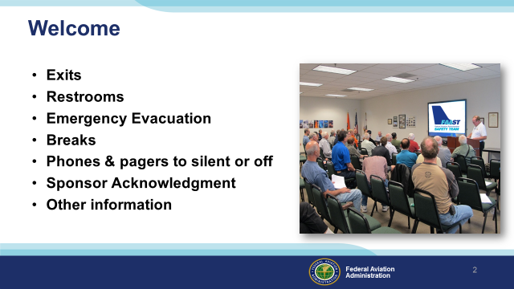 | Slide 2  Presentation Note: Here’s where you can discuss venue logistics, acknowledge sponsors, and deliver other information you want your audience to know in the beginning.  You can add slides after this one to fit your situation. (Next Slide)
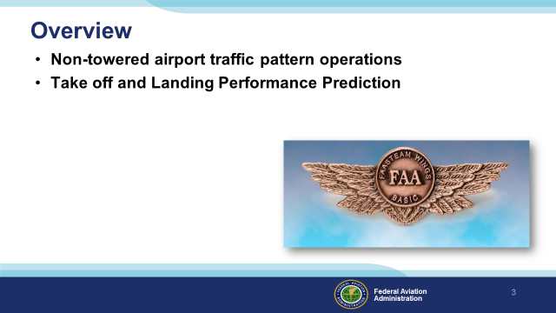 | Slide 3  Today we’ll be discussing pattern operations at non-towered airports and the importance of takeoff and landing performance prediction.  Presentation Note: If you’ll be discussing additional items, add them to this list.  (Next Slide)
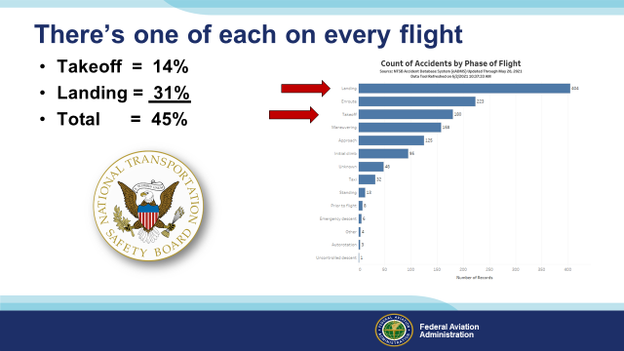 | Slide 4  Each aircraft flight begins with a takeoff and hopefully ends with a successful landing. But According to the NTSB, it doesn’t always work out that way. A study group of 1300 recent General Aviation accidents included 180 accidents that occurred during the Takeoff phase of flight. That’s fourteen percent of the total. (Click)  404 accidents occurred in the Landing phase – more than twice as many as for takeoff. (Click)  That means that almost half of all general accidents occur during either takeoff or landing so it’s logical to spend some time on the subject. But first, in fairness, let’s put these findings into perspective.  (Next Slide)
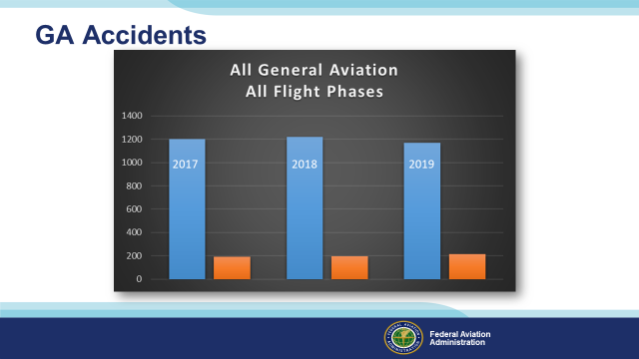 | Slide 5  The latest General Aviation mishap data available at this writing indicate a remarkable consistency. In this 3-year period we averaged 1200 accidents of which 200 were fatal. That’s a great improvement of the numbers just fifteen years ago but we can do better.  (Next Slide)
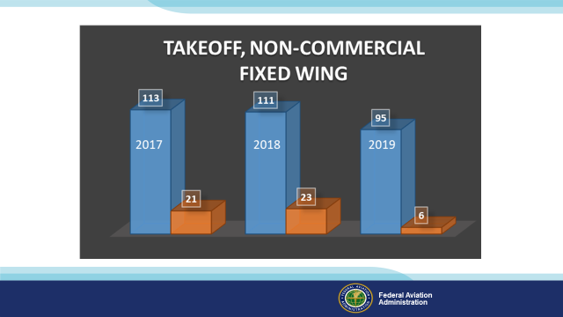 | Slide 6  In that same period, we averaged a little over a hundred takeoff accidents of which an average of 16 were fatal. We hope that the reduction in numbers of takeoff accidents in 2019 is not an anomaly but rather the beginning of a downward trend. The Covid pandemic will account for fewer hours flown and hopefully fewer accidents – especially in 2020 and 2021 so it will be a while before we see comparable data.  (Next Slide)
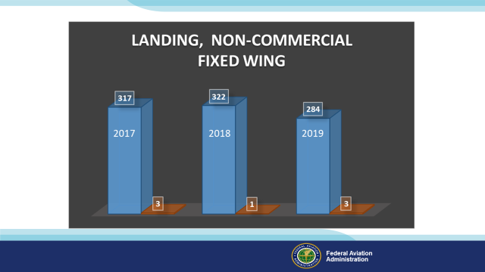 | Slide 7  Landing accidents outnumber takeoff accidents by three to one but they are much less likely to result in fatalities. That’s likely because landing accidents usually result from loss of control on the runway at low angles of attack, when power is reduced, and the airplane is slower. Takeoff accidents often occur after a loss of power at high angles of attack. Pilots must respond quickly and correctly to maintain aircraft control to a successful forced landing.  (Next Slide)
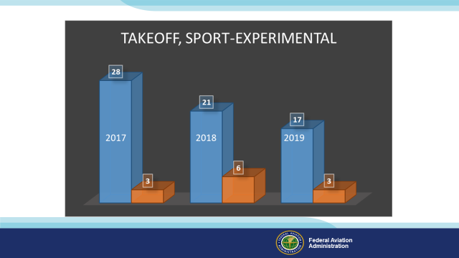 | Slide 8  Light-sport and experimental aircraft have had a somewhat disproportional mishap experience. Here we seem to be moving in the right direction but when you take into account the relatively small numbers of these aircraft, their accident experience is significantly greater than GA aircraft manufactured under traditional certification standards.  (Next Slide)
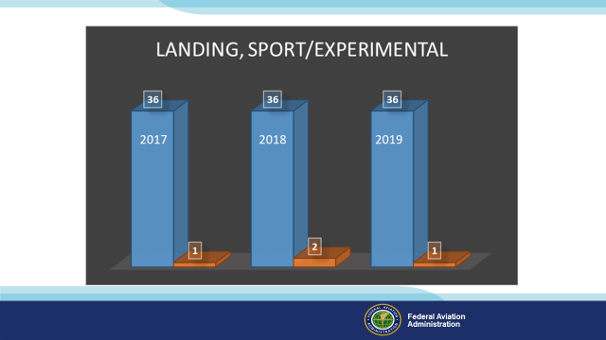 | Slide 9  The same holds true in landing accident data. Relatively small numbers of events but also a small pool of aircraft.  (Next Slide)
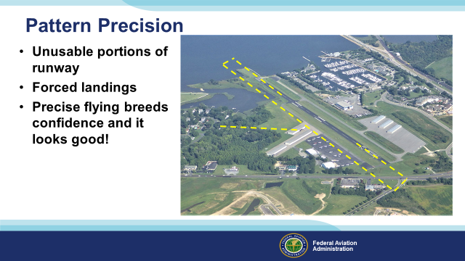 | Slide 10  We’re all familiar with pattern operations. They’re an essential part of every flight. But sometimes we take routine tasks for granted and that can lead to less precise flying. You may ask, “What does it matter if I land a little long? I have 4 times the runway I need.” Well even if you never fly to shorter fields it’s still important to be precise on longer runways for three reasons: (Click)  - Runways occasionally are compromised so you may have less distance available to land. (Click)  - Our aircraft are extremely reliable but we may have to carry out a forced landing at any time. If your landings are always on speed and on your declared landing spot, you’ll be much more confident in managing a forced landing should the need arise. (Click)  - And last but certainly not least - precise flying in the pattern makes you sharper in other flight procedures. It breeds confidence in you and in your passengers and besides; it looks good!  So with precision in mind, let’s take a look at the top five tips for optimal takeoffs.  (Next Slide)
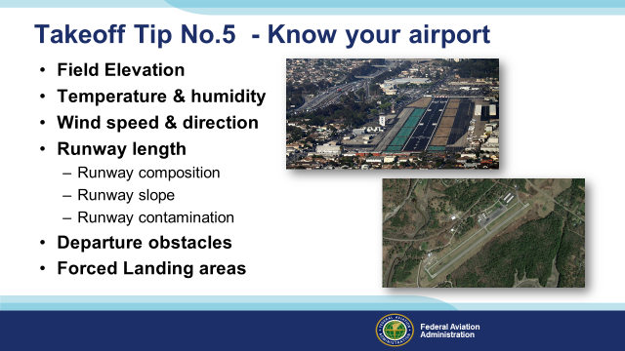 | Slide 11  Number 5 – Know your airport. Field elevation, temperature, and humidity numbers will enable you to calculate density altitude. Density altitude is essential to takeoff planning because aircraft performance is directly related to it. (Click)  Obviously, we need to know wind speed and direction in order to decide which runway to use and to calculate our takeoff distance. (Click)  Runway length is essential of course. In fact, knowing runway lengths for airports you intend to use is specifically listed as a required preflight action in 14 CFR § 91.103. (Click)  But runway composition, slope, and contamination will all affect takeoff performance so they must be considered as well. (Click)  Factor in departure obstacles and terrain and identify forced landing opportunities near the airport and along your departure path. There are a lot of forced landing opportunities around Wiscasset, Maine pictured here. (Click)  But Hawthorne airport in California is another matter. Forced landings are definitely more challenging in urban environments.  (Next Slide)
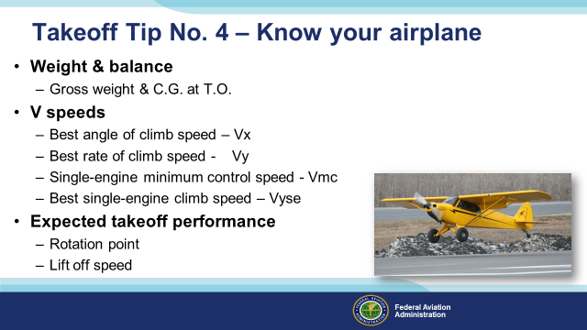 | Slide 12  Weight and balance calculations tell you whether you’re within acceptable limits and they yield a takeoff weight that, along with runway length and a number of other factors will result in expected takeoff and climb performance.  Speaking of climb, you’ll want to know your best angle and rate of climb speeds . Multi engine pilots will need to know their minimum control speed with critical engine failed (Vmc), and best single-engine climb speed. We’ll get into more takeoff calculations in a minute or two.  (Next Slide)
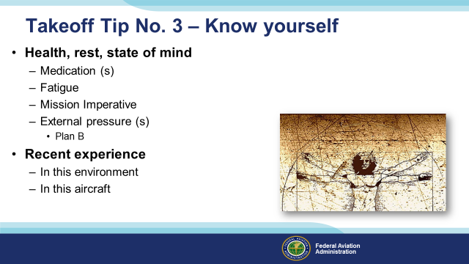 | Slide 13  Accurate assessment of your health and well being are essential to safe flight. Knowing how prescription and/or over the counter medications may affect you while flying is essential of course. But, just as important, is an understanding the conditions that occasion the need for medications. In order to function well in the air, you need adequate rest. The effects of fatigue are magnified while flying. Is there pressure to complete the mission today? If so that can add to pressures external to the mission itself. A little stress is healthy a little too much stress can be deadly. Wise pilots take this into account and develop alternative “Plan B” alternatives for times when too much is riding on successful mission completion. Waiting for better weather, more rest, adding another pilot of flight instructor, and even back-up commercial travel plans are all useful strategies to employ.  Finally, pilots must have accurate assessment of their performance in the mission aircraft and environment. Pilots who participate in regular proficiency training are generally better equipped to cope with flight challenges.  (Next Slide)
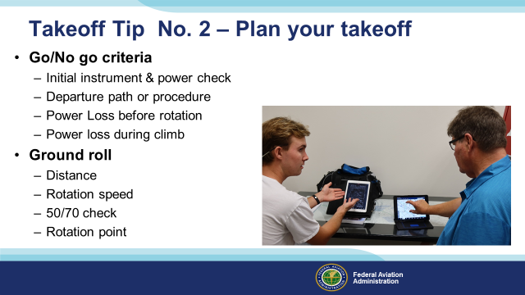 | Slide 14  There are two recommended ways to join the pattern from the upwind side.  One method is to cross midfield 500 feet above pattern altitude. Maintain this altitude until approximately 2 miles distant from the downwind leg. Descend to pattern altitude and then turn to join the downwind leg at a 45 degree angle.  Note: It’s important to descend before turning because you want to have a good view of traffic on and joining the downwind leg.  (Next Slide)
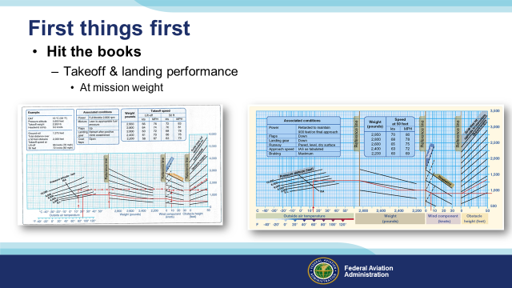 | Slide 15  Before you begin to work on your takeoff calculations, you’ll need to create some expectations; so hit the books and determine what sort of takeoff and landing performance you’ll get. Document these numbers and compare with your actual performance. Be sure to calculate performance based on the weight you expect to be while flying  (Next Slide)
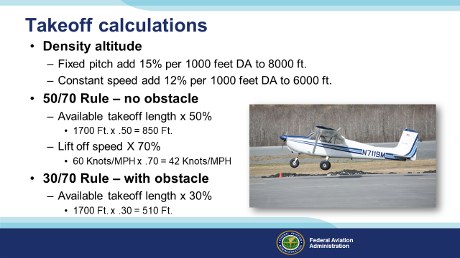 | Slide 16  Here are some rules of thumb when making takeoff calculations.  If you have a fixed pitch prop, add 15% to your calculated takeoff distance for each 1000 foot increase in density altitude up to 8000 feet. (Click)  For constant speed props add 12% per 1000 feet of density altitude up to 6000 feet. (Click)  When planning takeoff from unobstructed runways establish a landmark at 50% of your calculated takeoff distance.  When on the take off roll you should have 70% of your lift off speed at that point. If you don’t – the safest thing is to abort the takeoff and reduce weight or wait for more favorable wind and temperature conditions. (Click)  In this example we’re assuming an available takeoff area of 1,700 feet. 50% of 1700 is 850 feet. If our lift off speed is 60 knots or MPH. 70% of that figure is 42. That’s the airspeed you’ll want to see at the halfway point (Click)  If you must clear obstructions on takeoff you’ll need to have 70% of your rotation speed by the time you’ve travelled 30% of your available takeoff distance. 30% of 1700 is 510 feet. You’ll still need 42 knots or MPH by this point in order to comfortably clear the obstacle.  (Next Slide)
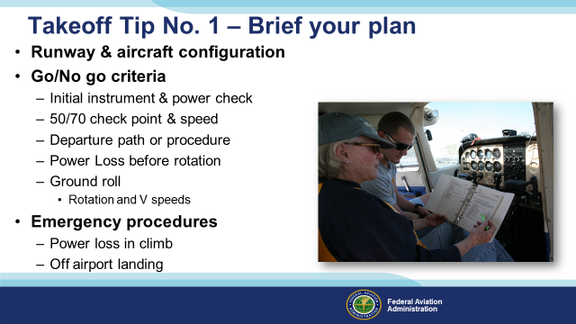 | Slide 17  Vocalize your plan even if there’s no one to hear it but you. It’s the best way to review your expectations and prepare for emergencies. Note the runway you’ll use and the aircraft takeoff configuration. There will be several Go/No go decision points. You’ll do an instrument check to confirm power and airspeed indications. Assuming no obstructions you’ll want to see 70% of your lift off speed at or before 50% of your available takeoff distance is behind you. Describe your departure path and note what you’ll do in case of a power loss before rotation. State your rotation, lift off and climb speeds. Followed by what you’ll do if power is lost in the climb and where you’ll go if you have to carry out an off airport landing. Your brief should sound something like this.  This will be a flaps up takeoff on runway two five at Wiscasset. If initial power and acceleration are OK, we’ll proceed to our 50/70 check point. If there’s power loss prior to rotation we’ll maintain control & stop on the runway. We have a left crosswind from 230 at 12 Knots. We’ll rotate at 55 knots, then accelerate to Vy which is 78 knots and fly the extended runway center line to 1,500 feet and clear of the pattern then turn left on course and accelerate to cruise climb of ninety knots. If we lose power prior to 1,500 feet, we’ll fly at best glide speed of 65 knots and land straight ahead.  Now let’s take a look at the top 5 tips for landing.  (Next Slide)
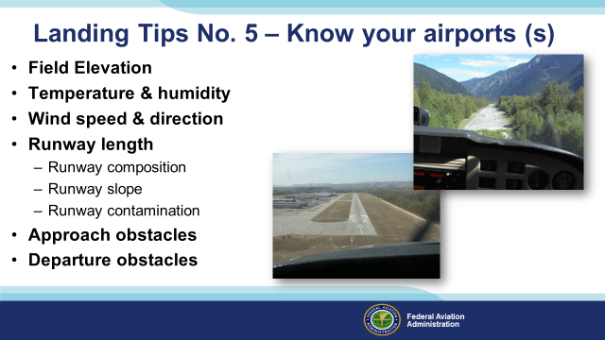 | Slide 18  Landing tip number five looks a lot like a takeoff tip with a couple of important differences. When taking off, we only have to plan for one airport. We’re in a great position to evaluate runway condition and we have enough data to make accurate takeoff performance calculations.  Landing may involve more than one airport. If we’re IFR we may have one or more alternates to consider and even VFR airports become untenable from time to time. Field condition information may be great or it may fall short of that. From what we can see in the photo, committing to a landing at this airport – even if we’ve never been there before – is reasonable. It’s paved, unobstructed, well marked, and it even has a VASI. However……. (Click)  This airport, if you can call it that, is something quite different isn’t it? It’s definitely obstructed, of dubious composition and condition, and any airport services are unlikely. If we don’t make a good landing that leaves the airplane in serviceable condition, we may be stuck here for a while. If you’re thinking about trying your hand at back country flying, arranging for an airport checkout with a knowledgeable local instructor is a very good idea.  (Next Slide)
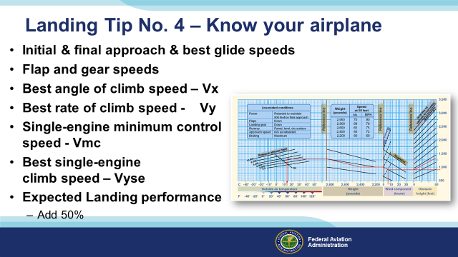 | Slide 19  As with takeoff – you’ll want to be intimately familiar with approach, flap, and gear speeds. In the event of a go-around, you’ll also need to know your climb speeds. Hitting the performance charts will give you expected landing performance data. A convenient rule of thumb is to add 50% to your expected landing distance. If you fly with precision, you’ll never have to use it but if something like a contaminated runway or decreased braking capability crops up, you’ll have more runway to deal with it.  (Next Slide)
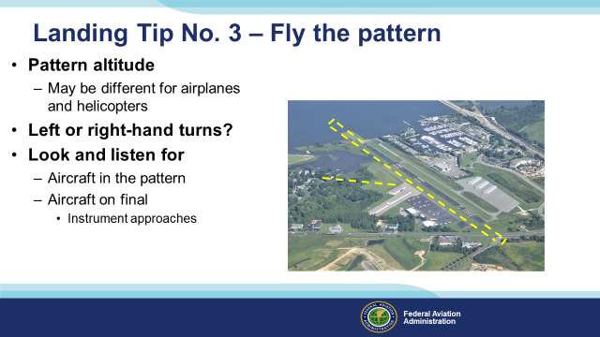 | Slide 20  Short cuts can be useful but we recommend against them when it comes to airport traffic patterns. Flying the published pattern is the best way to maintain an orderly, predictable traffic flow at non-towered airports. Be aware that patterns altitudes and patterns themselves are often different for airplanes and helicopters. Standard patterns make all turns to the left but there are plenty of non-standard right hand patterns out there so make sure you know to go with the flow.  Finally, look and listen for other aircraft in the pattern and be sure to broadcast your position and intentions. Pay particular attention to aircraft on final in front of and possibly behind you. Aircraft on instrument approaches may be landing straight in so see and avoid is the order of the day for all parties.  (Next Slide)
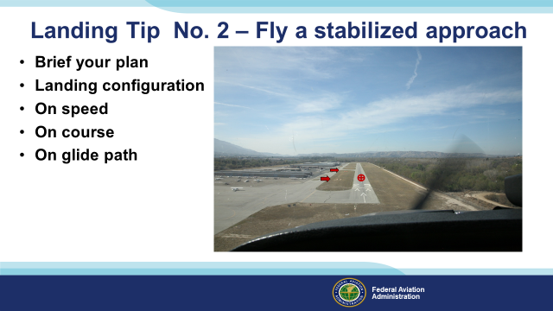 | Slide 21  As with the takeoff, it’s good to brief your approach and landing plan. Just vocalizing what you expect to see and do will make it easier to stay ahead of your aircraft. Approach and landing briefings will also help you to recognize when things aren’t going according to plan and when a go-around or missed approach is in order.  Once established on final approach it’s essential to maintain speed and glide path. Maybe the runway you’re using is ten thousand feet long but you should still maintain a glide path that will result in touching down in the first third of the runway. To help build precision, pick a runway stripe and try to land on it every time without adding power. Many runways are served with approach path indicators. The VASI (Visual Approach Slope Indicator) is hard to see in this picture but it’s prominent enough in real life. When electronic and/or visual glide slope information is available it’s good policy to follow its’ guidance.  (Next Slide)
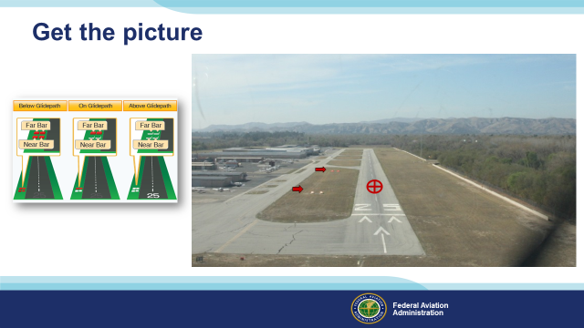 | Slide 22  Now we can clearly see the VASI and if we stay on the glide slope, we’ll touch down on or very close to the target. (Next Slide)
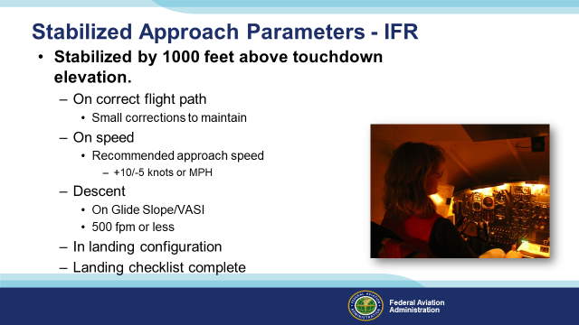 | Slide 23  Back to stabilized approaches: For instrument operations we want to be stabilized no lower than 1000 feet above the runway, on the correct flight path to the touchdown zone. That means we’re on a direct course from 1000 feet to the airport. We use a power setting the will yield the recommended approach speed for our aircraft in landing configuration.  In the descent department, maintain the glide slope if you’re landing on a precision approach runway, or not more than a 500 foot per minute rate of descent unless a greater descent rate is required for approach. You’re stabile if you have to make only small corrections in pitch, heading, and power to maintain the path. Before you’re 1000 feet above touchdown you also need to be configured for landing with the landing checklist complete.  Many instrument pilots want to have all this done by the time they reach the final approach fix. They’ll generally be a little higher than 1000 feet at that point but it’s a good practice that will give you plenty of time to concentrate on flying to the missed approach fix.  If the wind is gusting we can add some speed to compensate but no more than half of the gust factor. If the wind is at 12 knots and gusting to 18, we can add 3 knots to our final approach speed.  So what if we’re not stabile by the time we descend to within 1000 feet of the runway? Well the answer is simple – we go around and set up a more stabile approach on the next try. This can be a tough decision to make, especially if you must make another instrument approach. That’s why you have to be committed to the decision before you reach the 1000 foot point. Then it’s simple: if you’re stabile you continue – if not; go around and set up again.  Presentation note: Ask the audience about their best practices and at what point in the approach they are configured and stabile.  (Next Slide)
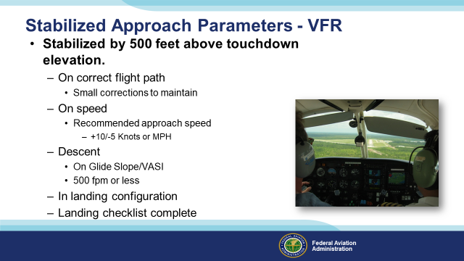 | Slide 24  VFR parameters are essentially the same except that you can get a little closer to the ground before making the go around decision. If you’re flying a pattern you need to be stable on final, in landing configuration with the landing checklist complete. If you’re not stabile at 500 feet – go around.  But what if you’re flying a close pattern and you’re still on base leg at 500 feet? No need to go-around – at least not yet. If you’re configured for landing, on speed, and on course to the final leg you’re stable and you can continue the approach. If you’re not on speed and/or on course though, it’s definitely time to consider going around and trying it again.  Presentation note: Ask the audience about their VFR best practices and at what point in the approach they are configured and stabile.  (Next Slide)
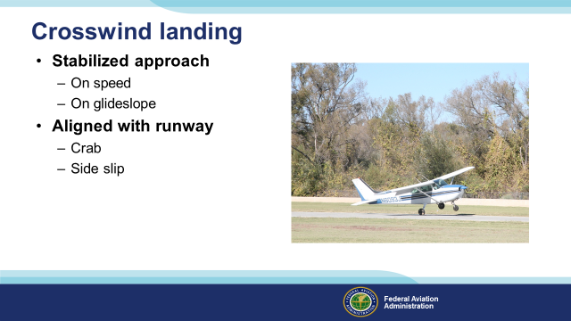 | Slide 25  Crosswind operations add another dimension to the landing process. Here too a stabilized approach is paramount. Maintain your target airspeed, descent, and runway alignment.  Some pilots crab into the wind until just before touchdown. Others prefer to establish a side slip on final and maintain it all the way to touchdown. Either way, you must be aligned with the runway before and after the rubber meets the road. As the aircraft slows, crosswind control inputs must increase to compensate for reduced control authority.  (Next Slide)
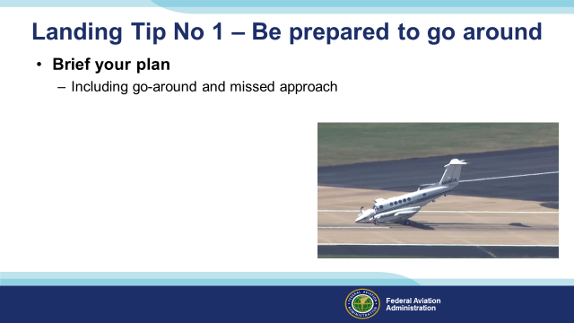 | Slide 26  Your approach has been a thing of beauty. The King Air ahead will be clear of the runway before you touch down. You’re configured for landing and stable. You can almost taste that hundred dollar hamburger. Then this happens. (Click)  Can you believe it? Right at the intersection. Both runways will be unusable for who knows how long. Now what? (Click)  Well, if you briefed your approach and landing plan and if you included go-around and missed approach procedures, you’ll be way ahead of the game. The worst outcome will be you’ll have to put off that expensive gourmet experience until next week. The challenge of go-arounds is they can become your best option at any time. If you’re always prepared for the eventuality with pre-briefed missed approach criteria, you won’t waste time deciding whether you need to go around or not.  (Next Slide)
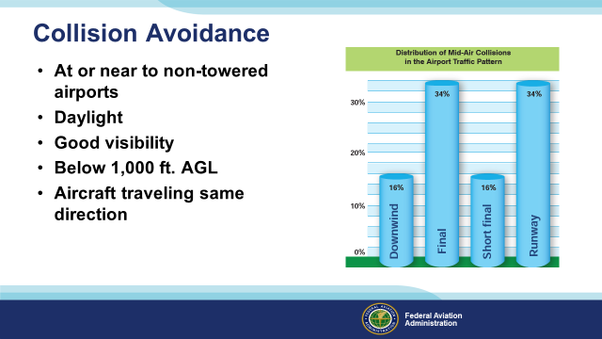 | Slide 27  Here are some sobering statistics. The majority of mid-air collisions occur at or near to non-towered airports in daylight with good visibility. They usually occur below 1,000 feet AGL and more often than not, between aircraft traveling the same direction. In some years, half of the mid-air collisions result from one aircraft overtaking another on final approach.  These is not surprising. Airports do concentrate traffic operating to and from them and there are three things we need to do to minimize potential for a close encounter of the worst kind.  (Next Slide)
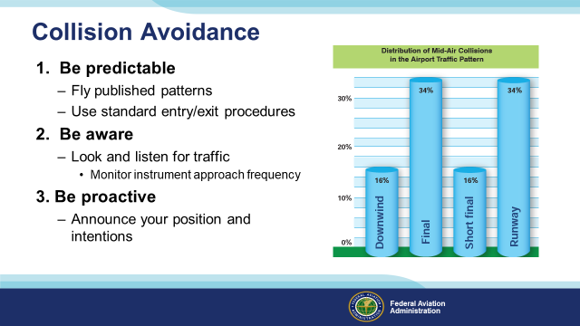 | Slide 28  Here are some tips for collision avoidance (Click)  - Be predictable – fly the published pattern at each airport and use standard pattern entry and exit procedures. (Click)  - Be aware – look and listen for traffic in and near the airport. Some pilots use a 2nd radio to monitor the instrument approach frequency. That way they’ll be aware of aircraft on approach that will be descending to and possibly beyond the missed approach point. (Click)  - Be proactive – announce your position and intentions on the Common Traffic Advisory Frequency.  (Next Slide)
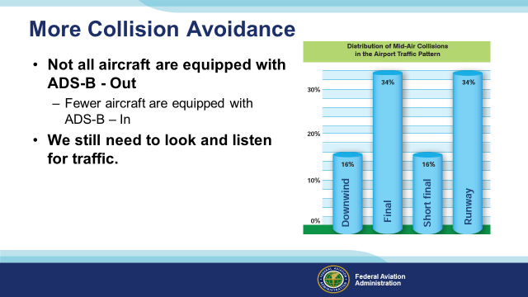 | Slide 29  Most aircraft must now be equipped with ADS-B-Out and if you have ADS-B-In equipment you’ll be able to see them on your cockpit display. Many un-equipped airplanes are still flying though so you still need to look and listen for traffic.  (Next Slide)
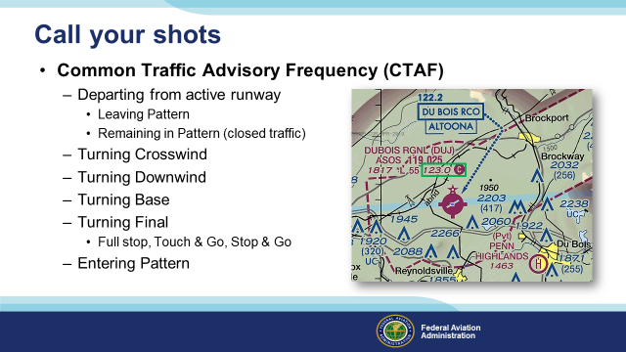 | Slide 30  You can make life easier and reduce collision at non-towered airports by keeping other pilots informed as to your position and intentions.  Use the Common Traffic Advisory Frequency to announce your position and intentions. Announce your intention to depart and whether you intend to leave the area or remain in the pattern. Announcing the turns rather than the pattern leg tells other traffic in the area just where to look to spot your aircraft. For identifying traffic in the pattern, aircraft type is much more useful than the tail number.  (Next Slide)
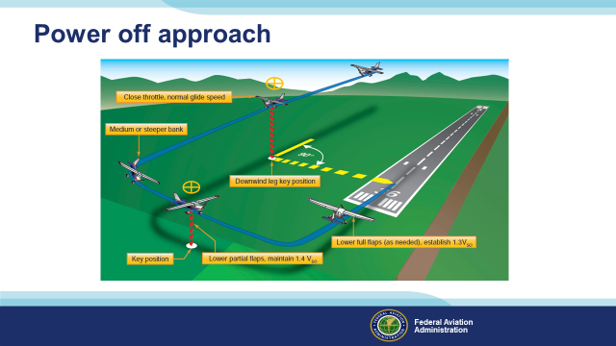 | Slide 31  When you can consistently hit your landing targets try power-off accuracy landings from key positions on base and downwind. This is excellent preparation for off-airport forced landings.  (Next Slide)
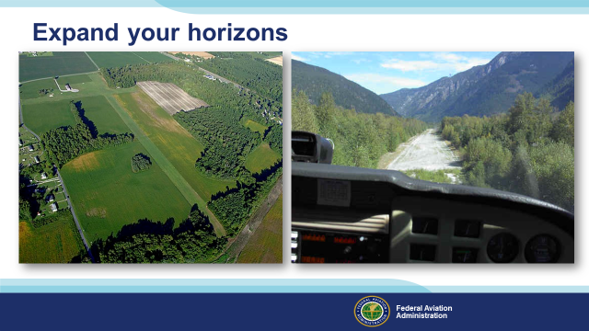 | Slide 32  Every runway is different. Here are two that offer minimal approach guidance but maximal fun. The strip on the right is considerably more challenging than the grass field on the left. We encourage you to expand your horizons but be sure to consult local instructor talent before operating at unfamiliar, challenging, destinations. That said, a structured approach to new flying challenges is an excellent way to increase pilot proficiency, comfort, and confidence.  (Next Slide)
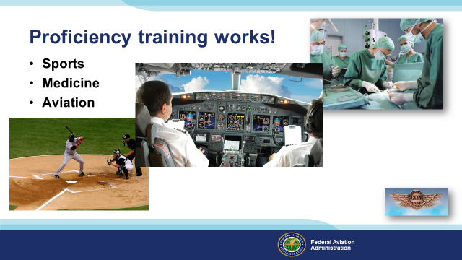 | Slide 33  Can you imagine how well professional athletes would perform if they didn’t practice between games or stay in shape during the off season? (Click)  Would you choose to be treated by doctors who had no continuing education since graduating from medical school? (Click)  Or how about a professional pilot flight crew who never train for emergencies?  Pros know that proficiency is not a destination but rather a journey that never ends.  Regular training keeps the them at peak performance every time they take to the air.  (The End)
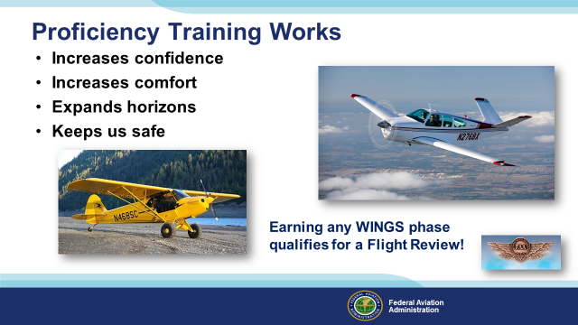 | Slide 34  Proficiency training works for General Aviation pilots too. Pilots who participate in the FAA WINGS Pilot Proficiency program fly with more confidence. They and their passengers are comfortable in the air. And proficiency training can expand our horizons by exploring the operational capabilities of our present aircraft or introducing us to more complex and capable planes as well as more challenging destinations.  Most importantly - proficiency training keeps us safe. (Click)  And pilots who earn WINGS phases also qualify for a flight review.  (Next Slide)
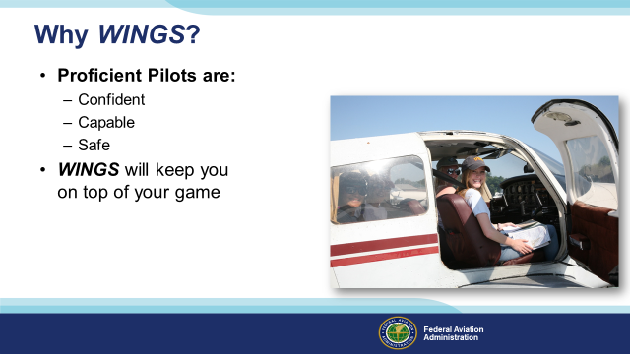 | Slide 35  So why WINGS? Well proficiency is key to success in almost every thing worth doing – especially flying. Proficient pilots are confident, capable, and safe.  WINGS is a proficiency training system specifically designed for general aviation pilots and, regular participation will keep you on top of your flying game.  (Next Slide)
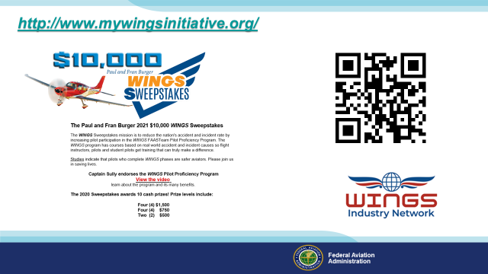 | Slide 36  Now there are even more reasons to participate in WINGS. Every time you complete a WINGS Phase you’re eligible to win cash the WINGS Sweepstakes.  The sweepstakes is generously funded by Paul Burger, a long time advocate for general aviation safety and a retired aviator who believes participation in this program saves lives. VISIT WWW.MYWINGSINITATIVE.ORG to learn more and enter the sweepstakes.  (Next Slide)
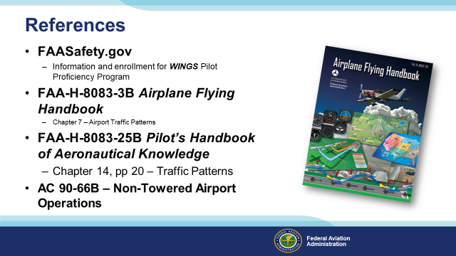 | Slide 37  Here are a few references for additional information:  I’ll leave this slide on screen while I take some questions from the audience.  Presentation note: Take questions from the audience while they copy information from the screen. Then:  (Next Slide)
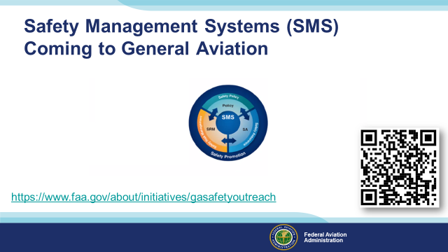 | Slide 38  Safety Management Systems are a set of policies and processes that can increase the safety and efficiency of any flight operation. And FAA is bringing SMS to General Aviation. You may have heard of SMS but thought it was only for large organizations but actually SMS can be scaled to fit any operation large or small.  There are 4 major components to a Safety Management System (Click)  Safety Policy – a documented commitment to safety that runs from the head of an organization to its newest member. (Click)  Safety Risk Management – a process that identifies hazards within an operation, determines to what extent an identified hazard may impact flight safety, and controls the risk of occurrence to an acceptable level. (Click)  Safety Assurance – By collecting and analyzing information derived from safety performance data Safety Assurance ensures the performance and effectiveness of Safety Risk Controls. (Click)  Safety Promotion communicates safety information and commitment throughout the organization. (Click)  You can find more information about Safety Management Systems at the URL on the Screen.  (Next Slide)
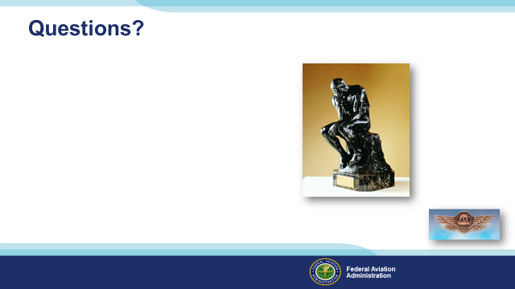 | Slide 38  Presentation Note: You may wish to provide your contact information and main FSDO phone number here. You can also add WINGSPro contact information.  Modify with your information or leave blank.  (Next Slide)
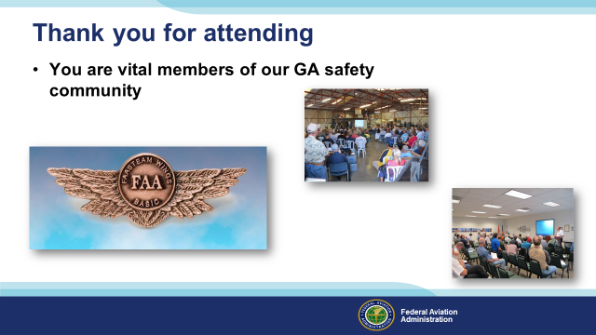 | Slide 39  Your presence here shows that you are vital members of our General Aviation Safety Community. The high standards you keep and the examples you set are a great credit to you and to GA.  Thank you for attending.  (Next Slide)
Slide 40
(The End)
Appendix I – Equipment and Staging
Equipment:
- Projection Screen & Video Projector suitable for expected audience
  - Remote computer/projector control available at lectern or presenter location
    - In lieu of remote – detail a Rep to computer/projector control.
- Presentation Computer
  - Note: It is strongly suggested that the entire program reside on this computer.
- Back up Projector/Computer/Media as available.
- PA system suitable for expected audience
  - Microphones for Moderator and Panel
    - Optional Microphone (s) for audience
- Lectern (optional)
Staging:
- Arrange the projection screen for maximum visibility from the audience.
- Equip with PA microphones
- Place Lectern to one side of screen. This will be used by presenters and moderator
- IMPORTANT – Once you have completed outreach on this topic, please help us track the outreach you have done by entering a PTRS record.



