General Aviation Joint Steering Committee
Pilots and Medications
Outreach Guidance Document
2023/10-29-305(I)PP

This outreach guidance is provided to all FAA and aviation industry groups that are participating in outreach efforts sponsored by the General Aviation Joint Steering Committee (GAJSC). It is important that all outreach on a given topic is coordinated and is free of conflicts. Therefore, all outreach products should be in alignment with the outline and concepts listed below for this topic.

Outreach Month: September 2025

Topic: Safety Wire
Failure to properly secure aircraft components has led to system and component failures. Some of those failures have compromised powerplant and control system operation resulting in crashes.

Background:

Because improper or absent aircraft component safety wiring continues to cause accidents, pilots and mechanics should carefully inspect for proper component assembly security.

Teaching Points:
- Pilots and mechanics should note component safety provisions during inspections.
- Safety wire and devices must be properly installed in order to be effective.
- Safety wire should be installed so that tension is applied in the component tightening direction.
- Castelated nuts should have cotter keys installed.
- At least 1/32 inch of bolts should protrude from fiber lock nuts.

References:
- Safety Wire Power Point
  - Available on the National FAASTeam Share Point site under Approved Resources.

Abstract: This 15 to 20-minute presentation describes various safety technologies intended to prevent loosening or loss of aircraft components. It prescribes safety component installation and inspection and discusses consequence of improper installation.

Slides | Script
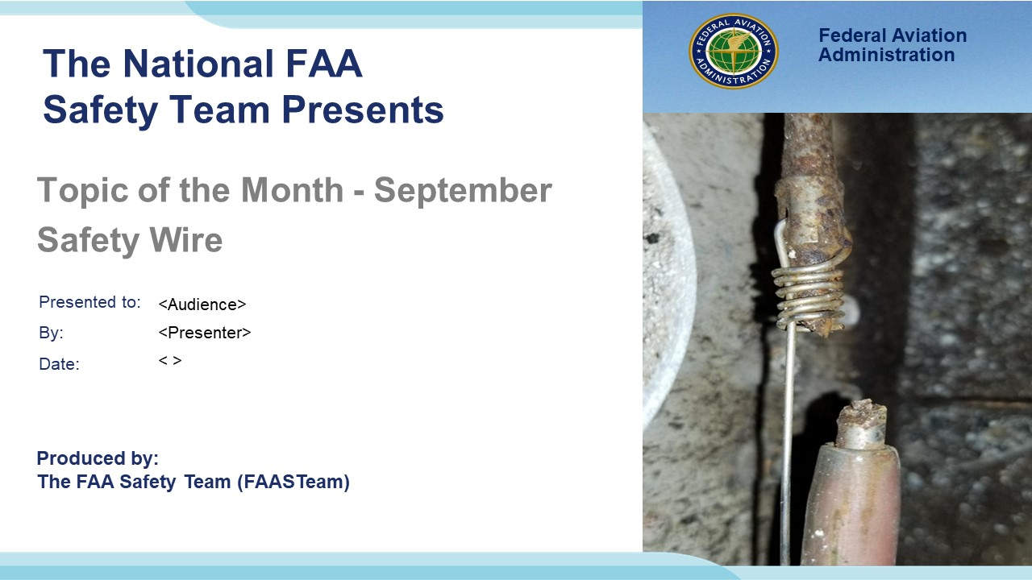 | Slide 1  2023/10-29-305(I)PP Original Author: (Guy Minor) (03/06/2020); POC (Guy Minor), AFS-930 (Airworthiness FPM), Office (707-704-3530); Edited by: John Steuernagle (05/24/2024)  Presentation Note: This is the title slide for (Safety Wire)  Script - We have included a script of suggested dialog with most slides. The script will always appear in a non-italic font. Presenters may read the script or modify it to suit their own presentation style. See template slides 5 and 6 for examples of slides with script.  Presentation Instructions - (stage direction and presentation suggestions) will be preceded by a Bold header: the instructions themselves will be in Italic fonts. See slide 2, for an example of slides with Presentation Instructions only.  Program control instructions - will be in bold fonts and look like this: (Click) for building information within a slide; or this: (Next Slide) for slide advance.  Background information - Some slides may contain background information that supports the concepts presented in the program.  The production team hope you and your audience will enjoy the show. Break a leg!  (Next Slide)
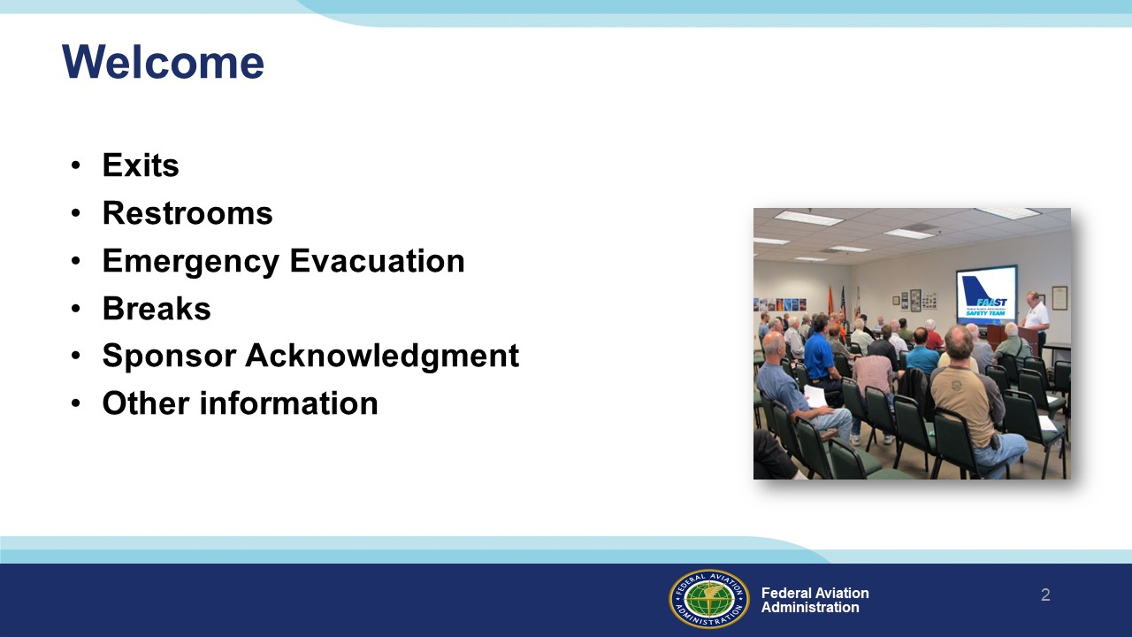 | Slide 2  Presentation Note: Here’s where you can discuss venue logistics, acknowledge sponsors, and deliver other information you want your audience to know in the beginning.  You can add slides after this one to fit your situation.  (Next Slide)
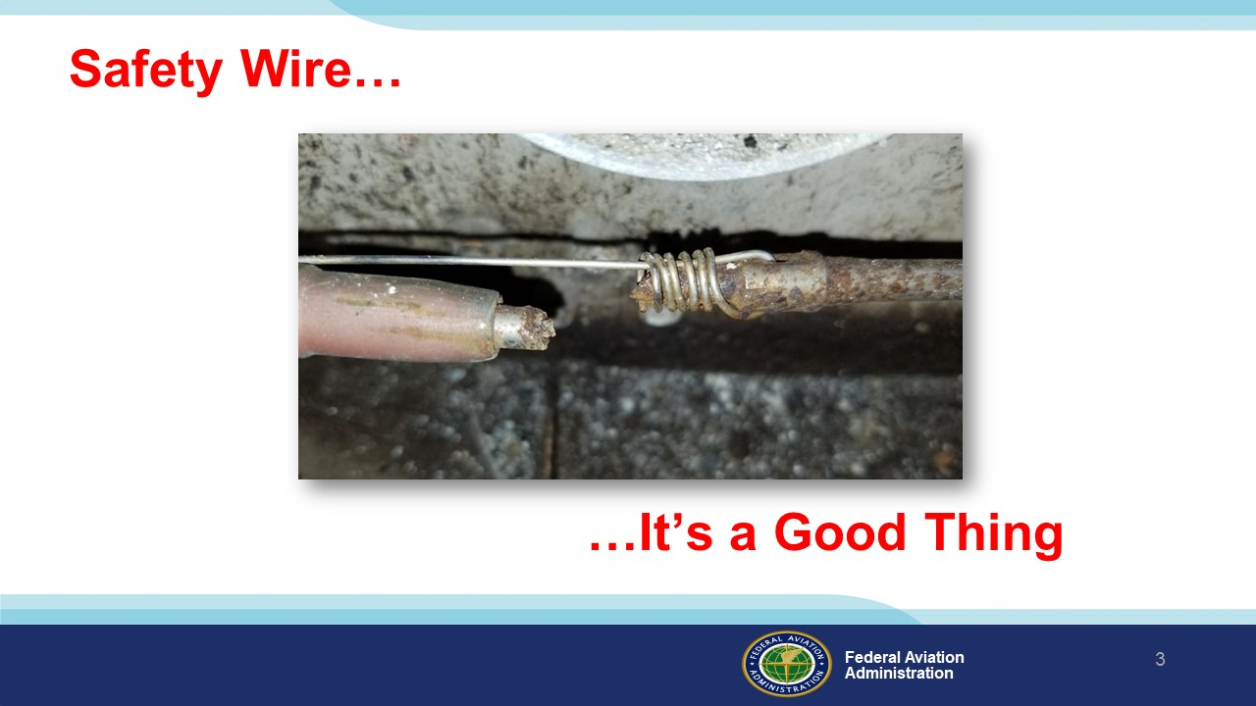 | Slide 3  Safety Wire. It is a good thing.  (Next Slide)
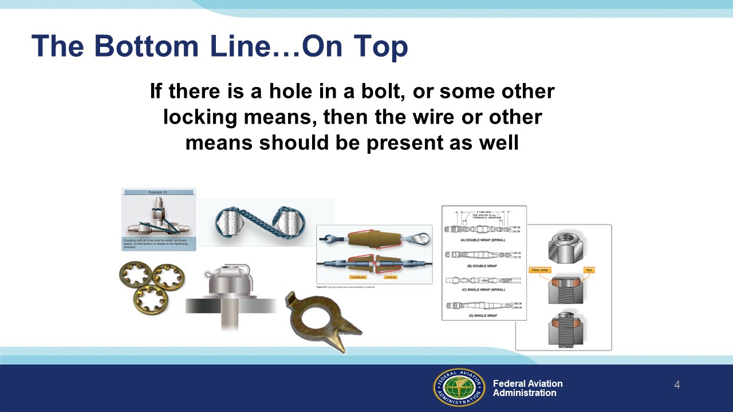 | Slide 4  “Why isn’t this bolt safety wired” is a rational question. If you are used to seeing a piece of hardware with a locking device and you notice the locking device is missing, then ask the question. It could save your life.  (Next Slide)
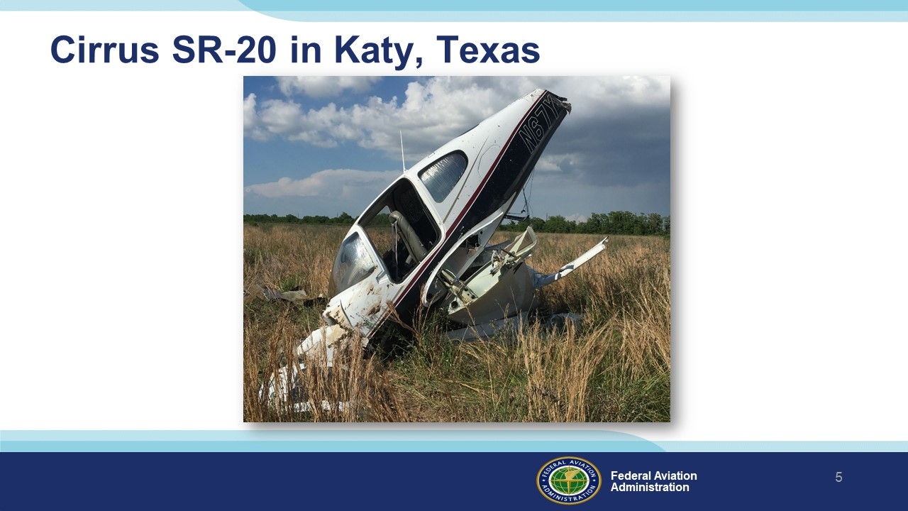 | Slide 5  CEN18LA195 On May 27, 2018, in Houston, Texas a Cirrus SR-20 airplane crashed shortly after takeoff. The pilot reported that he could not maintain roll control of the airplane. The airplane began to roll to the left. The pilot was able to counteract with right aileron input initially, but the airplane continued to roll to the left. The pilot continued to use right aileron and trim, lowered the nose, and executed a straight-in forced landing just beyond the departure end of the runway.  The Pilot survived with minor injuries.  (Next Slide)
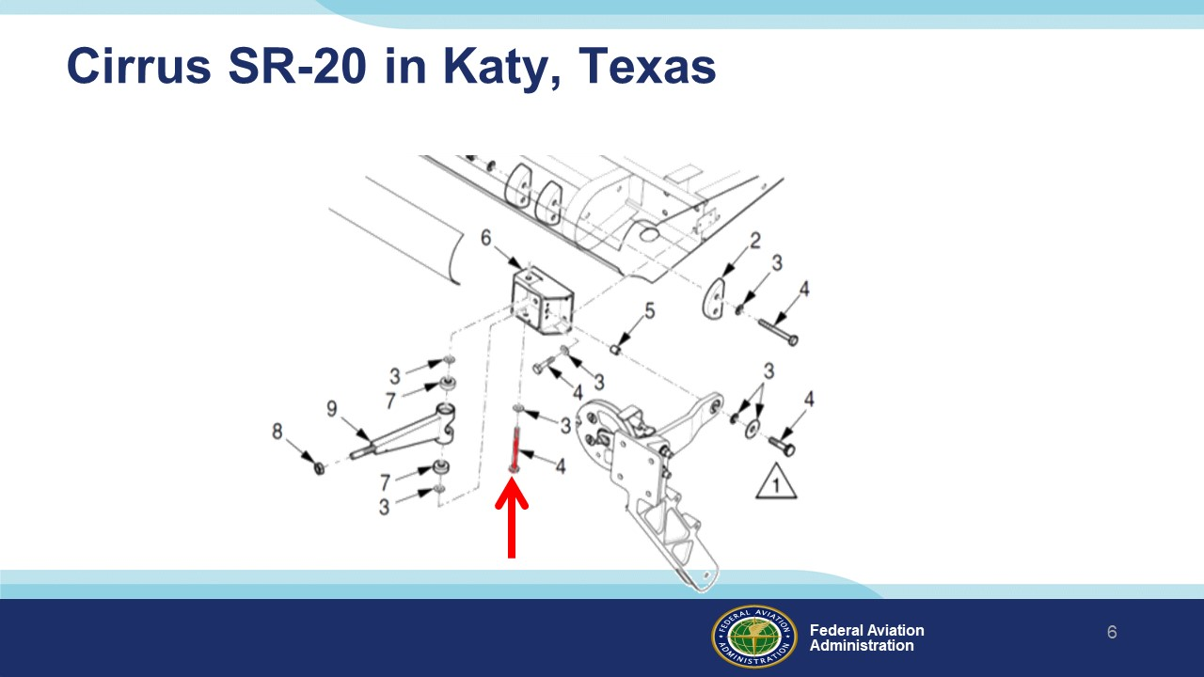 | Slide 6  Examination of the airplane after the accident revealed that the left aileron actuation arm and attach bolt were missing with no associated impact damage. Further investigation indicated that the safety wire was missing from the actuation bolt, indicated by the red arrow.  (Next Slide)
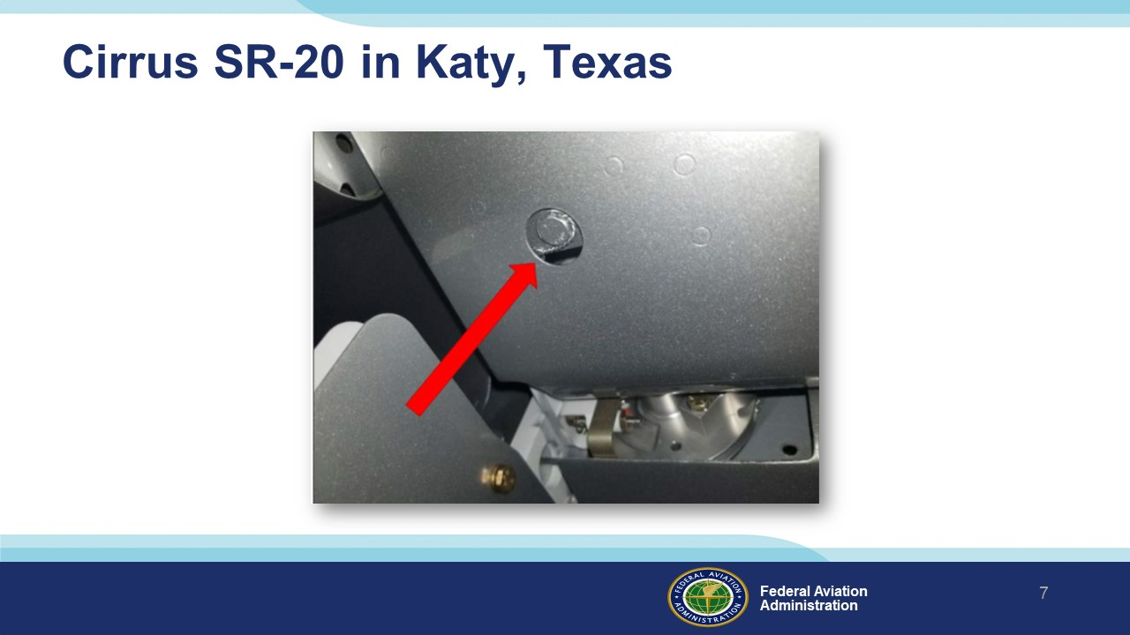 | Slide 7  As the bolt is readily visible during a walk around inspection, we recommend that all owners and operators visually verify the presence of the required safety wire before further flight. (See the illustration photo) If safety wire is not present, have a qualified maintenance provider correct the situation before further flight.  (Next Slide)
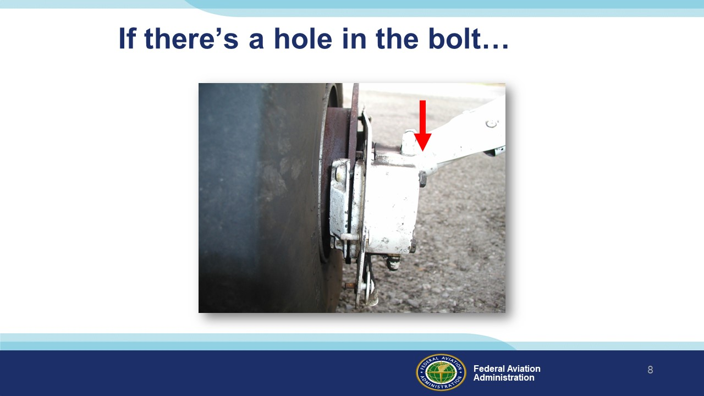 | Slide 8  If there is a hole in the bolt…  Background:  This airplane took a test flight with the brake caliper and hub nut finger tight. See the gap between the cylinder and the brake pad backing plate?  (Next Slide)
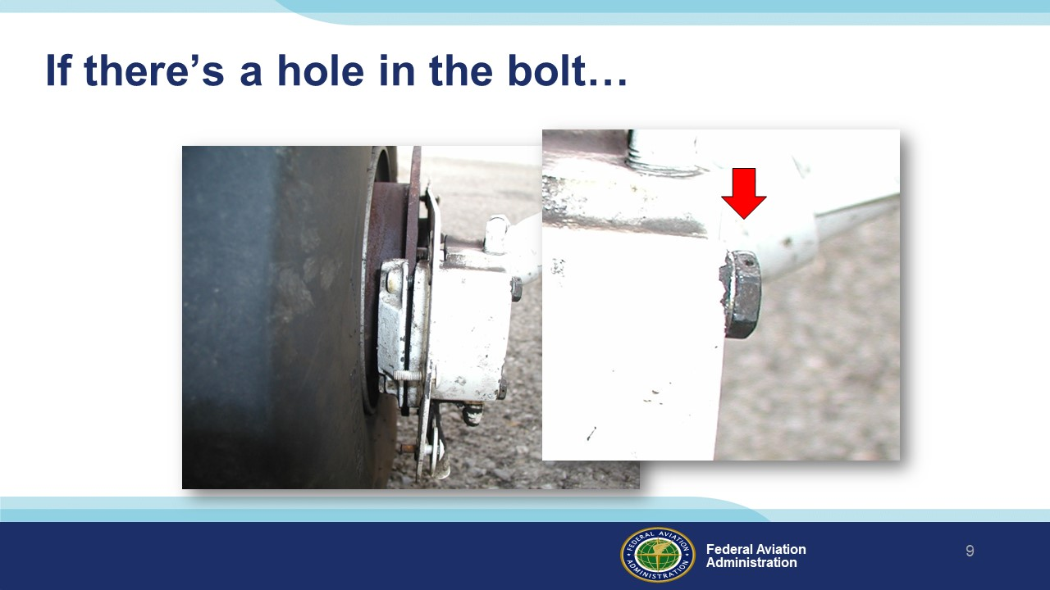 | Slide 9  …Like this…  (Next Slide)
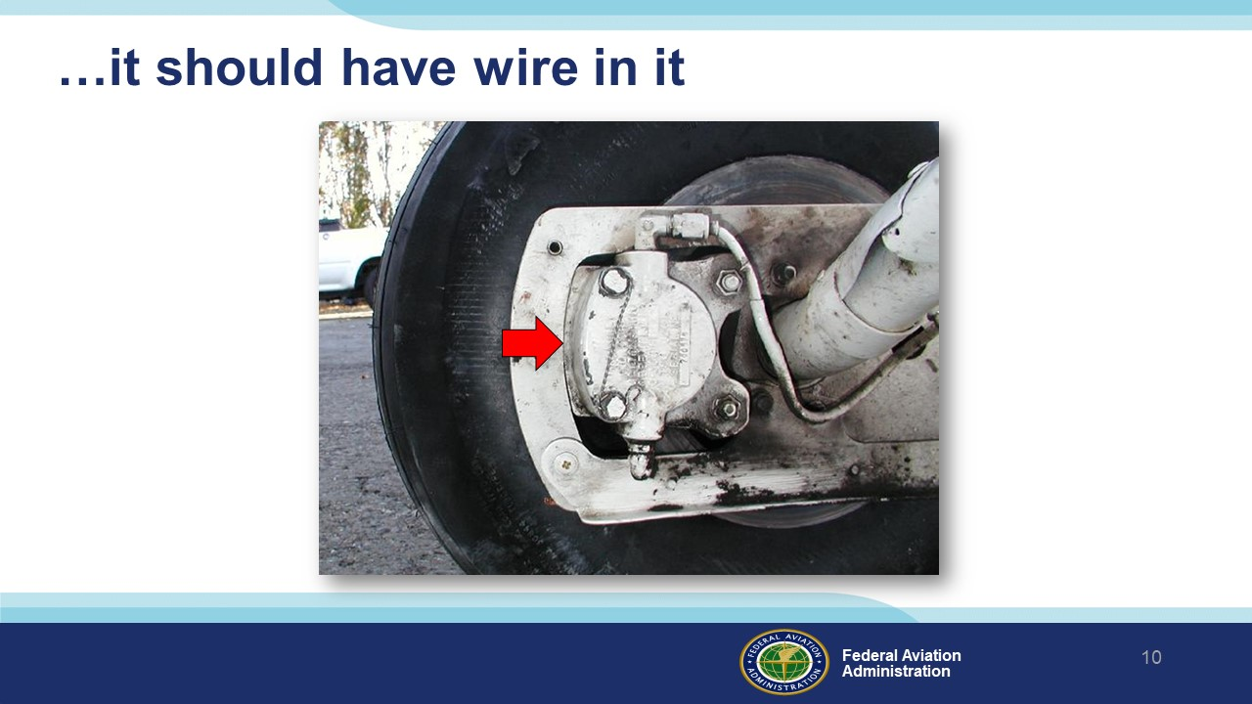 | Slide 10  It should have wire in it, or it is time to ask the rational question, “Why isn’t this bolt safety wired?” There could be good reason, or it could be the maintenance is not finished.  (Next Slide)
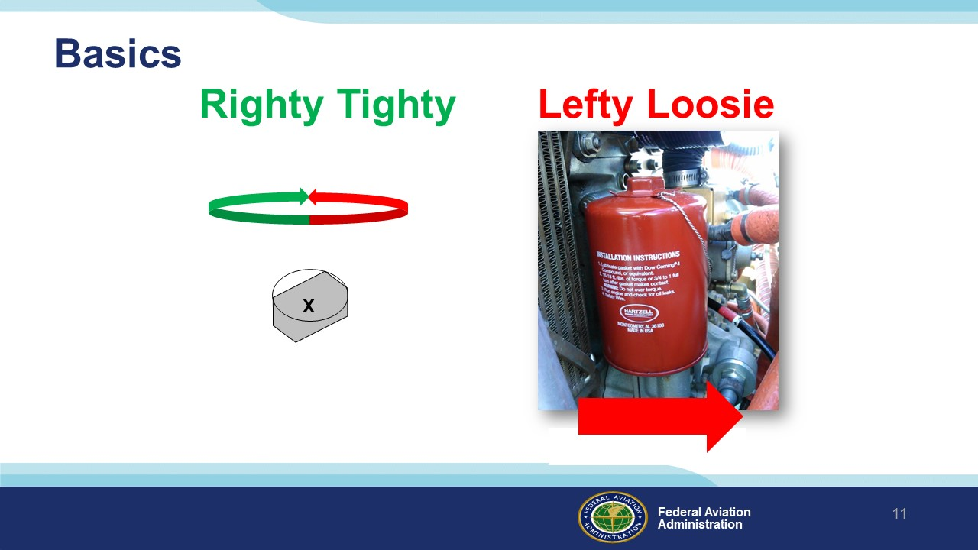 | Slide 11  I realize it sounds a little condescending to start here, but most mechanics say this inside their heads several times a day...Never out loud.  Do you see the key reason the person who safety wired the oil filter should have asked themselves this question?  (Next Slide)
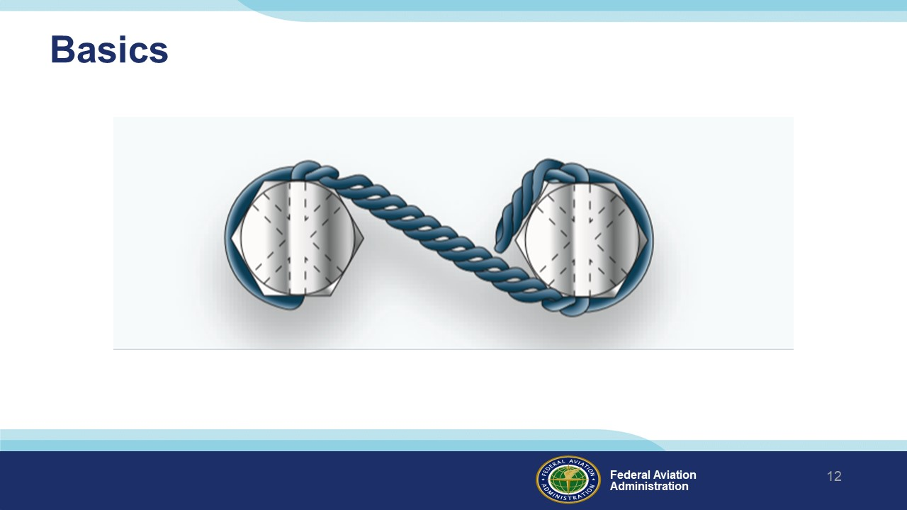 | Slide 12  Here are two bolts prevented from loosening by safety wire.  (Next Slide)
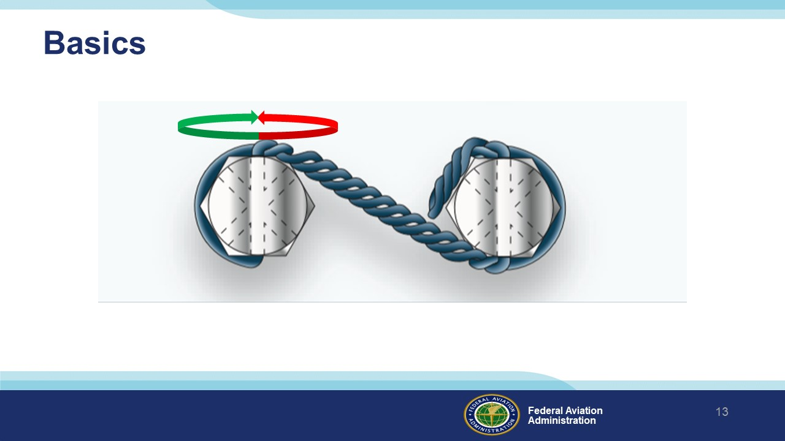 | Slide 13  To evaluate the effectiveness of the safety wire first say the words…Righty Tighty…Lefty Loosey.  (Next Slide)
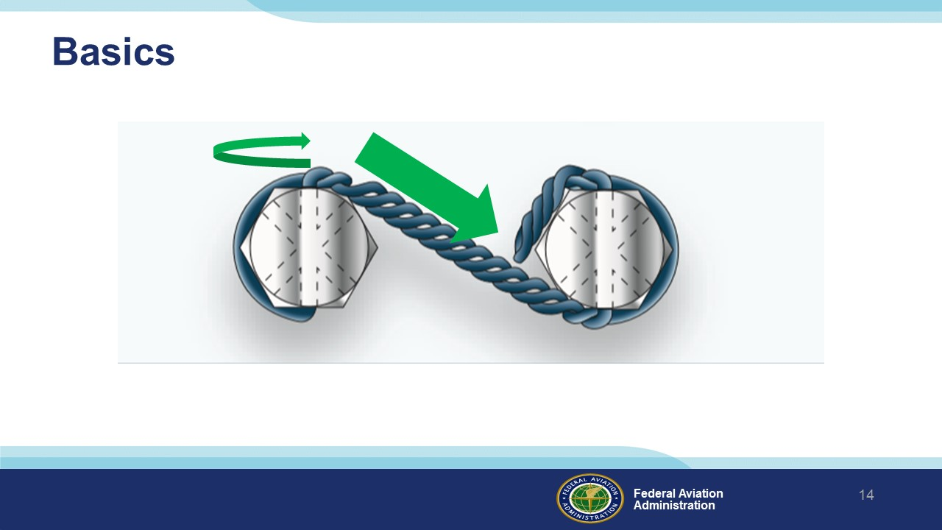 | Slide 14  Then ensure that the safety wire is applied so that it is in tension in the direction that would cause the bolt to “Tighty”.  (Next Slide)
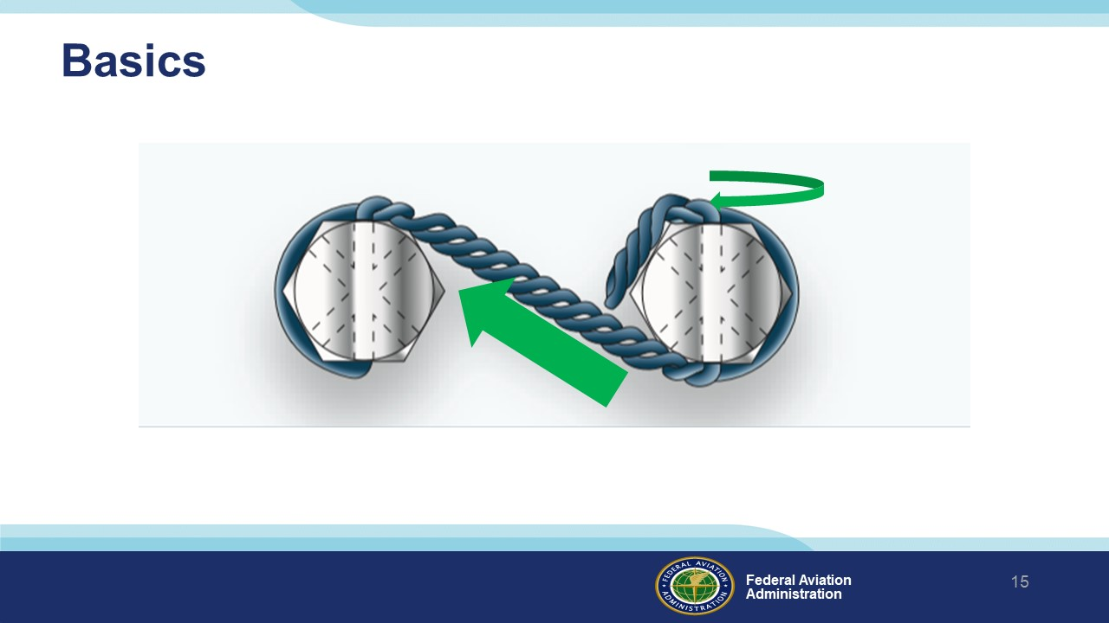 | Slide 15  The other one too.  (Next Slide)
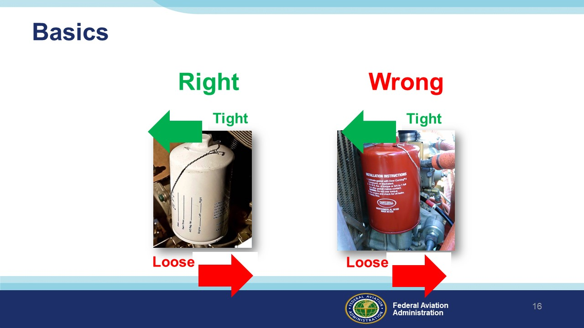 | Slide 16  Here is an example of an oil filter (the white one) wired in the correct direction to contrast the oil filter wired in the wrong direction ( the red one).  (Next Slide)
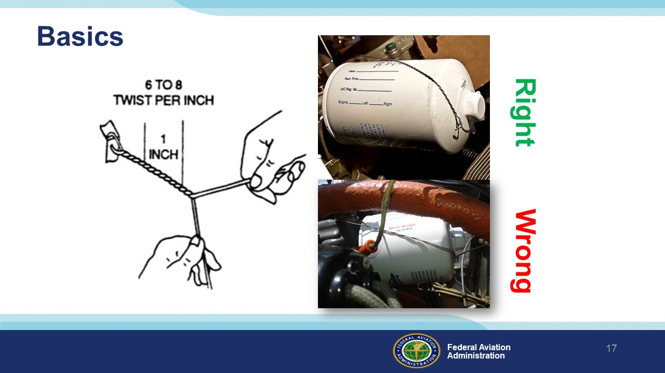 | Slide 17  The AC 43.13-1b calls out 6 to 8 twists per inch. It is probably not required for you to pull out your ruler and calculator. Just notice there is a difference between a nice tight job and sloppy. Because…  (Next Slide)
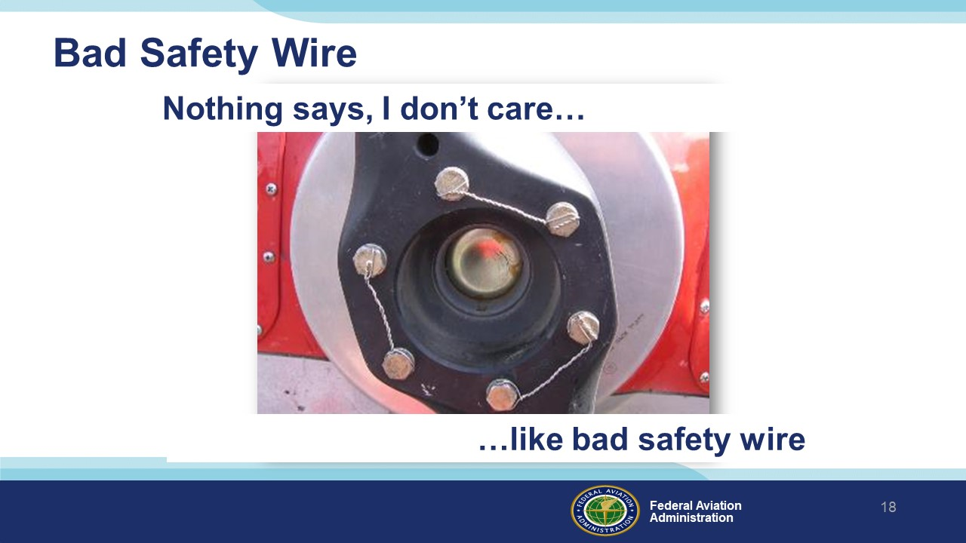 | Slide 18  Nothing says, “I don’t care” like a bad safety wire job. If you see this, it might be worth checking to see what else they screwed up.  (Next Slide)
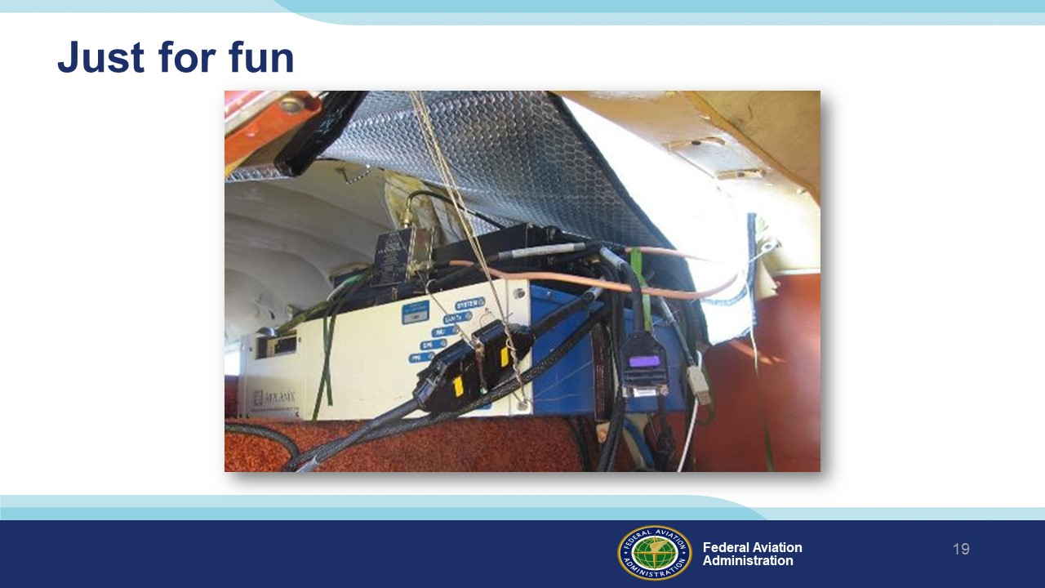 | Slide 19  This is a traffic reporter’s plane with the radio transmitter installed with safety wire; which is a whole new world of wrong safety wiring. We pulled this airplane out of the San Francisco Bay.  (Next Slide)
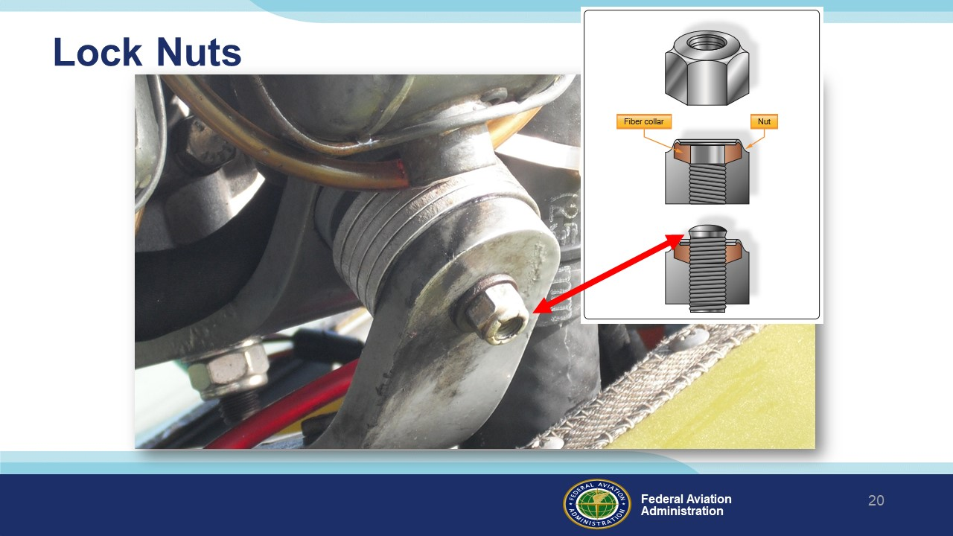 | Slide 20  This isn’t safety wire, but it is another issue that might cause you to ask a question. See how the locking fiber is not contacting the bolt?  Background:  The AC 43.13 will say:  After the nut has been tightened, make sure the rounded or chamfered end of the bolts, studs, or screws extends at least the full round or chamfer through the nut. Flat end bolts, studs, or screws should extend at least 1⁄32 inch through the nut.  (Next Slide)
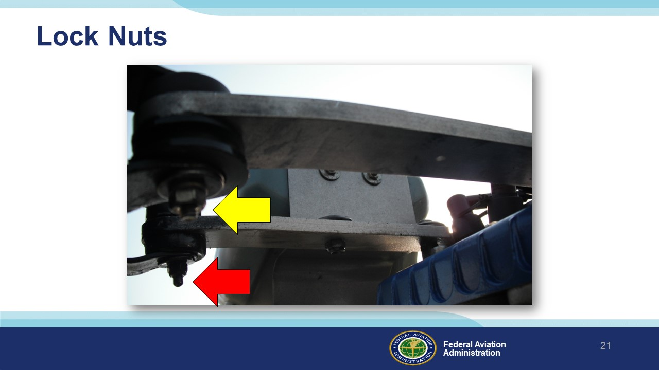 | Slide 21  Here is another issue that should bring a question to mind. See the how the red arrow points at a fiber lock nut? Look closely at the nut at the point of the yellow arrow. It is not a lock nut.  (Next Slide)
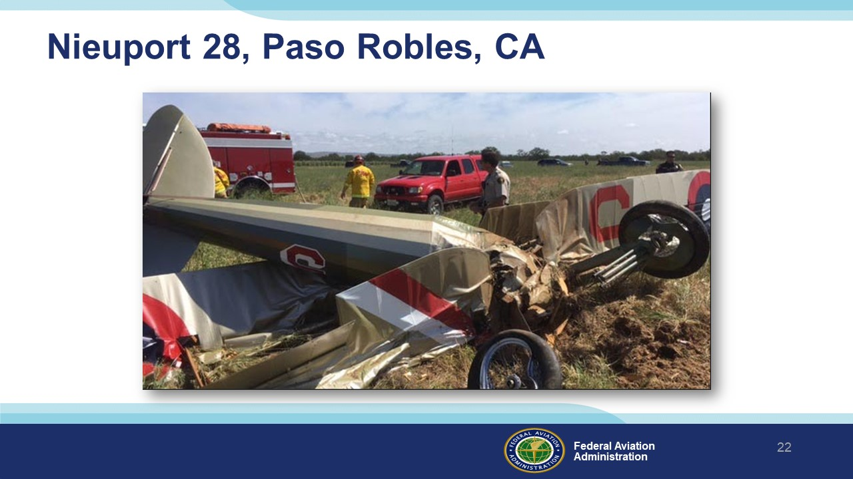 | Slide 22  WPR17FA089 April 23, 2017, This experimental amateur-built World War I fighter replica departed from a private airstrip for a local flight. The airplane climbed, turned left, and entered the downwind leg for the runway. Shortly thereafter the airplane descended in a steep nose down attitude until it impacted terrain. Signatures observed at the accident site and the damage to the airplane were consistent with a near vertical impact attitude into terrain.  (Next Slide)
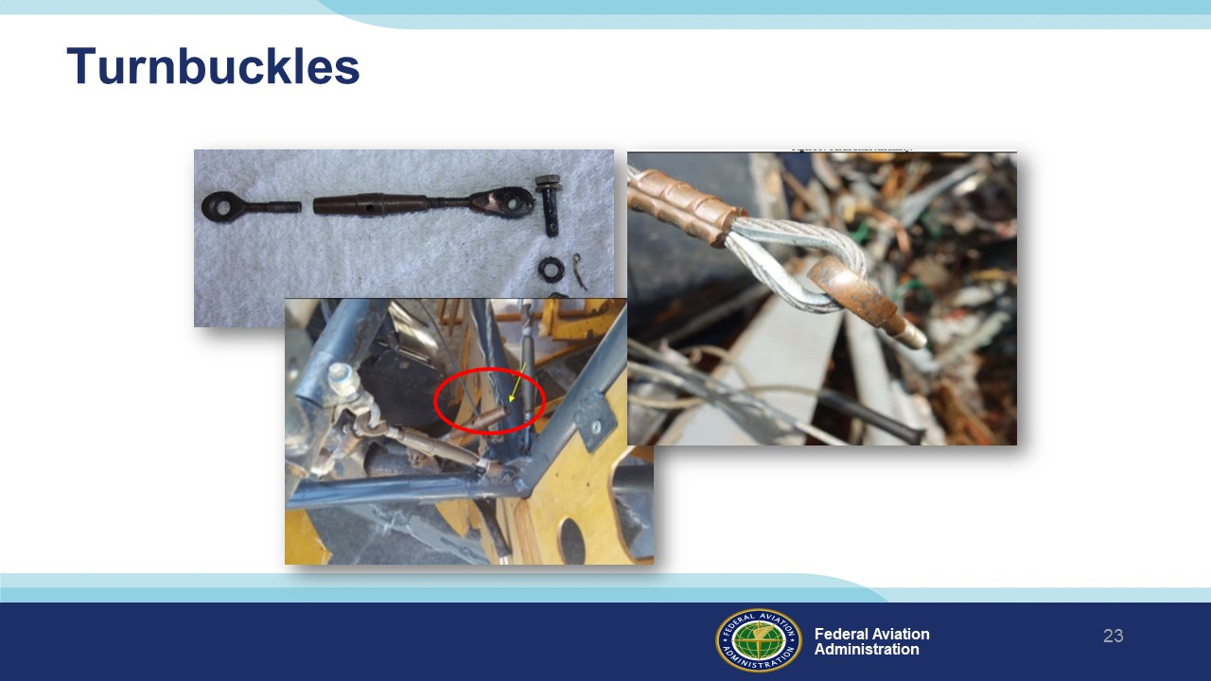 | Slide 23  Post-accident examination of the airplane revealed that an elevator flight control cable rod end had separated from its turnbuckle connection, which resulted in the pilot losing pitch control of the airplane. No safety wire was found at the connection of the turnbuckle and the separated cable rod end, even though it should have been safety wired according to proper maintenance procedure. It is likely that the unsecured connection gradually loosened over time until it finally disconnected during the accident flight.  (Next Slide)
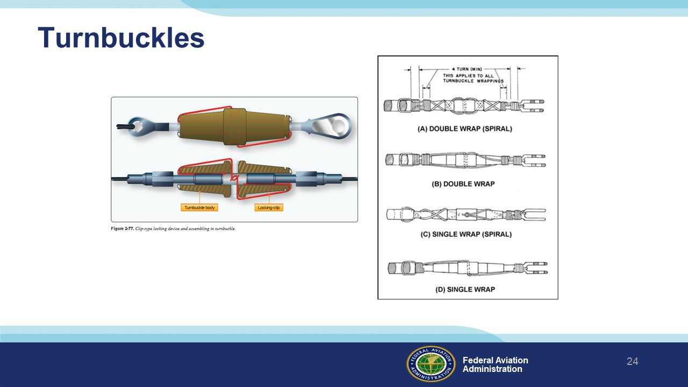 | Slide 24  Turnbuckles should either have safety clips as depicted in the left picture or safety wire as shown in the right picture.  (Next Slide)
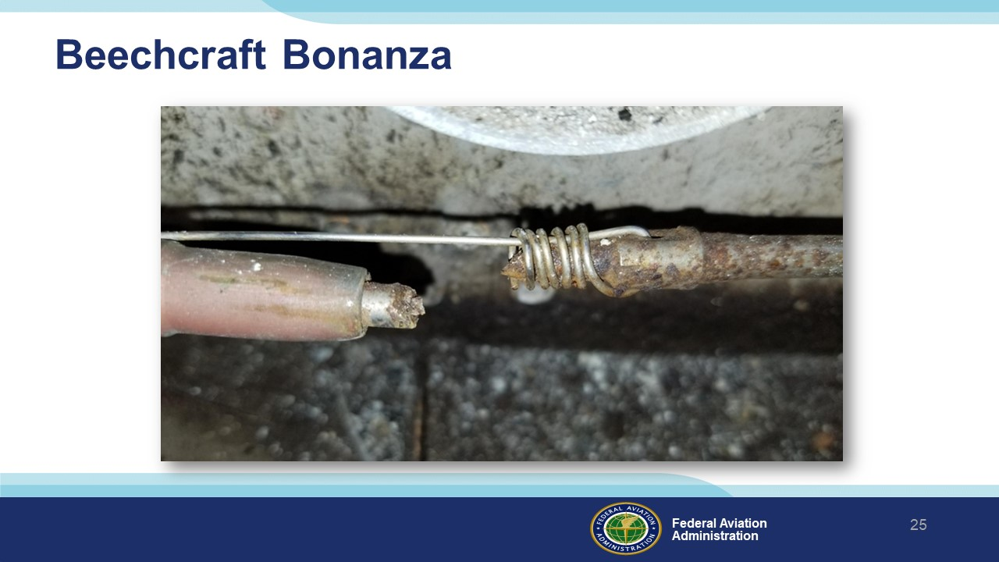 | Slide 25  Here is the picture from the beginning of the presentation. It depicts an aileron cable separation. This airplane had been flying without a noticeable change in handling. It is a save for safety wire, but a reminder to inspect control cables.  Background:  The American Bonanza Society is aware of six recent cases of failure of the swaged end of flight control cables at the turn buckles in Beech piston airplanes. Four were in aileron control cables, one in an elevator control cable and one in a rudder control cable. Two of these cases are currently under investigation by the U.S. National Transportation Safety Board. Failure of a control cable connection at the turn buckle will result in loss of use of the associated control surface(s) and probable loss of control of the aircraft in flight. NOTE: This condition is not related to the control cable failures that were subject of an Australian (CASA) Airworthiness Directive in 2012.  In all these cases the failure resulted from corrosion of the swaged end of the cable in turn buckles located beneath heater ducts (in the case of the aileron cables) or beneath the overhead fresh air inlet duct in the aft fuselage (the rudder and elevator cables). The American Bonanza Society has also received several reports from mechanics who have found cables and turn buckles in these areas that are very wet from condensation but that did not yet show signs of corrosion.  (Next Slide)
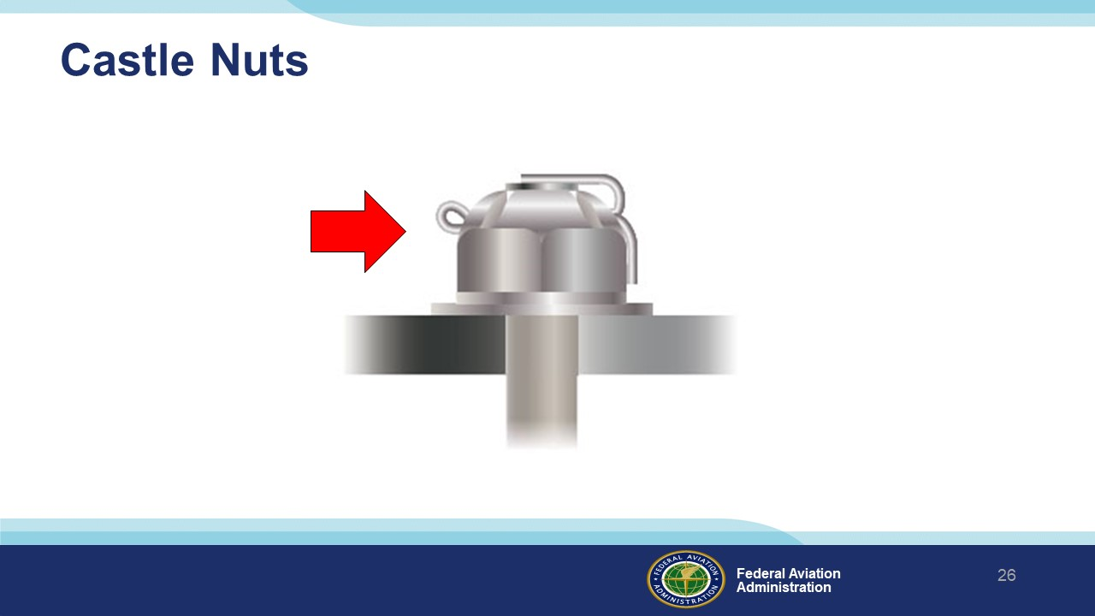 | Slide 26  Castle Nuts require a cotter pin to lock them.  (Next Slide)
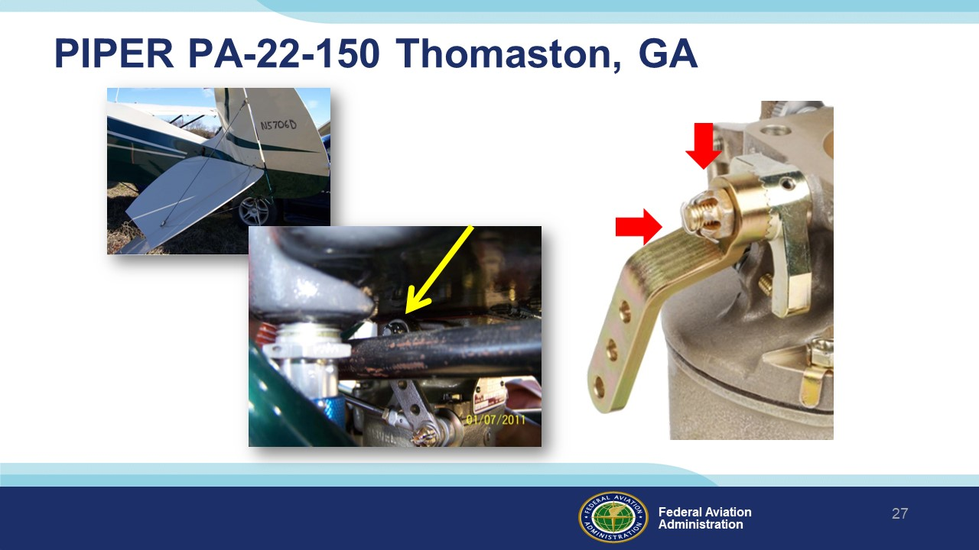 | Slide 27  In this case a Piper Tri Pacer experienced an off-airport landing and substantial damage due to the throttle cable coming loose. The castle nut that holds the throttle arm to the carb was loose and did not have a cotter pin installed.  Background:  ERA11CA108 According to the pilot, the airplane had returned to service after being restored by an airframe and powerplant mechanic with inspection authorization. The pilot performed several takeoffs and landings prior to the accident flight, and noted that the airplane seemed to operate normally. The pilot departed to another airport where he completed a simulated instrument approach to about 50 feet above the runway. He then commenced a go-around over the departure end of the runway with the airplane about 300 feet above the ground. The engine experienced a partial loss of power and the pilot maneuvered the airplane to a hay field, where he performed a forced landing. During the landing roll, the horizontal stabilizer struck a hay bale resulting in substantial damage to the empennage.  A post-accident examination of the wreckage by a Federal Aviation Administration inspector revealed that a cotter pin was not installed on the throttle arm retaining nut. The throttle arm retaining nut was finger tight and the throttle arm was loose, which resulted in excessive play in the throttle linkage.  (Next Slide)
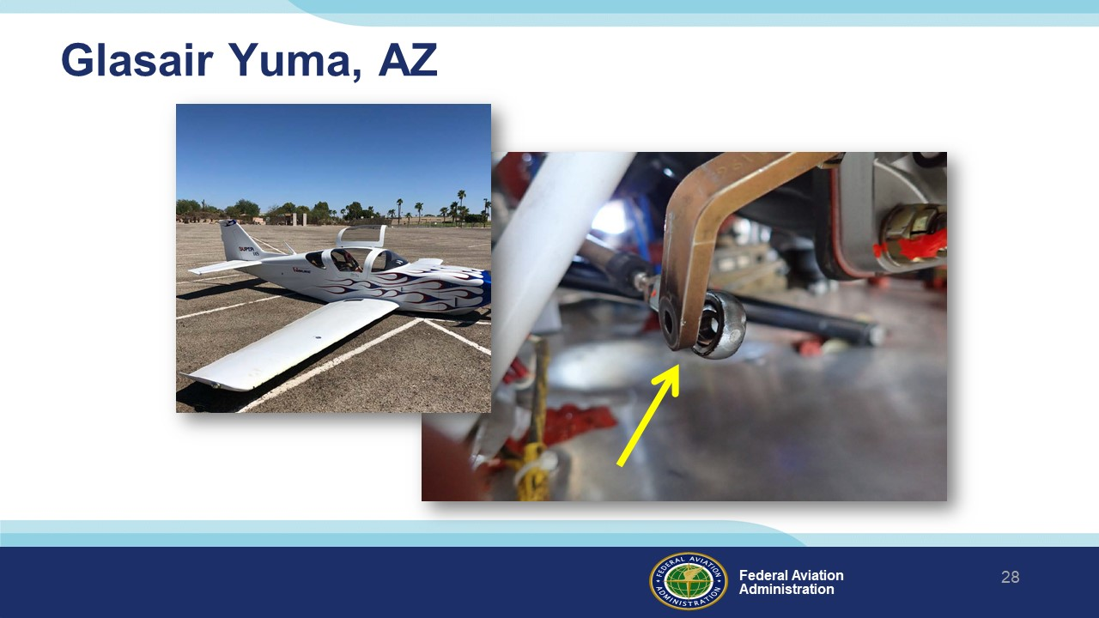 | Slide 28  WPR18LA250, August 27, 2018, About 37 minutes into the flight, the pilot noticed that the engine manifold pressure was dropping, along with the airplane's airspeed, consistent with a partial loss of engine power. The engine then experienced a total loss of power while he was maneuvering for an emergency landing to a nearby airport. The airplane subsequently landed short of the runway and sustained substantial damage to the aft fuselage.  Post accident examination of the engine revealed that the throttle linkage had detached from the throttle arm of the fuel injection servo. The rod end bearing for the linkage and the throttle arm were intact and undamaged, but the connecting bolt and its associated washers, castellated nut, and cotter pin were missing. It is likely that the bolt securing the linkage had not been sufficiently tightened and secured with a cotter pin during the installation.  (Next Slide)
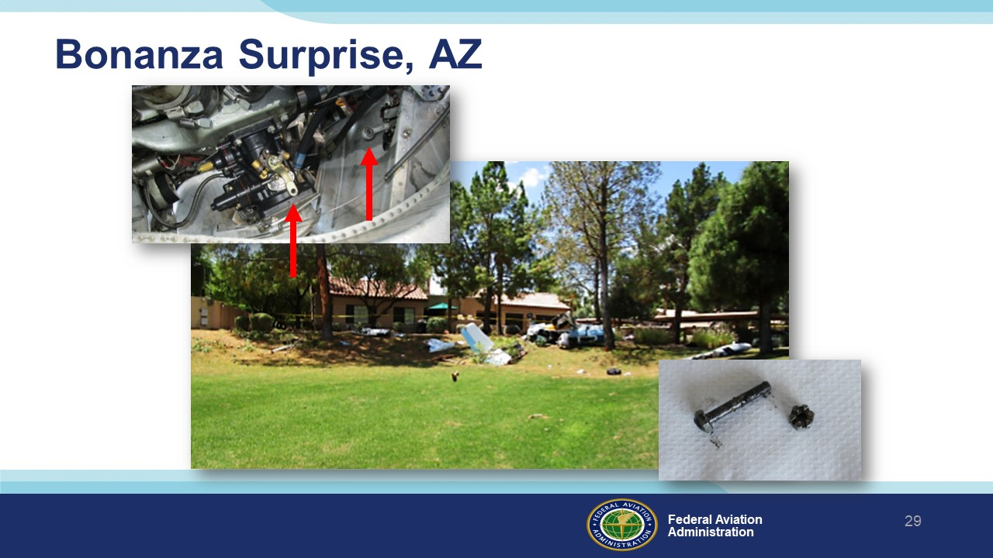 | Slide 29  A flight instructor was asked to complete a maintenance test flight of the airplane following the installation of a carburetor. The engine stopped responding to throttle control. The engine remained at idle power as the airplane descended and impacted trees in a residential area.  Examination of the wreckage revealed that the carburetor throttle cable was detached from the throttle body linkage. The bolt and castellated nut used to secure the throttle cable to the linkage were found lying separately in the engine cowling; a cotter pin had not been used to secure the nut on the bolt.  This accident was fatal for the pilot and seriously injured the passenger.  Background:  WPR16FA102 May 7, 2016, A flight instructor was asked to complete a maintenance test flight of the airplane following the installation of a repaired carburetor. He elected to use the flight to provide instruction to another pilot who had requested a checkout in the airplane. The checked pilot reported that the flight was initially normal, but then the engine stopped responding to throttle control. According to the checked pilot, the engine remained at idle power as the airplane descended and impacted trees in a residential area.  Examination of the wreckage revealed that the carburetor throttle cable was detached from the throttle body linkage. The bolt and castellated nut used to secure the throttle cable to the linkage were found lying separately in the engine cowling; there was no evidence that a cotter pin had been used to secure the nut on the bolt, as required.  It is likely that the loss of engine power resulted from the failure of the mechanic who installed the carburetor to install the cotter pin when he attached the throttle cable to the carburetor. During the maintenance test flight, the castellated nut backed off of the bolt, which resulted in a loss of throttle control.  (Next Slide)
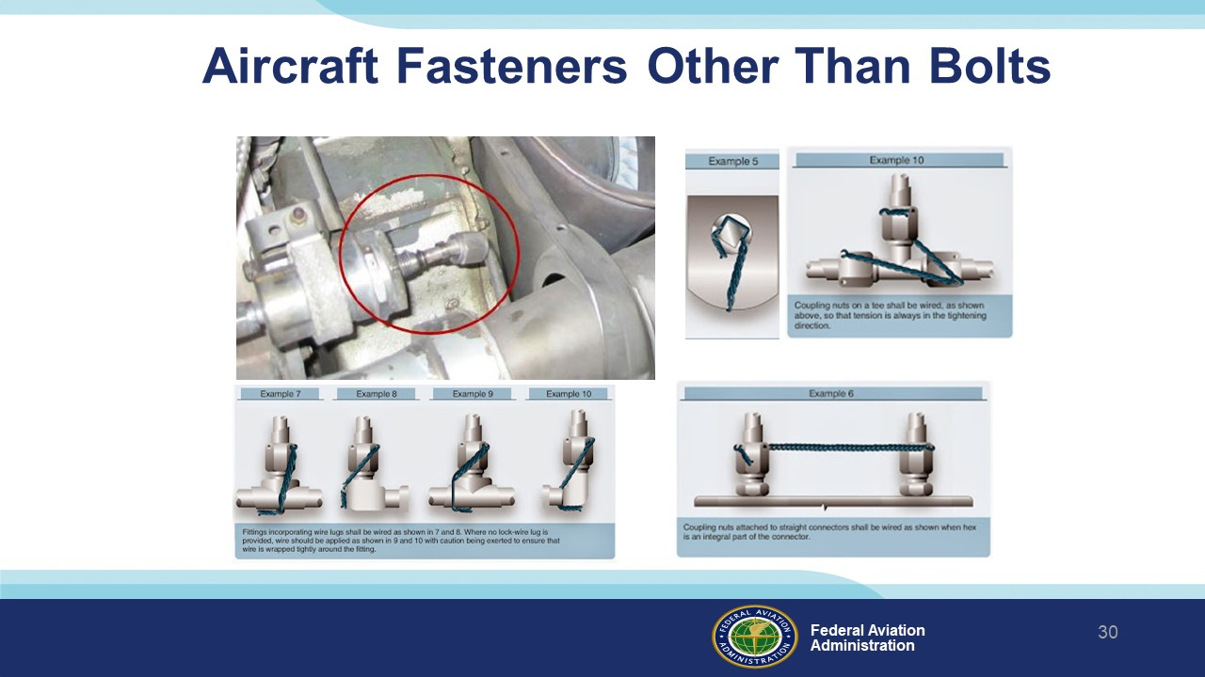 | Slide 30  There are many other parts that require safety wire or other means of locking. The FAA publishes an Advisory Circular that outlines the various locking methods.  (Next Slide)
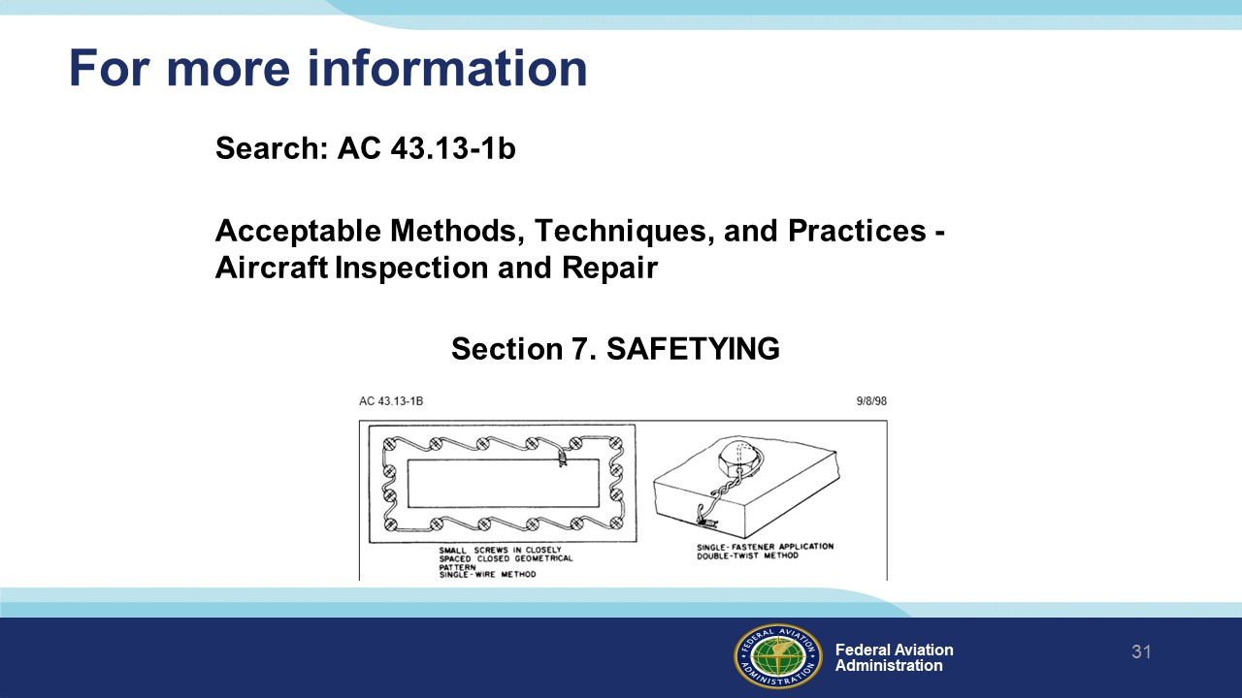 | Slide 31  For more information on aircraft fastener safety search AC43.13-1b. AC 43.13-1b is free online and in section seven you will find the definitive reference for aircraft fastener safety.  (Next Slide)
 | Slide 32  Presentation Note:  You may wish to provide your contact information and main FSDO phone number here. Modify with  Your information or leave blank.  (Next Slide)
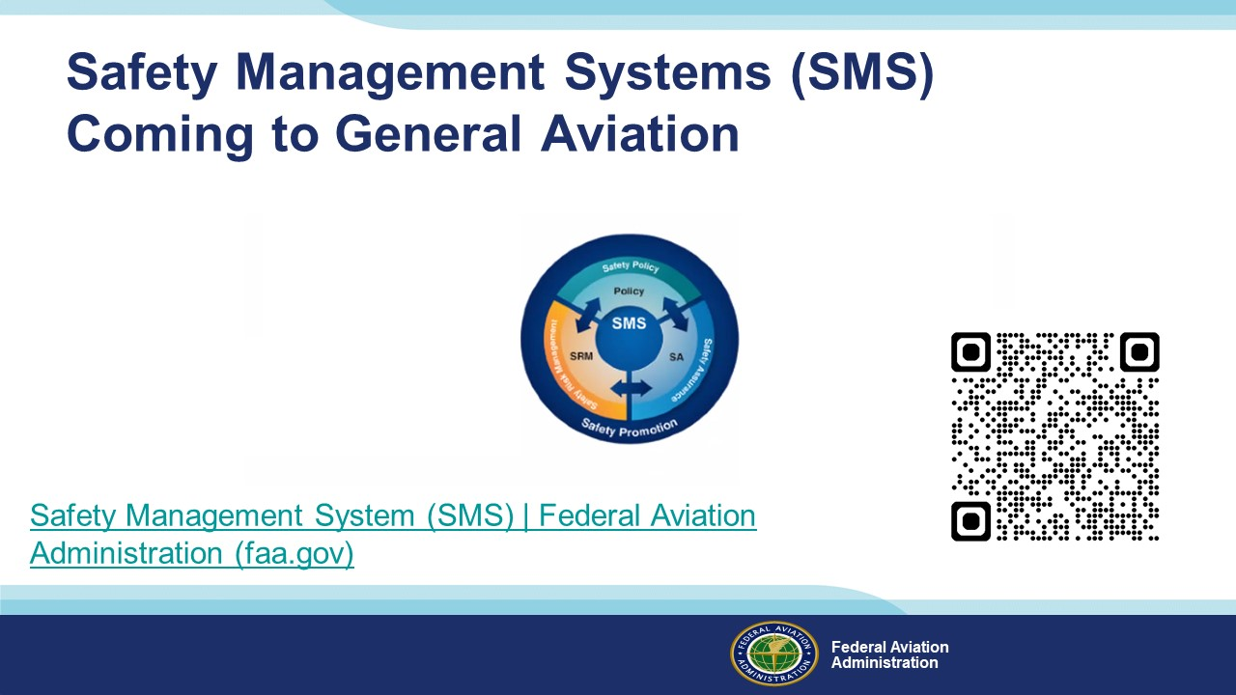 | Slide 33  Safety Management Systems are a set of policies and processes that can increase the safety and efficiency of any flight operation. And FAA is bringing SMS to General Aviation. You may have heard of SMS but thought it was only for large organizations but actually SMS can be scaled to fit any operation large or small.  There are 4 major components to a Safety Management System (Click)  Safety Policy – a documented commitment to safety that runs from the head of an organization to its newest member. (Click)  Safety Risk Management – a process that identifies hazards within an operation, determines to what extent an identified hazard may impact flight safety, and controls the risk of occurrence to an acceptable level. (Click)  Safety Assurance – By collecting and analyzing information derived from safety performance data Safety Assurance ensures the performance and effectiveness of Safety Risk Controls. (Click)  Safety Promotion communicates safety information and commitment throughout the organization. (Click)  You can find more information about Safety Management Systems at the URL on the Screen.  Presentation note: Allow sufficient time for audience to copy link then:  (Next Slide)
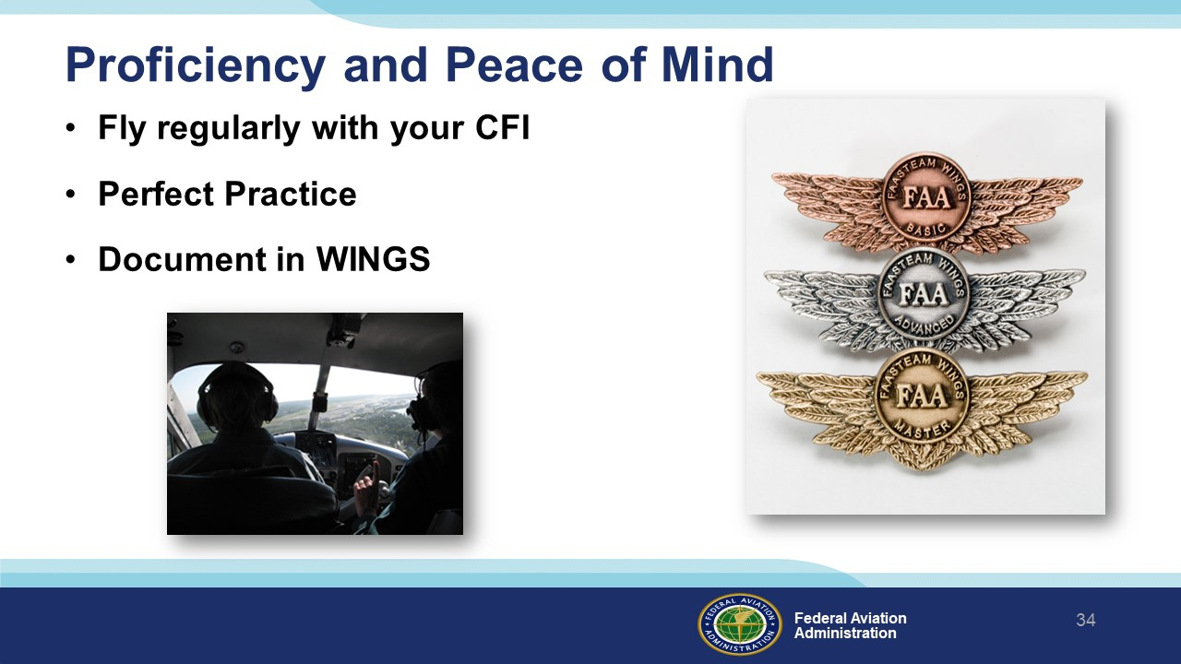 | Slide 34  There’s nothing like the feeling you get when you know you’re playing your A game and in order to do that you need a good coach (Click)  So, fly regularly with a CFI who will challenge you to review what you know, explore new horizons, and to always do your best. Of course you’ll  have to dedicate time and money to your proficiency program but it’s well worth it for the peace of mind that comes with confidence. (Click)  Vince Lombardi, the famous football coach said, “Practice does not make perfect. Only perfect practice makes perfect.” For pilots that means  flying with precision. On course, on altitude, on speed all the time. (Click)  And be sure to document your achievement in the Wings Proficiency Program. It’s a great way to stay on top of your game and keep you flight review current.  (Next Slide)
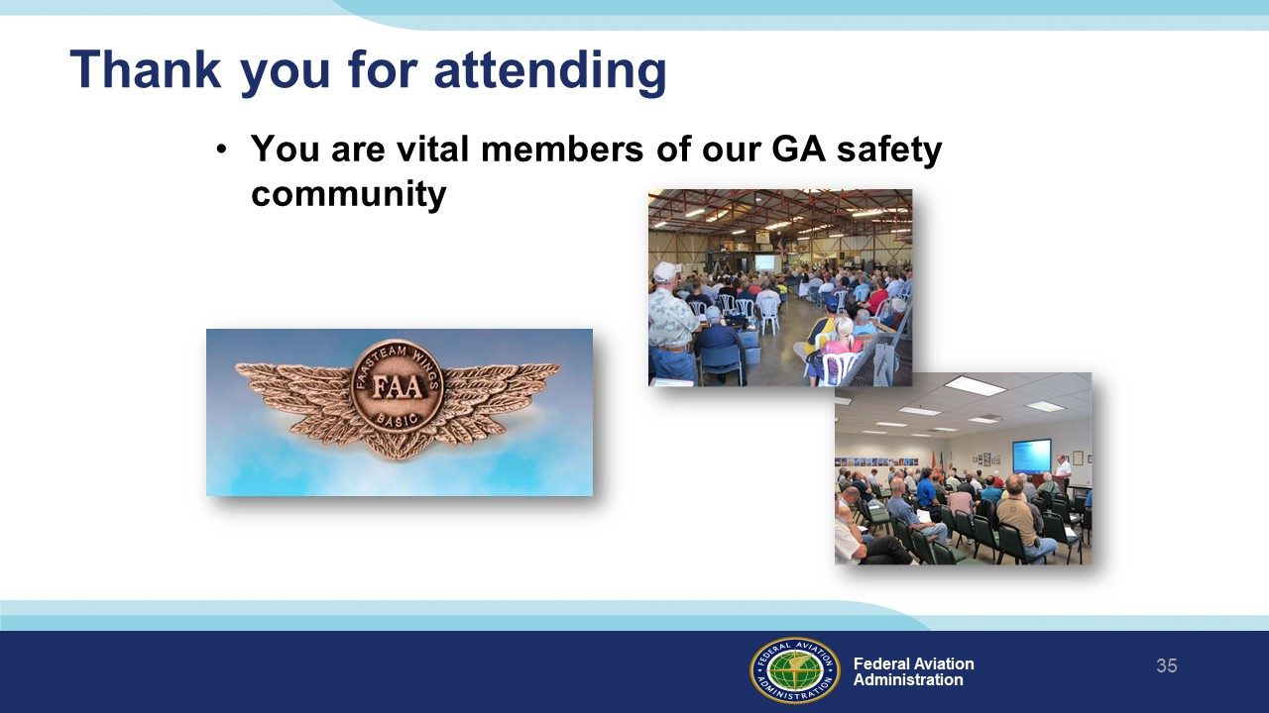 | Slide 35  Your presence here shows that you are vital members of our General Aviation Safety Community. The high standards you keep and the examples you set are a great credit to you and to GA.  Thank you for attending.  (Next Slide)
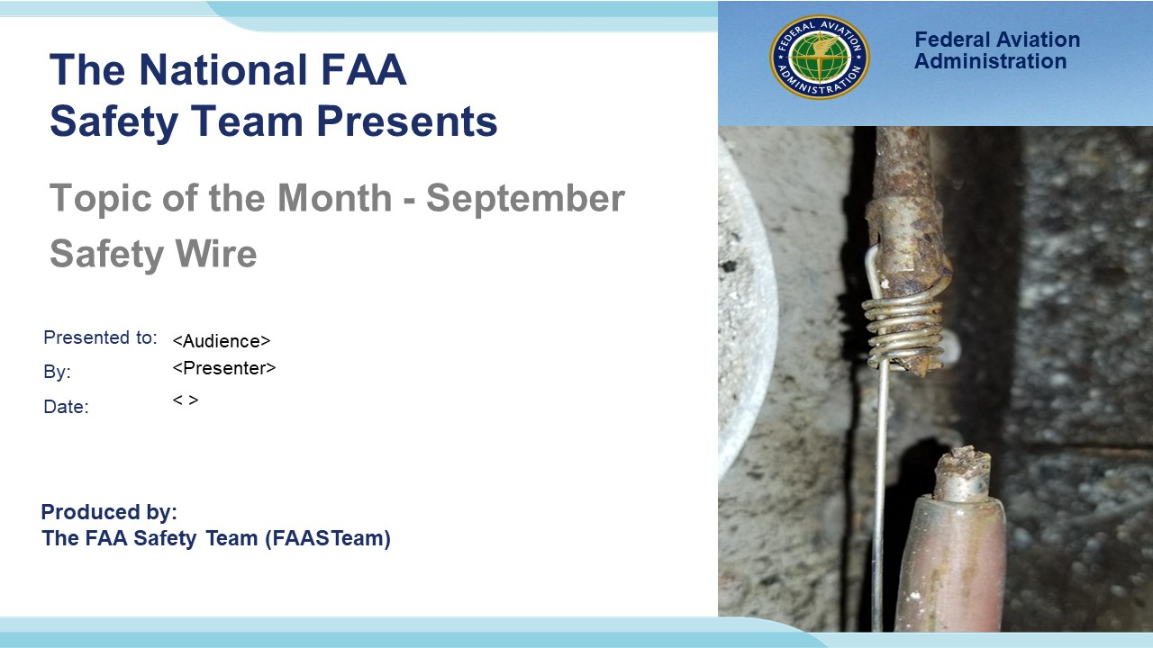 | Slide 36  (The End)

IMPORTANT – Once you have completed outreach on this topic, please help us track the outreach you have done by entering a PTRS record.

